VIDEO 1:

IDENTIFIERS:

Name in java program is called identifier which can be used for identification purpose, it can be method name, variable name, class name or label name.

ex: class test{

public static void main(String[] args){

int x=10;

}

}

Here identifiers are 5.

Rules for defining java identifiers:

allowed characters in java

1. **a to z ,0 to 9, A to Z, $, _**

if we use other character we get compile time error

ex: total_number // valid

total# //invalid

2. Identifier can't start with digit.

total123 //valid

123total //not valid

3. java identifiers is case sensitive,also java is written in case sensitive

ex: class test{

int number=10;

int Number=20;

int NUMBER=30;

}

4. no length limit with java indentifier but not good practice

int xxxxxxxxxxxxxxxxxxxxxxxxxxxxxxxxx=10;

5. we can't user reserved words as identifiers

int x=10; //valid

int if =20; //invalid

6.All predifined java class name and interface name we can use as identifiers even though it is valid but it is not good practice because it reduces readibilty and creates confusion.

int String = 888;

sop(String); // 888

int Runnable = 999;

sop(Runnable) //999;

which of the following are valid java identifiers

ca$h //V

_$_$_$_$_ //V

all@hands //NV

java2Share //V

Integer //V

Int //V

int //NV

Reserved words:

in java some words are reserved words(53) to represent some meaning and functionality such type of words are called reserved words.

Reserved words(53)

i) Keywords(50): reserve word associated with functionality

i.a)used keywords(48) ex: if, else,.........

i.b)unused keyword(2) ex: goto, const

ii) reserved literals(3) : reserved word associated with value.

ex: true, false, null

Keywords for datatypes(8):

byte, short, int, long, float, double, boolean, char

keywords for flow control(11):

if, else, switch, case, default, while, do, for, break, continue, return

keywords for modifiers(11):

public, private, protected,static,final,abtract,synchronized,native,strictfp(1.2Version), transient,volatile

keywords for exception handling(6):

try, catch, finally,throw,throws,assert(1.4V)

class related keyword(6):

class, interface, extends,implements,package,import

object related keywords(4):

new,instanceof,super,this

In java return type is mandatory, if method won't return anything then we have to declare method with void return type method but in c lang. return type is optional under default return is int.

void is return type keywords

Unused keywords:

i) goto : usage of goto created several problems in old languages and hence some people banned this keyword in java.

ii) const: use of final instead of const.

goto and const are unused keyword and if we are trying to use we will get compile time error.

Reserved literals(3):

true, false - values of booleand data type

null - default value for object reference

enum(1.5V) keyword : we can use enum to define a group of names constants

enum month{

JAN,FEB....DEC;

}

conclusions:

1.All 53 reserved in java contains only lower case alphabet symbols.

2. In java we have new keyword and there is no delete keyword in java because of destruction of useless object is the responsibility of garbage collector.

3.The following are new keywords in java:

strictfp,assert,enum

VIDEO 2:

DATA TYPES

1.In java every variable and every expression has some type. Each and every datatype is clearly defined ,every assignment should be checked by compiler for type compatibility because of above reason we can conclude java language is strongly typed programming language.

int x=10.5 // compiler check for data type i.e strongly typed

2.JAVA is not considered as pure OOP langauge because several OOP feature are not supported by java like operator overloading, multiple inheritance etc,. Moreover we are depending primitive datatype which are non-objects.

3.Primitive Data type(8):

3.1. Numeric data types

3.1.1. Integral data types (byte, short, int, long)

3.1.2. Floating point data types(float, double)

3.2. Non-numeric data types (char, boolean)

except boolean and char remaining data types are considered as signed data types because we can represent both the postive and negative numbers.

1. Integral data type

1.1 byte (1 byte = 8 bit)

X _ _ _ _ _ _ _

Max value= 0 1 1 1 1 1 1 1 = 64 + 32 + 16 + 8 + 4 + 2 + 1 = 127

X = 0 for +ve

X = 1 for -ve

MAX_VALUE= +127

MIN_VALUE = -128

Range= -128 to +127

+ve numbers stored directly in memory but -ve numbers are stored in 2's compliment form.

wrapper class: Byte

default value: 0

byte b= 10 ; valid

byte b =127; valid

byte b = 128 ; invalid compile time error(possible last of precision found: int required : byte)

byte b=10.5; invalid compilte time error(possible last of precision found: double required : byte)

byte b= true; //invalid compile time error(incompatible types found: boolean required: byte)

byte b= "Vicky" //invalid (incompatible type found: java.lang.String

required: byte)

byte is the best choice if i want to handle data in terms of streams either from the file or from the network(File supported form and netwrok supported form is byte).

1.2. short (2 byte =16 bits)

This is the most rarely used data type in java.

Range: [-2^15 to 2^15 - 1] = [-32768 to 32767]

wrapper class: Short

default value: 0

short s= 32767; valid

short s= 32768; invalid compile time error(possible last of precision found: int required : short)

short s=10.5; //invalid

short s=true; //invalid

short data type is best suitable for 16 bit processor like 8085 but these processor are outdated and hence corresponding short data type is also outdated data type.

1.3. int(4 byte = 32 bits)

Range: [-2^31 to 2^31 - 1] = [-2147483648 to 2147483647]

wrapper class: Integer

default value: 0

int is the most commonly used data type in java.

int x=2147483647 //vaild

int x = 2147483648 invalid compile time error(integer number too large)

int x= 2147483648L; invalid compile time error(possible last of precision found: long required : int)

int c= true; invalid compile time error(incompatible types found: boolean required: int)

VIDEO 3:

1.4. long

sometimes int may not enough to hold big values we should go for long type.

long l= 126000*60*60*24*1000;

The number of characters present in big file may exceed int range hence return type of length method is long but not int.

long l=f.length();

size = 8 byte(64bits)

Range= -2^63 to 2^63 - 1

wrapper class: Long

default value: 0

2.Floating point data types:

2.1.float

5 to 6 decimal accuracy

single precision(less accuracy)

size : 4 byte

Range : -1.7e38 to 1.7e38(1.7 * 10^38)

wrapper class: Float

default value: 0.0

2.2.double

14 to 15 decimal accuracy

double precision(more accuracy)

size : 8 byte

Range : -3.4e308 to 3.4e308

wrapper class: Double

default value: 0.0

3.boolean datatype(1 bit)

size : not applicable(virtual machine dependent)

Range : not applicable(but allowed values are true/false )

wrapper class: Boolean

default value: false(in java is false ,c/c++ default value is true)

boolean b= true; //valid

boolean b= 0; //incompatible types found:int required : boolean

boolean b= True; //cannot found symbol: variable True location: class Test

boolean b="True";//invalid

int x=0;

if(x)

sop("Hello");

else

sop("Hi");

No error in c, c++ but in java it given compilation error

(compile time error(CE) : incompatible type found: int required: boolean).

while(1){

sop("Hello");

}

// Hello infinite time in c,c++ but in java compilation error

4.char

old languages(c,c++) are ASCII Code based and the number of allowed different ASCII Codes are <=256 to represent these 256 characters 8 bit are enough hence the size of char in old languages is 1 byte.

c,c++ can only have characters like a-z,A-Z,0-9,$,&,<,*,<,(,),6,%.....

But java is unicode based and the number of different unicode character are >=256 and <=65536 ,to reperesent these many characters 8 bit may not enough compulsory we should go for 16 bits,hence size of char in java is 2 byte

Java can have characters like a-z,A-Z,0-9,$,&,<,*,<,(,),6,%..... and also other characters which don't have ascii values like(tamil characters,hindi characters etc..)

size: 2 byte(16 bits);

Range : [0 to 65535(2^16)]

wrapper class: Character

default value: 0(represent space value)

NOTE: null is default value for object reference, and we can't apply for primitive if we trying to use primitive then we will get CE.

ex: char ch=null;

CE: incompatible types found:<nulltype> required: char

VIDEO 4:

LITERALS

int x = 10;

int - data type/keyword

x - name of varaible/ identifier

10 - constant/literal

Any constant value which can be assigned to the variable is called literal.

Intergral literals

For intergal data types(byte,short,int,long) we can specify literal value in the following ways:

1.Decimal literal(base 10)

Allowed digits are 0 to 9

ex: int x = 10;

2. Octal form(base 8)

Allowed digits are 0 to 7

Literal value should be prefix with 0.

ex: int x = 010; //8

3.Hexadecimal form(base 16)

Allowed digits are 0 to 9 and a to f.

For extra digits(a to f) we can use both lower and upper case characters. this is one of very few areas where java is not case sensitive.

The literal value should be prefixed with 0x or 0X.

ex: int x = 0X10; //16

These are only possible ways to specify literal value for integral data types.

int x= 10//valid

int x= 0786 // invalid CE: integer number too large(allowed digits are 0 to 7 only)

int x=0777//valid output 511(in decimal form)

int x=0XFace //valid(64206 output)

int x=0XBeef//valid

int x=0XBeer//invalid

class Test{

psvm(String[] args){

int x=10;

int y=010;

int z=0X10;

sop(x+" "+y+" "+z);//output -> 10 8 16

}

}

(10)base8 = (?)base 10

0*8^0 + 1*8^1 = 8

(10)base16 = (?) base 10

0*16^0 + 1*16^1 =16

By default every integral literal is of int type but we can specify explicitly as long type by suffixed with l or L.

int x = 10;valid

long l = 10L;valid

int x=10L; //Invalid CE:PLP found:long required:int

long l = 10;//valid

There is no direct way to specify byte and short literal explicitly but indirectly we can specify whenever we are assigning integral literal to the byte variable and if the value within the range of byte then compiler treats it automatically as byte literal similarly short literal also.

byte b = 10;

byte b =127;

byte b = 128;//CE:PLP found:int required : byte

Floating point literals:

By default every floating point literal is of double type and hence we can't assign directly to the float variable but we can specify floating point literal as float type by suffixed with f or F.

Ex:

float f = 123.456;//CE: PLP found : double required : float

float f = 123.456f;//valid

double d = 123.456;//valid

we can specify floating point literal as double type by suffixed with d or D offcourse this convention is not required.

double d=123.4567D;//valid

float f =1233.456d; CE: PLP found : double required : float

(we can't store double value (8byte) into float variable(4byte) )

We can specify floating point literals only in decimal form and we can't specify in octal and hexadecimal forms.

double d=123.456;//decimal form

double d=0123.456;//decimal form

double d=0X123.456;//hexadecimal form CE: malformed floating point literal.

we can assign integral literal directly to floating point variables and that integral literal can be specified either in decimal, octal or hexadecimal forms.

double d =10;

double d = 0786;//octal invalid CE: integer number too large

double d = 0XFace;//valid because we are assigning the decimal value of 0XFace(64206.0)

double d=0786.0;//valid

double d=0XFace.0;//invalid

we can't assign floating point literals to integral types.

double d= 10;

int x =10.0;//invalid CE: PLP found: double required : int

we can specify floating point literal even in exponential form.

double d =1.2e3;//1200.0

float f = 1.2e3;//invalid PLP ....

float f= 1.2e3F;//valid

Boolean Literals:

The only allowed value are true/false

boolean b=true//valid

boolean b=0;//invalid

boolean b=True//IV

boolean b="true";//IV

VIDEO 5:

Char Literals:

char ch = 'a';

char ch=a;//IV CE: cannot find symbol: variable a location: class Test

char ch="a"; CE: incompatible type found; java.lang.String required : char

char ch='ab'; CE1 : unclosed char literal CE2: unclosed char literal CE3: not a statement

we can specify char literal as integral literal which represents Unicode value of the character, and that integral literal can be specified either in decimal, octal or hexadecimal form but allowed range is o to 65535

char ch = 97;

sop(ch)// a

char ch = 0XFace;

char ch= 0777;

char ch = 65535;

char ch = 65536;//INV CE:PLP found:int required :char

we can specify char literal in Unicode which is nothing but '\uxxxx' xxxx= 4 digit hexadecimal number.

char ch ='\u0061'; // a

char ch='\n'

char ch='\t'

char ch='\m'//INV CE: illegal escape character

Escape characters:

\n - newline

\t - horizontal tab

\r - carriage return

\b - Back space

\f - Form Feed

\' - Single quote

\" - Double quote

\\ - Backslash

SOP("This is ' Symbol");//Inv

sop("This is \' Symbol"); //Valid

sop("This is \" symbol");

sop("This is \\character");

char ch=0xBeer//inv

char ch=\uFace; //Inv

char ch='\ubeef'; //V

char ch='\m';//Inv

char ch='\iface'; //Inv

String Literal:

Any sequence of character within double quotes is treated as string literal.

Ex:

String s= "Vicky";

1.7 Version enhancement with respect to literals:

1. Binary literals

for Integral data type until 1.6 version we can specify literals values in the following form decimal form, octal form, hexadecimal form but from 1.7 version onwards we can specify literal values even in binary form.

Allowed digits are 0 and 1.

Literal value should be prefixed with b/B

Ex:

int x = 0B1111;

sop(x);//15

Usage of _ in numeric literals

from 1.7 version onwards we can use _ between digits of numeric literals.

The main advantage of this approach readability of the code will be improved.

double d= 123456.789;

||

double d = 1_23_456.7_8_9;

At the time of compilation these _ symbols will be removed automatically hence after compilation the above lines will becomes.

double d =123456.789;

we can use more than one _ symbol between the digits

double d =1___23_456_5_7.789;

we can use _ symbol only between the digits if we are using anywhere else, we will get compile time error

double d=_1_2_3_45.7_8_9;//INv

double d=1_2_3_4_.7_8_9;//INv

double d=1_2_3_4.7_8_9_;//Inv

byte(1byte)->short(2byte)->int(4byte)->long(8byte)->float(4byte)->double(8byte)

char(2byte)->int(4byte)

8byte long value we can assign to 4-byte float variable because both are following different memory representation internally.

VIDEO 6:

Arrays:

An array is a indexed collection of fixed numbers of homogenous data elements. The main advantage of array is we can represent huge number of values by using single variable so that readability of the code will be improved but the main disadvantage of array fixed in size i.e. once we create an array there is no chance of increasing or decreasing the size based on our requirement hence to use arrays concept compulsory we should know the size in advance which may not possible always.

Array declaration:

1D array declaration:

1. int[] x; //recommended because name is clearly separated from type
2. int []x;
3. int x [];

At the time of declaration, we can’t specify the size otherwise we will get CE.

int[6] x; // CE

int [] x;// valid

2D array declaration:

int [][] x; //valid

int [][]x; valid

int x [][]; valid

int [] []x; valid

int [] x[]; valid

int []x[]; valid

int [] a, b;// a->1D b->1D

int[] a[],b;// a->2D b->1D

int[] a[],b[];// a->2D b->2D

int[] []a, b;// a->2D b->2D

int[] []a, b[];// a->2D b->3D

If we want to specify dimension before the variable the facility is applicable only for first variable in the declaration, if we are trying to apply for remaining variable we will get CE.

int[] []a,[]b; //Invalid CE

3D array declaration:

int[][][] a;// valid

int [][][]a;//valid

int a[][][];//valid

int [] [][]a;//valid

int[] a[][];//valid

int[] []a[];//valid

int[][] []a;//valid

int [][] a[];//valid

int [][]a[];//valid

int []a[][];//valid

Array creation:

Every array in java is object only hence we can create arrays by using new operator.

int[] a = new int[3];



a



sop(a.getClass().getName()); // [$\overline{⊥}$

For every array, corresponding class are available and these classes are part of java language and not available to the programmer level.

|  |  |
| --- | --- |
| Array type | Corresponding class name |
| int [] | [ $\overline{⊥}$ |
| int[] [] | [[ $\overline{⊥}$ |
| double[] | [D |
| short[] | [S |
| byte[] | [B |
| boolean[] | [Z |

At the time of array creation compulsory, we should specify the size otherwise we will get CE

int [] x=new int [] ;//invalid

int [] c= =new int [6] ;//valid

It is legal to have an array with size 0 in java.

int[] x= new int[0];//valid

If we are trying to specify array size with some negative int values then we will get runtime exception saying NegativeArraySizeException

int[] x = new int[-3]; //No CE but Runtime error: NegativeArraySizeException

To specify array size the allowed datatypes are byte , short, char, int if we are trying specify any other type then we will get compile time error(CE).

int[] x= new int[];

int[] x =new int[‘a’];//valid

byte b=20;

int [] x = new int[b] ;//valid

short s= 30;

int [] x= new int[s]; //valid

int[] x=new int[10L]; //CE PLP found : long required: int

The maximum allowed array size in java is 2147483647 which is the maximum value of int datatype.

Even in the first case we may get runtime error if sufficient heap memory is not available.

int[] x=new int[2147483647]; //valid

int[] x =new int[2147483648]; //invalid CE : integer number too large

VIDEO 7:

2D array creation:

In java 2D array not implemented by using matrix style some people followed arrays of array approach for multidimensional array creation.

The main advantage of this approach is memory utilization will be improved.

Subject marks

|  |  |  |  |  |
| --- | --- | --- | --- | --- |
| 12 | 13 | 12 | 57 | 34 |
| 13 | 89 | 67 | 23 | X |
| 12 | 56 | X | X | X |
| 89 | X | X | X | X |
| 90 | 76 | X | X | X |

|  |  |  |  |  |
| --- | --- | --- | --- | --- |
|  |  |  |  |  |

|  |  |
| --- | --- |
| 12 | 56 |

|  |
| --- |
| 89 |

|  |  |
| --- | --- |
| 90 | 76 |

|  |  |  |  |
| --- | --- | --- | --- |
| 13 | 89 | 67 | 23 |

|  |  |  |  |  |
| --- | --- | --- | --- | --- |
| 12 | 13 | 12 | 57 | 34 |

int [] [] x=new int[5][];

x [0] = new int [5];

x [1] = new int[4];

x [2] = new int[2];

x [3] = new int[1];

x[4] = new int[2];

int[] a=new int[];//iv

int[] a=new int[3];//v

int [][] a=new int[][];//iv

int [][] a= new int[3][];v

int[][] a=new int[][4];//iv

int [][] a= new int[3][4];//v

int[][][] a=new int[3][4][5];//v

int[][][] a= new int[3][4][];//v

int[][][] a=new int[3][][5];//iv

int[][][] a =new int[][4][5];//iv

Array initialization:

Once we create an array every element by default initializer with default value.

int [] x=new int[3];

sop(x);// [ $\overline{⊥}$@3225a5

sop(x[0]);//0

|  |  |  |
| --- | --- | --- |
| 0 | 0 | 0 |

Note : whenever we are trying to print any reference variable, internally to_string method will be called which is implemented by default to written the string in the following form:

classname@hashCode_in_hexadecimalform.

int [][] x=new int[2][3];

sop(x);// [[$\overline{⊥}$@3225a5 (x is 2D array reference)

sop(x[0]);// [$\overline{⊥}$@19821f (x[0] is 1D array reference)

sop(x[0][0]);// 0

int [][] x=new int[2][];

sop(x);// [[$\overline{⊥}$@3e45a5 (x is 2D array reference)

sop(x[0]);// null

sop(x[0][0]);// RE: NullPointerException

|  |  |
| --- | --- |
| null | null |

x

objects

If we are trying to perform any operation on null, then we will get RE saying NullPointerException.

Once we create an array every array element by default initializer with default values. If we are not satisfied with default values, then we can override these values with our customised values.

int [] x=new int[3];

x[0]=10;

x[1]=20;

x[2]=40;

x[3]=50;//RE: ArrayIndexOutOfBoundException

x[-3]=80;//RE: ArrayIndexOutOfBoundException

x[2.5]=90;//CE: PLP found : double required: int

VIDEO 8:

Array declaration, creation, and initialization in a single line.

int [] x= {10,20,30};

char [] ch={‘a’, ’e’, ’i’, ’o’, ’u’};

We can declare, create, and initialize in a single line.

int [] []x= {{10,20},{30,40,50}};

int[] x ;

x = {10,20,30}; //CE : illegal start of expression

If we want to use this shortcut compulsory we should perform all activities in a single line, if we are trying to divide into multiple lines, we will get CE.

length vs length() :

length:

length is final variable applicable for arrays, length variable represents the size of array.

int[] x=new int[6];

sop(x.length()); //CE : cannot find symbol: method length() location : class int[]

sop(x.length);// 6

length() :

length() method is a final method applicable for string objects.

length() method returns number of character present in the string.

String s = “Durga”;

Sop(s.length); // CE : cannot find symbol : variable length location : class java.lang.String

Sop(s.length());// 5

Note: length variable applicable for arrays but not for string objects whereas length() method applicable for string objects but not for arrays .

String[] s={“A”,”AA”,”AAA”};

Sop(s.length); //3

Sop(s.length());//Invalid CE: cannot find symbol : method length() location: class String[]

Sop(s[0].length);//Iv CE: cannot find symbol : variable length location: java.lang.String

Sop(s[0].length());//1

In multidimensional array, length variable represents only base size but not total size.

int[][] x=new int[6][3];

sop(x.length); // 6

sop(x[0].length);// 3

|  |  |  |  |  |  |
| --- | --- | --- | --- | --- | --- |
|  |  |  |  |  |  |

|  |  |  |
| --- | --- | --- |
|  |  |  |

|  |  |  |
| --- | --- | --- |
|  |  |  |

|  |  |  |
| --- | --- | --- |
|  |  |  |

|  |  |  |
| --- | --- | --- |
|  |  |  |

|  |  |  |
| --- | --- | --- |
|  |  |  |

|  |  |  |
| --- | --- | --- |
|  |  |  |

x

There is no direct way to find total length of multidimensional array but indirectly we can find as follows:

x[0].length + x[1].length + …………………….+ x[5].length

Anonymous Arrays:

An array without name is called Anonymous Arrays.

Sometimes we can declare array without name such type of arrays called Anonymous Arrays.

The main purpose of Anonymous Arrays is just for instant usage(one time usage).

We can create Anonymous Arrays as follows:

new int[] {10,20,30,40};

new int[3]{10,20,30,};//CE

new int[][] {{10,20},{30,40,50}};//we can create multidimensional Anonymous Arrays also.

While creating Anonymous Arrays we can not specify the size otherwise we will get CE.

Based on our requirement we can give the name for Anonymous Array then it is no longer Anonymous Array.

Int[] x = new int[]{10,20,30,40};

public class simple {

public static void main(String[] args) {

*sum*(new int[] {10,20,30});//one time usage therefore we use Anonymous Array and don’t create new array.

}

private static void sum(int[] is) {

// **TODO** Auto-generated method stub

int total=0;

for(int x1: is) {

total=total+x1;

}

System.***out***.println(total);

}

}

int [] x={10,20,30};

sop(x.length);

sop(x[0]);

sop(x[1]);

In the above example just to call sub method we require an array but after completing sub method call we are not using that array any more hence for this one time requirement Anonymous Array is best choice.

Array element assignment:

Case 1: Primitive Arrays

int[] x= new int[5];

x[0]=10;

x[1]=’a’;

x[2]=b;//invalid

short s = 30;

x[3]=s;

x[4]=10L; //Invalid PLP found : long required : int

Case 2: Object type arrays

In the case of object type arrays as array elements we can provide either declare type object or its child class objects.

Ex:

Object[] a=new Object[10];

a[0]= new Object();

a[1]=new String();

a[2]=new Integer(10);

Ex: Abstract class type arrays

It’s child class objects are allowed

Number [] n =new Number [10];

n[0] = new Integer(10);

n[1]=new Double(10.5);

n[2]=new String(“durga”);// incompatible types found : java.lang.String

Case 3: Interface type arrays

For interface type arrays as array elements, its implementation class object is allowed.

Runnable [] r =new Runnable [10];

r[0] = new Thread();

r[1] = new String(“Durga”);// incompatible types found : java.lang.String required : Runnable

VIDEO 9:

Array variable assignment:

int[] x= {10,20,30,40};

char[] ch={‘a’,’b’,’c’,’d’};

int[] b=x;// valid

Case 1: Element level promotion are not applicable at array level.

For example, char element can be promoted to int type whereas char array cannot be promoted to int array.

int[] c= ch;//invalid CE: incompatible types found: char[] required : int[]

Which of the following promotion will be performed automatically:

char -> int//V

char[]->int[]//Inv

int->double//v

int[]->double[]//inv

float->int//inv

float[]->int[]//inv

String -> Object//v

String[] -> Object[]//Valid (But in the case of object type arrays, child class type array can be promoted to parent class type array)

Ex:

String[] s={“A”,”B’,”C”};

Object[] a= s;

Case 2:

Whenever we are assigning one array to another array internal elements won’t be copied just reference variable will be reassigned.

int[] a= {10,20,30,40};

System.out.println(a);// [I@76ed5528

int b[]= {60,70};

System.out.println(b);// [I@2c7b84de

a=b;  
 b=a;  
 System.out.println(a);// [I@2c7b84de

System.out.println(b);// [I@2c7b84de

|  |  |  |  |  |  |
| --- | --- | --- | --- | --- | --- |
| 10 | 20 | 30 | 40 | 50 | 60 |

**a**

|  |  |
| --- | --- |
| 70 | 80 |

**b**

Case 3:

Whenever we are assigning one array to another array the dimensions must be matched.

For Ex: in the place of one dimensional int array we should provide one dimensional array only, if we are trying to provide any other dimensions, we will get CE.

int[][] a=new int[3][];

a[0]=new int[4][3];//CE incompatible types found :int[][] required : int[]

a[0]=10;//CE Incompatible type found: int required : int[]

a[0]=new int[2];

|  |  |
| --- | --- |
|  |  |

**a**

Whenever we are assigning one array to another array both dimensions and type must be matched but sizes are not required to match.

Ex1:

Class Test{

Psvm(String[] args){

for(int i=0;i<=args.length;i++)

sop(args[i]);

}  
}

Java Test A B C // A B C then error RE: ArrayIndexOutOfBoundException

Java Test A B//A B then error RE: ArrayIndexOutOfBoundException

Java Test // RE: ArrayIndexOutOfBoundException

Ex: 2  
Class Test{  
Psvm(String[] args){  
String argh={“x”,”y”,”z”};  
args=argh;

for(String s:args)

sop(s);

}  
}

Java Test A B C // x y z  
Java Test A B// x y z  
Java Test // x y z

|  |  |  |
| --- | --- | --- |
| A | B | C |

**args**

|  |  |  |
| --- | --- | --- |
| X | Y | Z |

argh

int [] [] a =new int [4][3];//5 objects

a [0]=new int[4];//1 object

a [1] =new int[2];//1 objects

a=new int [3][2];//4 objects

Total how many objects are created? // 11 objects

Total how many objects eligible for Garbage collector? // 7

|  |  |  |  |
| --- | --- | --- | --- |
|  |  |  |  |

|  |  |
| --- | --- |
|  |  |

|  |  |  |  |
| --- | --- | --- | --- |
|  |  |  |  |

**a**

|  |  |  |
| --- | --- | --- |
|  |  |  |

|  |  |  |
| --- | --- | --- |
|  |  |  |

|  |  |  |
| --- | --- | --- |
|  |  |  |

|  |  |  |
| --- | --- | --- |
|  |  |  |

|  |  |
| --- | --- |
|  |  |

|  |  |
| --- | --- |
|  |  |

|  |  |
| --- | --- |
|  |  |

11 circles = 11 objects

VIDEO 10:

Types of Variables:

Division 1:

Based on type of value represented by variable all variables are divided into two types:

1. Primitive variables : can be used to represent primitive values.

Ex: int x =10;

2. Reference variables: can be used to refer objects.

Ex: Student s = new Student ();

S

Division 2:

Based on positional declaration and behaviour all variables are divided into three types:

1.Instance Variables:

* If the value of variable is varied object to object, such type of variables are called instance variables.

Student s1= new Student();

Student s2=new Student();

Student s3=new Student();

Heap memory

s1 s2 s3

* For every object a separate copy of instance variable is created.
* Instance variable should be declared within the class directly but outside any method block or constructor.
* Instance variable will be created at the time of object creation and destroyed at the time of object destruction hence the scope of instance variable exactly same as scope of object.
* Instance variable will be stored in the heap memory as the part of object.
* **We cannot access instance variable directly from static area, but we can access by using object reference. But we can access instance variables directly from instance area.**

**Ex:**

Class Test{

int x=10;

psvm(String [] args){

sop(x); // non-static variable x cannot be referenced from static content.

Test t= new Test();

Sop(t.x); //10;

}

public void m1(){

Sop(x); // 10

}

}

* For instance variables, JVM will always provide default values and we are not required to perform initialization explicitly.

Ex: class Test {

int x;

double d;

boolean b;

String s;

Psvm(String[] args){

Test t1=new Test();

Sop(t1.x);//0

Sop(t1.d);//0.0

Sop(t1.b);//false

Sop(t1.s);//null

}

}

* Instance variables are also called object level variables or attribute.

2.Static Variables:

* If the value of variable is not varied from object to object, then it is not recommended to declare variable as instance variable. we have to declare such type of variable at class level by using static modifier.
* In the case of instance variable, for every object a separate copy will be created but in the case of static of variable single copy will be created at the class level and shared by every object of the class. Thus, saves memory.
* Static variables should be declared within the class directly but outside of any method or block or constructor.

Static variable

(Single copy)

object 3:

Object 1: object 2:

Static variables will be created at the time class loading and destroyed at the time of class unloading hence scope of static variable is exactly same as .class file.

Java Test

1. Start JVM
2. Create and start main thread.

Static Variables creation

1. Locate Test.class file.
2. Load Test.class
3. Execute main () method.
4. Unload Test.class

Static variable destruction

1. Terminate main Method.
2. Shutdown JVM.

* Static variables will be stored in method area. i.e Static variables are allocated memory in the data segment, not the stack segment
* We can access static variables either by object reference or class name but recommended to use class name, within the same class it is not required to use class name and we can access directly.

Ex: class Test {

static int x = 10;

psvm(String[] args){

Test t= new Test();

Sop(t.x);//valid

Sop(Test.x);//valid

Sop(x);valid

}

}

* **We can access static variable from both instance and static areas.**

Ex: class Test{

Static int x= 10;

Psvm(String[] args){

Sop(x);

}

Public void m1(){

Sop(x);

}

}

* For static variables JVM will always provide default values and we are not required to perform initialization explicitly.

Ex: class Test{

static int x;

static double d;

static boolean b;

static String s;

Psvm(String[] args){

Test t1=new Test();

Sop(t1.x);//0

Sop(t1.d);//0.0

Sop(t1.b);//false

Sop(t1.s);//null

}

}

* Static variables are also known as class level variable or fields.

Ex: class Test {

static int x =10;

int y=10;

psvm(String[] args){

Test t1=new Test();

t1.x=888;

t1.y=999;

Test t2=new Test();

Sop(t2.x + “ “ + t2.y); // 888 10

}

}

VIDEO 11:

3.Local Variables:

* Sometimes to meet temporary requirements of the programmer we can declare variables inside a method or block or constructor such type of variables is called local variables/temporary variable/stack variables/automatic variables.
* **Local variables will be stored inside stack memory.**
* Local variables will be created while executing the block in which we declared it, once block execution completes automatically local variable will be destroyed. Hence the scope of local variables is the block in which we declared it.

Ex: class Test{

Psvm(String[] args){

int i=0;

for(int j=0;j<3;j++){

i=i+j;

}

Sop(i+” “+j); // CE: cannot find symbol symbol : variable j location : class Test

}

}

Ex: class Test{

Psvm(String[] args){

try{

int j = Integer.parseInt(“Ten”);

}

catch(NumberFormatExecution e){

j = 10; // // CE: cannot find symbol symbol : variable j location : class Test

}

Sop(j); //// CE: cannot find symbol symbol : variable j location : class Test

}

}

* For local variables, JVM won’t provide default values, compulsory we should perform explicitly before using that variable i.e. if we are not using then it is not required to perform initialization.

Ex: class Test{

Psvm(String[] args){

int x;

sop(“hello”);//hello

sop(x);//invalid CE : variable x might not have been initialized.

}

}

class Test{

psvm(String[] args){

int x;

if(args.length>0)

{ x=10; }

sop(x);// CE : variable x might not have been initialized.

}

}

class Test{

psvm(String[] args){

int x;

if(args.length>0)

x=10;

else

x=20;

sop(x);

}

}

Java Test A B

O/p: 10

Java Test

O/p: 20

Note1: It is not recommended to perform initialization for local variables inside logical blocks because there is not guarantee for the execution of these block always at run time.

Note 2: It is highly recommended to perform initialization for local variables at the time of declaration at least with the default values.

* The only applicable modifier for local variables is ”final”, by mistake if we are trying to apply any other modifier we will get CE.

Ex: class Test{

int x =10;

static int y=20;

psvm(String[] args){

int z = 30

}

}

Ex: class Test{

Psvm(String[] args){

public int x= 10;

private int x = 10;

protected int x=10;

static int x =10; illegal start of expression

transient int x =10;

volatile int x=10; //illegal

final int x =10; //valid

}

}

Note: If we are declaring with any modifier then by default it is default, but this rule is applicable only for instance and static variables but not for local variables.

Conclusions:

1. For instance, and static variables JVM will provide default values and we are not required to perform initialization explicitly but for local variable JVM won’t provide default values compulsory we should perform explicitly before using that variable.
2. Instance and static variables can be accessed by multiple threads simultaneously and hence these are not thread safe, but in the case of local variable for every thread a separate copy will be created, and hence local variables are thread safe.

t2(x=10) t3(x=10)

t1 t2 t3 t1 t2 t3 t1 (x=10)

Uninitialized array:

class Test {

int [] x;

psvm(String[] args){

Test t= new Test();

Sop(t.x);//null

Sop(t.x[0]);//RE : NullpointerException

}

}

VIDEO 12:

var-arg method (variable number of argument methods):

Until 1.4 version, we can’t declare method with variable number of arguments, if there is change in number of argument compulsory we should go with new method, it increases the length of the code and reduces readability. To overcome this problem, some people introduces var-arg method in 1.5 version according to this we can declare a method which can take variable number of arguments such type of methods are called var-arg method.

We can declare var-arg method as follows: m1(int… x), internally m1(int[] x)

We can call this method by passing any int values including zero number.

m1();

m1(10);

m1(10,20);

m1(10,20,30);

Class Test{

Psv m1(int… x){

Sop(“The number of argument: ”+ x.length);

}

Psvm(String[] args){

m1();

m1(10);

m1(10,20,30);

}

}

Internally var-arg parameter converted into one dimensional array hence within var-arg method we can differentiate values by using index.

Class Test{

Psvm(String[] args){

Sum(); //The sum : 0

Sum(10,20);//The sum: 30

Sum(10,20,30);//The sum: 60

}

Public static void sum(int... x){

int total=0;

for(int x1 : x)

total= total+x;

sop(“The sum:”+total);

}

}

Case 1:

m1(int[] x) m1(int… x)//valid m1(int…x)//valid

m1(int []x) m1(int …x)//valid m1(int. ..x)//invalid

m1(int x []) m1(int x…)//invalid m1(int .x..)//invalid

Case 2:

We can mix var-arg parameter with normal parameter.

m1(int x, int… y) //one parameter should be passed other is optional.

m1(String s, double… y)

Case 3:

If we mix normal parameter with var-arg parameter, then var-arg parameter should be last parameter.

m1(double… d, String s);//invalid

m1(char ch, String… s);//valid

Case 4:

Inside var-arg method we can take only one var-arg parameter and we can’t take more than one var-arg method.

m1(int… x, double… d); //invalid

case 5:

Inside a class we can’t declare var-arg method and corresponding 1D array method simultaneously otherwise we will get compile time error (CE: cannot declare both m1(int[] ) and m1(int… ) in Test.

class Test {

psv m1(int... x){

sop(“int… “);

}

Psv m1(int[] x){

Sop(“int[]”);

}

}

Case 6:

In general, var-arg method would get least priority i.e. if no other method matched then only var-arg method will get the chance, it is exactly same as default case inside switch.

Class Test{

Psv m1(int… x){

Sop(“var-arg method”);

}

Psv m1(int x){

Sop(“General method”);

}

Psvm(String[] args){

m1(); // var-arg method will be called.

m1(10,20);// var-arg method will be called

m1(10);// general method will be called

}

}

Equivalence between var-arg parameter and 1D array:

Wherever 1D array present, we can replace with var-arg parameter.

m1(int[] x) 🡺 m1(int… x)

main(String[] args) 🡺 main(String… args)

Wherever var-arg parameter present we can’t replace with 1D array.

m1(int… x) 🡺 m1(int[] x) //invalid change

Note:

1. m1(int… x) 🡺 int [] x
2. m1(String… x) 🡺String [] x
3. m1(int… x) 🡺 int [] x
4. m1(int[]… x) 🡺int[][] x //2D int array
5. m1(int[][]… x) 🡺 int[][][] x //3D int array

class Test{

psvm(String[] args){ **x**

|  |  |
| --- | --- |
|  |  |

int[] a ={10,20,30};

int[] b={40,50,60};

|  |  |  |
| --- | --- | --- |
| 10 | 20 | 30 |

|  |  |  |
| --- | --- | --- |
| 40 | 50 | 60 |

m1(a,b);

}

Psv m1(int[]… x){

for(int[] x1: x)

sop(x1[0]);// 10 40

}

}

VIDEO 13:

Whether class contains main method or not and whether main method is declared according to requirement or not these things won’t be checked by compiler, at run time JVM is responsible to check these things. If JVM unable to find main method, then we will get runtime exception saying NoSuchMethodError: main.

Class Test {

}

Java Test.java

Java Test

RE: NoSuchMethodError: main

At run time JVM always searches for the main method with the following prototype.

public static void main(String[] args)

Command-line arguments.

This is the name which is configure inside JVM.

main() method won’t return anything to JVM.

Without existing object also JVM has to call this method.

To call by JVM from anywhere.

The above syntax is very strict and if we perform any change then we will get runtime exception saying NoSuchMethodError:main.

Acceptable Changes:

Even though above syntax is very strict the following changes are acceptable.

static public void main(String[] args) //The order of modifier is not important

main(String[] args)

main(String []args)

main(String[] value)

main(String... args)

class Test{

static final synchronized strictfp public void main(String… value){

Sop(“Valid main method”);

}

}

Case 1:

Overloading of the main method is possible but JVM will always call String array argument main method only, the other overloaded method we have to call explicitly like normal method call.

Class Test{

Psvm(String[] args){

Sop(“String[]”);

}

Psvm(int[] args){

Sop(“int []”);

}

}

Output: String[]

Case 2:

Inheritance concept applicable for main method hence while executing the child class if child class doesn’t contain main method, then parent class main method will be executed.

class p {

Psvm(String[] args){

Sop(“parent main”);

}

}

class c extends p{

}

Save file with “p.java”

Java p.java

c.class

p.class

Java p

Ouput: Parent main

Java c

Output: Parent main

Case 3:

It seems overriding concept applicable for main method, but it is not overriding and it is method hiding.

class p{

Psvm(String[] args){

Sop(“parent main”);

}

}java

class c extends p{

psvm(String[] args){

sop(“Child main”);

}

}

Save file with “p.java”

Java p.java

c.class

p.class

Java p

Ouput: Parent main

Java c

Output: Child main

Note: For main method inheritance and overloading concepts are applicable but overriding concept is not applicable, instead of overriding method hiding is applicable.

VIDEO 14:

1.7 version Enhancement w.r.t main method:

Until 1.6 version if the class doesn’t contain main method then we will get run time exception saying NoSuchMethodError: main but from 1.7 version onwards instead of NoSuchMethodError:main we will get more elaborated error information.

Ex:

Class Test{  
}

1.6 version

Javac Test.java

Java Test

RE: NoSuchMethodError:main

1.7 version

Javac Test.java

Java Test

Error: main method not found in class Test, please define the main method as: public static void main(String[] args)

From 1.7 version onward, main method is mandatory to start the program execution hence even though class contain static block it won’t be executed if the class doesn’t contain main method.

Class Test{

static{

sop(“Static block”);

}

}

1.6 version

Javac Test.java

Java Test

Output: static block

RE: NoSuchMethodError:main

1.7 version

Javac Test.java

Java Test

Error: Main method not found in class Test

Class Test{

static{

sop(“Static block”);

System.exit(0);

}

}

1.6 ver

Javac Test.java

Java Test

Output: Static Block

1.7 version

Javac Test.java

Java Test

Error: Main method not found in class Test

Class Test{

static{

sop(“Static block”);

System.exit(0);

}

Psvm(String[] args){

Sop(“main method”);

}

}

1.6 version

Javac Test.java

Java Test

Output: Static Block

main method

1.7 version

Javac Test.java

Java Test

Output: static block

Main method

|  |  |
| --- | --- |
| 1.6 version | 1.7 version |
| Check for main()  RE:NoSuchMethodError:main  Execute main()  Execute static block and static variable assignments.  Identification static method | Error: Main method not found in class Test, please define the main method as psvm(String[] args)  Execute main()  Execute static block and static variable assignments.  Identification static method  Check for main() method |

Q). Without writing main method is it possible to print some statements to the console?

Yes, by using static block but this rule is applicable until 1.6 version but from 1.7 version onwards it is impossible to print some statements to the console without writing main method.

VIDEO 15:

Command Line Arguments:

The arguments which are passing from command prompt are called Command Line Arguments. With these Command Line Arguments JVM will create an array and by passing that array as argument JVM will call main method.  
ex: Java Test A B C

args[0]=A, args[1]= B args[2]= C args.length =3

class Test{

psvm(String[] args){

int n= Integer.parseInt(args[0]);

sop(“The square of “ + n +’is”+(n*n));

}

}

Java Test 4

Output: 16

The main objective of command line arguments is we can customise behaviour of the main method.

Case 1:

Class Test{

Psvm(String[] args){

for(int i=0;i<=arg.length;i++){

sop(args[i]);  
 }  
 }  
 }

Java Test A B C

Output: A B C

RE: ArrayIndexOutOfBoundException

Java Test A B

Output: A B

RE: ArrayIndexOutOfBoundException

Java Test

RE: ArrayIndexOutOfBoundException

Case 2:

Class Test{

Psvm(String[] args){

String argh={“X”,”Y”,”Z”};  
 args= argh;  
 for(String s: args){  
 sop(s);  
 }  
 }  
}

Java Test A B C

X Y Z

Java Test A B

X Y Z

Java Test

X Y Z

Case 3:

Within main method command line arguments are available in String form.

Class Test{

Psvm(String[] args){

Sop(args[0]+args[1]);

}

}

Java Test 10 20

Output: 1020

Case 4:

Usually space itself is separator between command line arguments, if our command line arguments itself contains space then we have to enclose that command line argument within double quotes.

Class Test{

Psvm(String[] args){

Sop(args[0]]);

}

}

Java Test “Note book”

Output: Note book

VIDEO 16:

Java coding standards:

Whenever we are writing java code it is highly recommended to follow coding standards.

Whenever we are writing any components, its name should reflect the purpose of that component(functionality).

The main advantage of this approach is readability and maintainability of the code will be improved.

Ex:

Ameerpet Standard

class A{

public int m1(int x, int n){

return x+y;

}

}

Hi-tech city Standard

package com.durgasoft.scjp;

public class Calculator{

public static int add(int number1, int number2){

return number1 + number2;

}

}

Coding standard for classes:

Usually, class names are nouns.

Should start with uppercase character and if it contains multiple words every inner word should start with uppercase character.

Ex:

String

StringBuffer

Account

Dog

Coding standard for interfaces:  
Usually, interface names are adjectives.  
Should start with uppercase character and if it contains multiple words every inner word should start with uppercase character.  
Ex:

Runnable  
Serializable  
Comparable

Coding standards for methods:

Usually, method names are either verbs or verb-noun combinations.

Should starts with lower case alphabet symbols and if it contains multiple words then every inner word should start with upper case character (Camel case conventions).

print ()

sleep ()

run ()

eat ()

getName()

setSalary()

Coding standards for variables:

Usually, variable names are noun.

Should starts with lower case alphabet symbols and if it contains multiple words then every inner word should start with upper case character (Camel case conventions).

Ex:

name

age

salary

mobileNumber

Coding standards for constants

Usually, constant names are noun.

Should contains only upper-case alphabet and if it contains multiple words then these words are separated with underscore symbol.

Ex:

MAX_VALUE  
MAX_PRIORITY  
NORM_PRIORITY  
MIN_PRIORITY  
PI

Note: Usually we can declare constants with public, static, and final modifiers.

JavaBean Coding Standards:

JavaBean is simple java class with private properties and public getter and setter methods.

public class StudentBean{

private String name;

public void setName(String name){

this.name=name;

}

public String getName(){

return name;

}

}

Syntax for setter method:

It should be public method.

Return type should be void.

Method name should be prefixed with set.

It should take some arguments i.e., it should not be no argument method.

Syntax for getter method:

It should be public method.

Return type should not be void.

Method name should be prefixed with get.

It should not take argument.

VIDEO 17:

Operators and assignments:

Increment/decrement

Post-increment, post-decrement

y=x++, y=x--

Pre-increment, pre-decrement

y=++x, y=--x

|  |  |  |  |
| --- | --- | --- | --- |
| Expressions | Initial values of x | Value of y | Final value of x |
| Y=++x | 10 | 11 | 11 |
| Y=x++ | 10 | 10 | 11 |
| Y=--x | 10 | 9 | 9 |
| Y=x-- | 10 | 10 | 9 |

We can apply incremental and decremental operators only for variables but not for constant values if we are trying to apply for constant values then we will get Compile time error.

Ex1:

class Test{

public static void main(String[] args){

int x=10;

int y=++10;

sop(y);//unexpected type required: variable Found: value

}

}

Ex2:

Nesting of incremental and decremental operators not allowed.

int x = 10;

int y = ++ (++x);

sop(y); //unexpected type required : variable Found: value

Ex3:

For final variable we cannot apply incremental or decremental operator.

final int x = 10;

x=11;

sop(x);//CE: cannot assign a value to find variable x

Ex4:

final int x = 10;

x++;

sop(x);//CE: cannot assign a value to find variable x

Ex5:

we can apply incremental or decremental operators for every primitive type except Boolean.

char ch=’a’;

ch++;

sop(ch);// b

double d = 10.5;

d++;

sop(d);//11.5

boolean b = true;

b++;

sop(b);//CE: operator ++ cannot be applied to boolean.

Difference between b++ and b+=1:

If we apply any arithmetic operator between two variables a and b the result type is always max (int, type of a, type of b)

Ex:

byte a= 10;

byte b= 20;

byte c= a+b;//CE: possible loss of precision found: int required: byte (max(int, byte, byte) = int so we can’t store int to byte)

byte c=(byte)(a+b)// 30

sop(c);

byte b = 10;

b=b+1;//max(int,byte,int) = int So we can’t to store int to byte therefore we get CE: possible loss of precision found : int required: byte .

b=(byte)(b+1);//valid

sop(b);

But in the case of increment and decrement operator internal typecasting performed automatically.

b++; 🡪 b = (type of b)(b+1)

byte b = 10;

b++;//b= (byte)(b+1)

sop(b);

Arithmetic Operators(+,-,*,/,%):

If we apply any arithmetic operator between two variables a and b the result type is always max (int, type of a, type of b)

byte + byte = int

byte + short = int

short + short = int

byte + long = long

long + double = double

float + long = float

char + char = int

Ex: sop(‘a’+’b’) ;//97 + 98 = 195

char + double = double

Ex: sop(‘a’+0.89) ;//97 + 0.89 = 97.89

Infinity:

In integral arithmetic (byte, short, long, int) there is no way to represent infinity hence if infinity is a result, we will get Arithmetic exception in integral arithmetic.

Ex: sop (10/0) ;// RE: Arithmetic exception: / by zero

But in floating point arithmetic (float and double) there is a way to represent to infinity.

Float and Double class contain following two constants: POSITIVE_INFINITY and NEGATIVE_INFINITY hence even though result is infinity we won’t get any RE: Arithmetic exception: / by zero.

sop(10/0.0);//Infinity

sop(-10.0/0);// -Infinity

NAN (Not a Number):

In integral arithmetic (byte, short, int, long)there is no way to represent undefined result and hence the result is undefined we will get RE: Arithmetic exception: / by zero

Ex: sop(0/0);//RE: Arithmetic exception: / by zero

But in Floating point arithmetic (float and double) there is a way to represent undefined results for these float and double classes contains NaN constant. Hence if the result is undefined we won’t get any arithmetic exception in floating point arithmetic.

sop(0.0/0);//NaN

sop(-0.0/0);// NaN

sop(10<Float.NaN);//false

sop(10<=Float.NaN);//false

sop(10>Float.NaN);//false

sop(10>=Float.NaN);//false

sop(10==Float.NaN);false

sop(Float.Nan==Float.NaN);//false

sop(10!=Float.NaN);//true

sop(Float.NaN!=Float.NaN);// true

1.It is Runtime Exception but not Compile time exception.

2.It is possible only in Integral arithmetic but not in floating point arithmetic.

3.The only operators which cause ArithmeticException

are / and %.

VIDEO 18:

String concatenation operator (+):

The only overloaded operator in Java is + operator sometimes it acts as automatic addition operator and sometimes it acts as string concatenation operator.

If at least one argument is String type, then + operator act as concatenation operator and if both arguments are number type then + operator acts as arithmetic operation operator.

String a = “ABCD”;

int b = 10, c = 20, d = 30;

sop(a+b+c+d); // ABCD102030

sop(b+c+d+a);//60 ABCD

sop(b+c+a+d);//30ABCD30

sop(b+a+c+d);//10ABCD2030

Consider the following declaration:

String a=” ABCD”;

int b=10, c=20, d=30;

which of the following expressions are valid?

1.a=b+c+d;// CE: Incompatible types found: int required: java.lang.String

2.a=a+b+c;//valid

3.b=a+c+d; // CE: Incompatible types found: java.lang.String required : int

4.b=b+c+d;//valid

Relational Operators(<,<=,>,>=):

We can apply relational operator for every primitive type except boolean.

Ex:

Sop(10<20);//true

Sop(‘a’<10);//false

Sop(‘a’<97.6);//true

Sop(‘a’>’A’);//true

Sop(true>false);//CE: operator > cannot be applied to boolean, boolean

We can’t apply relational operators for object types.

Sop(“ABCD123” > “ABCD”);//CE: operator > cannot be applied to java.lang.String, java.lang.String

Nesting of relational operator is not allowed otherwise we will get CE.

Sop(10<20);//true

Sop(10<20<30); 🡪 sop(true<30);// operator > cannot be applied to boolean, int

Equality operators (==, !=):

We can apply equality operators for every primitive type including boolean type also.

Ex:

Sop(10==20);//false

Sop(‘a’==’b’) ;//false

Sop(‘a’==97.0); //true

Sop(false==false) ;//true

We can apply equality operators for object types also.

For Object references r1 == r2 returns true if and only if both references pointing to the same object (reference comparison or address comparison).

r1 r2

Thread t1 = new Thread(); t1

Thread t2 = new Thread();

Thread t3 = t1; t3

Sop(t1==t2);//false t2

Sop(t1==t3);//true;

2 objects and 3 references

If we apply equality operators for object types then compulsory there should be some relational between argument types (either child to parent or parent to child or same type) otherwise we will get compile time error saying CE: incomparable types : java.lang.String and java.land.Thread

Thread t = new Thread();

Object o = new Object(); t

String s = new String(“ABCD”);

Sop(t==o);//false o

Sop(o==s);false

Sop(s==t);//CE: incomparable types :java.lang.String and java.land.Thread

s

Difference between == operators and equals () method?

In general we can use == operator for reference comparison (address comparison) and .equlas() method for content comparison

String s1 = new String(“ABCD”);

String s2 = new String(“ABCD”): s1

Sop(s1==s2);//false

Sop(s1.equals(s2));//true;

s2

Note: For any object reference r, r==null is always false, but null == null is always true.

String s = new String(“ABCD”);

Sop(s==null) ;//false

String s=null;

Sop(s==null);//true

Sop(null=null)//true

VIDEO 19:

instanceof operator:

we can use instanceof operator to check whether the given object is of particular type or not.

Ex:

Object o=l.get(0);

If(o instanceof Student){

Student s = (Student)o;

|  |  |  |  |
| --- | --- | --- | --- |
| Object1 | Object2 | Object3 | Object4 |

//perform Student specific functionality

} l

else if(o instanceof Customer){

Customer c =(Customer)o;

//perform Customer specific functionality

}

Syntax:

r instanceof X

r = object reference

X = class/ interface name

Object (parent class)

Runnable(interface)

Thread (subclass)

Ex1:

Thread t = new Thread();

Sop(t instanceof Thread);//true

Sop(t instanceof Object);//true

Sop(t instanceof Runnable);//true

Ex2:

Thread t = new Thread();

Sop(t instanceof String);//CE: inconvertible types found: java.lang.Thread required: java.lang.String

To Use instanceof operator compulsory there should be some relation between argument types either child to parent, parent to child or same type otherwise we will get Compile time error saying: inconvertible type.

Note: For any class or interface X, null instanceof X is always false.

Sop(null instanceof Thread);//false

Sop(null instanceof Runnable);//false

Bitwise Operators (&, |, ^):

& 🡪 AND 🡪 Returns true iff both arguments are true.

| 🡪 OR 🡪 Returns true iff atleast one argument are true.

^ 🡪 XOR 🡪 Returns true iff both arguments are different.

We can apply these operators for integral types also:

Sop(4 & 5);//4

100

&101

100 🡪 4

Sop(4 | 5);//5

100

|101

101 🡪 5

Sop(4 ^ 5);//1

100

^101

001 🡪 1

Bitwise Complement Operator (~):

We can apply this operator only for integral types but nor for Boolean type and if we are tyring to apply for boolean type then we will get Compile time error.

Sop(~true); //CE : operator ~ cannot be applied to Boolean

Sop(~4); // -5

4 🡪 0 0 0 0 0 ………. 0100 represent value (4)

Sign bit(used to represent +ve or -ve number i.e. 1 for -ve and 0 for +ve)

~4 🡪 1 1 1 1 1 …………………1011 = 32 bits

2’s compliment

Negative 000 ………. 0100

1

00………….00101 🡪 -5

The most significant bit acts as signed bit 0 mean positive number 1 means negative number. Positive numbers will be represented directly in the memory whereas negative numbers will be represented indirectly in the memory in 2’s compliment form.

Boolean compliment operator(!):

We can apply this operator only for boolean types but not for integral types.

Sop(!4);// CE: operator ! cannot be applied to int

Sop(!false); // true

Applicable for both boolean and integral types

Applicable for only integral types but not for boolean types

Applicable only for boolean type but not for integral types

VIDEO 20:

Short circuit operator(&&, ||):

These are exactly same as bitwise operators (&, |) except the following differences:

|  |  |
| --- | --- |
| &, | | &&, || |
| 1. Both arguments should be evaluated always. | 1. Second argument evaluation is optional. |
| 2.Relatively performance is low. | 2.Relatively performance is high. |
| 3.Applicable for both boolean and integral types. | 3.Applicable only for boolean but not for integral type |

Note:

x && y 🡪 y will be evaluated iff x is true i.e. if x is false then y won’t be evaluated.

X || y 🡪 y will be evaluated iff x is false i.e. if x is true then y won’t be evaluated.

int x = 10, y = 15;

if(++x < 10 & ++y > 15)

x++;

else

y++;

sop(x + “…” + y);

|  |  |  |
| --- | --- | --- |
|  | x | y |
| & | 11 | 17 |
| && | 11 | 16 |
| | | 12 | 16 |
| || | 12 | 16 |

int x = 10;

if(++x < 10 && (x/0 > 10))

sop(“Hello”);

else

sop(“Hi”);

output: Hi

if we replace && with & then we will get RE: saying AE / by zero.

Type-cast Operator:

1.Implicit typecasting:

* Compiler is responsible to perform implicit typecasting.
* Whenever we are assigning smaller datatype value to bigger datatype variable implicit typecasting will be performed.
* It is also known as widening or upcasting.
* There is no loss of information in this typecasting.
* The following are various conversion where implicit typecasting will be performed.

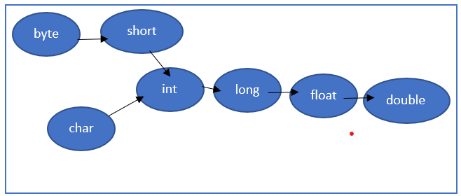

Move left to right

Ex:

int x =’a’;//compiler converts char to int automatically by implicit typecasting

sop(x);//97

double d = 10;

sop(d);// 10.0

2.Explicit typecasting

* Programmer is responsible to perform explicit typecasting.
* Whenever we are assigning bigger datatype value to smaller datatype variable explicit typecasting is required.
* It is also known as narrowing or down casting.
* There may be a chance of loss of information in this typecasting.
* The following are various conversion where explicit typecasting is required.



Move right to left

Ex:

int x = 130;

byte b = x;//CE: possible loss of precision found: int required : byte

byte b = (byte)x;

sop(b);// -126 (loss of information)

If we assign floating point values to integral types by explicit typecasting the digits after the decimal point will be lost.

Ex:

double d = 130.456;

int x = (int)d;

sop(x);//130

VIDEO 21:

Assignment Operators:

There are 3 types of assignment operators:

1.Simple assignment

Ex: int x = 10;

2.Chained assignment

Ex: int a, b, c, d;

a=b=c=d=20;

Sop(a+” “+b+” “+c+” “+d);//20 20 20

We can’t perform chained assignment at the time of declaration.

int a=b=c=d; // CE: cannot find symbol : variable b location : class Test (b,c,d not declared before)

int b,c,d;

int a=b=c=d=20;//valid (b ,c, d declared before)

3. Compound assignment (+=,-=,/=,%=.&=,|=,^=,>>=,>>>=,<<=):

Sometimes assignment operator mixed with some other operators such type of assignment operators are called compound assignment operators.

int a=10;

a+=20;

sop(a); // 30

In the case of compound assignment operators internal typecasting performed automatically

|  |  |  |  |
| --- | --- | --- | --- |
| byte b=10;  b=b+1;//max(int ,byte, int)  sop(b);//CE: PLP found: int required: byte | byte b=10;  b++;//b=(byte)(b+1);  sop(b);//11 | byte b = 10;  b+=1;(byte)(b+1)  sop(b);//11 | byte b = 127;  b+=3;  sop(b);// -126 |

int a,,b,c,d;

a=b=c=d=20;

a+= b-= c*= d/=2;(right to left evaluation)

sop(a+” “+b+” “+c+” “+d); -160 -180 200 10

Conditional Operator (? :)

a++, ++a ; 🡪 unary operator(1 argument)

a + b; 🡪 Binary operator (2 argument)

syntax of Conditional operator:

int x = (10 < 20)? 30 : 40; 🡪 Ternary operator (3 argument)

sop(x);// 30

int x = (10 > 20)? 30: ((40 > 50)? 60: 70) ;// 70

new Operator:

We can use new operator to create object.

Example:

Test t = new Test ();

Note: After creating object, constructor will be executed to perform initialization of an object hence constructor is not for creation of object, and it is for initialization of an object.

In java we have only new keyword but not delete keyword because destruction of useless object is the responsibility of garbage collector.

[] Operator:

We can use this operator to declare and create arrays.

Ex:

int [] x =new int [10];

VIDEO 22:

JAVA operator precedence:

1. Unary Operators:

[], x++, x--, ~, !, new, <type>

1. Arithmetic Operators:

*,/,%,+,-

1. Shift operators:

>>,>>>,<<

1. Comparison Operators:

<, <=, >, >=, instanceof

1. Equality operators:

==, !=

1. Bitwise Operators:

&, ^, |

1. Short circuit operators:

&&, ||

1. Conditional Operators:

?:

1. Assignment Operators:

=, +=, -=, *= ……..

Evaluation order of java operands:

In java we have only operators’ precedence but not operands precedence before applying any operators all operands will be evaluated from left to right.

class Test {

psvm( String[] args){

sop(m1(1) + m1(2) * m1(3) / m1(4) +m1(5) * m1(6));// 1+2*3/4+5*6 🡪 1 + 6/4 + 5*6 🡪1+ 1 + 5*6 🡪 1 + 1 + 30 🡪 2 + 30 🡪 32

}

public static int m1(int i){

sop(i);// 1 2 3 4 5 6

return i;

}

}

1+2*3/4+5-10/6%4*9+5   
1+6/4+5-10/6%4*9+5  
1+1+5-10/6%4*9+5  
1+1+5-1%4*9+5  
1+1+5-1*9+5  
1+1+5-9+5

VIDEO 23:

new vs newInstance()

We can use new operator to create an object if we know class name at the beginning.

Ex: Test t = new Test();

Student s= new Student();

Customer c= new Customer();

newInstance() is a method present in class “Class” we can use newInsatance() method to create an object if we don’t know class name at the beginning and it is available dynamically at runtime.

Ex:

class Student {

}

class Customer{

}

class Test {

public static void main (String[] args ) throws Exception{

Object o = Class.forName(args[0]).newInstance();

System.out.println(“Object created for: “ + o.getClass().getName());

}

}

Java Test Student

output: Object created for Student.

Java Test Customer

Output: Object created for Customer

Java Test java.lang.String

Output: Object created for java.lang.String

In the case of new operator based on our requirement we can invoke any constructor.

Ex:

Test t =new Test();  
Test t1= new Test(10);  
Test t2=new test(“ABCD”);

But newInstance method internally calls no-argument constructor hence to use newInstance method compulsory corresponding should contains no-argument constructor otherwise we will get runtime constructor saying InstantiationException.

While using new operator at runtime if the corresponding .class file is not available then we will get runtime exception saying NoClassDefFoundError : Test

Ex: Test t = new Test();

At runtime if Test.class file not available then we will get runtime exception saying NoClassDefFoundError: Test

While using newInstance Method at runtime if the corresponding .class file not available then we will get runtime exception saying ClassNotFoundException : Test123

Ex:

Object o = Class.forName(args[0]).newInstance();

Java Test Test123

At runtime if Test123.class file not available then we swill get RE: ClassNotFoundException

Q). Differences between new and newInstance

|  |  |
| --- | --- |
| new | newInstance |
| 1.It is Operator in java. | 1.It is a method present in java.lang.Class |
| 2.We can use new operator to create object if we know the class name at the beginning. | 2. We can use this method to create object if we don’t know the class name at the beginning and it is available dynamically at runtime. |
| 3.To use new operator class not required to contain no-arg constructor. | 3. To use newInstance() compulsory class should contain no-arg Constructor otherwise we will get RE: InstantiationException |
| 4.At runtime if class file not available then we will get RE: NoClassDefFoundError | 4. At runtime if class file not available then we will get RE: ClassNotFoundException |

Difference between ClassNotFoundException and NoClassDefFoundError:

For hard-coded class names, at runtime if the corresponding .class file not available then we will get RE: NoClassDefFoundError which is unchecked.

Ex: Test t = new Test();

At runtime if Test.class file is not available then we will get RE: NoClassDefFoundError: Test

For dynamically provided class names at runtime if the corresponding .class file is not available then we will get RE: ClassNotFoundException which is checked exception.

Ex: Object o = Class.forName(args[0]).newInstance();

Java Test Student

At runtime if Student.class file not available the we will get RE : ClassNotFoundException : Student

Difference between instanceof and isInstance():

instanceof is an operator in java, we can use instanceof to check whether the given object is of particular type or not and we know the type at beginning.

Ex: Thread t = new Thread ();

Sop(t instanceof Runnable);//true

Sop(t instanceof Object);//true

isInstance() is a method present java.lang.Class, we can use isInstance() method to check whether the given object is of particular type or not and we don’t know the type at the beginning and it is available dynamically at runtime.

Ex:

class Test {

psvm(String[] args) throws Exception{

Thread t = new Thread();

Sop(Class.forName(args[0]).isInstance(t));

}

}

Java Test Runnable

Output: true

Java test String

Output: False

isInstance() is a method equivalent of instanceof operator.

VIDEO 24:

Flow Control: flow control describes the order in which the statement will be executed at runtime.

1.Selection Statements.

Ex: if-else, switch ()

2. Iterative Statements.

Ex: while (), do-while (), for(), for-each loop (1.5 version)

3. Transfer Statements.

Ex: break, continue, return, try, catch, finally, assert (1.4 version)

VIDEO 25:

Selection statements:

int x = 0;

if(x)

sop(“Hello”);

else

sop(“Hi”);

Output: CE: incompatible types found : int required : boolean

int x = 10;

if(x=20)

sop(“Hello”);

else

sop(“Hi”);

Output: CE: incompatible types found : int required : Boolean

int x = 10;

if(x==20)

sop(“Hello”);

else

sop(“Hi”);

Output: Hi

boolean b = true;

if(b=false)

sop(“hello”);

else

sop(“hi”);

Output: hi

boolean b = false;

if(b==false)

sop(“Hello”);

else

sop(“Hi”);

Output: Hello

if(true)

sop(“hello”); //hello

if(true); //valid

if(true);

;;;;;;;;;;;;;;;;;;;;;; //valid

Else part and curly braces are optional without curly braces only one statement is allowed which should not be declarative statement.

Semi-colon is a valid java statement which is also known as empty statement.

if(true)

int x = 10;//invalid compile time error

if(true){

int x = 10;// valid

}

Note: There is no dangling else problem in java, every else is mapped to the nearest if statement.

Ex: if(true)

if(true)

sop(“hello”);

else

sop(“hi”);

Output: hello

VIDEO 26:

If several options are available, then it is not recommended to use nested “if else” because it reduces readability. To handle this requirement, we should go for switch statement.

The allowed argument types for the switch statements are byte, short, char, int until 1.4v but from 1.5v onwards corresponding wrapper classes and enum type also allowed and from 1.7v onwards String type also allowed. And not allowed values are long, float, double.

|  |  |  |
| --- | --- | --- |
| 1.4version | 1.5version | 1.7version |
| byte | Byte |  |
| short | Short |  |
| char | Character | String |
| int | Integer |  |
|  | enum |  |

Curly braces are mandatory except switch everywhere curly braces are optional.

Both case and default are optional i.e., an empty switch statement is a valid java syntax.

Ex:

int x =10;

switch(x) {

}

Inside switch every statement should be under some case or default i.e., independent statements are not allowed inside switch otherwise we will get Compile time error.

Ex:

int x =10;

switch(x) {

sop(“Hello”);//CE: case, default, or } expected

}

Every case label should be compile time constant (i.e. constant expression).

Ex:

int x = 10;

int y = 20;

//final y = 20;

switch(x) {  
 case 10: sop (“10”);  
 break;  
 case y:// CE: constant expression required.  
 sop (“20”); break;

}

If we declare y as final, then we won’t get any compile time error.

Both switch argument and case label can be expressions, but case label should be constant expressions.

Ex:

valid

int x = 10;

switch(x+1) {

case 10: sop (“10”);

break;

case 10+20+30: sop(“60”);

}

Every case label should be in the range of switch argument type otherwise we will get compile time error.

byte b = 10;

switch(b){

case 10: sop(“10”);

break;

case 100: sop(“100”);

break;

case 1000: sop(“1000”);

break;

}

Here range of byte is -128 to 127 , whereas we have case of 1000 which will give compile time error CE: possible loss of precision found : int required : byte

byte b = 10;

switch(b+1) // type = max(int,byte,int) =int

{

case 10: sop(“10”);

break;

case 100: sop(“100”);

break;

case 1000 : sop(“1000”);

break;

}

Here the argument is switch statement is int type and its range is more than 1000 therefore it will not give any error.

Duplicate case labels are not allowed otherwise we will get compile time error.

Ex:

int x = 10;

switch(x)

{

case 97 : sop(“97”);

break;

case 98: sop(“98”);

break;

case 99: sop(‘’99”);

break;

case ‘a’ : //CE: duplicate case label (a =97)

sop(“a”);

}

Fall through inside switch:

Within the switch if any case is matched from that case onwards all statements will be executed until break or end of the switch this is called fall through inside the switch.

Ex:

switch(x){

case 0 : sop(“0”);

case 1: sop(“1”);

break;

case 2: sop(“2”);

default: sop(“def”);

}

x = 0 🡪 0 1

x = 1 🡪 1

x = 2 🡪 2 def

x = 3 🡪def

The main advantage of fall through inside the switch is we can define common action for multiple cases(code reusability).

Ex:

switch(x){

case ‘a’ :

case ‘e’:

case ‘i’:

case ‘o’:

case ‘u’:

case ‘A’:

case ‘E’;

case ‘I’:

case ‘O’:

case ‘U’: sop(“x is vowel”);

}

Within the switch we can take default case at most once.

Default case will be executed if and only there is no case matched.

Within the switch we can write default case anywhere, but it is recommended to write as last case.

Ex:

switch(x){

default: sop(“Def”);

case 0: sop(“0”);

break;

case 1: sop(“1”);

case 2: sop(“2”);

}

x = 0 🡪0

x = 1 🡪 1 2

x = 2 🡪2

x = 3 🡪Def 0

VIDEO 27:

Iterative Statements:

1. while (): If we don’t know number of iteration in advance then we should go for while loop.

Ex:

while(rs.next()){

}

Sytnax:

while(b){

//action

}

The argument should be boolean type, if we are trying to provide any other type then we will get compile time error.

while(1){

sop(“Hello”);//CE : incompatible types found : int required : boolean

}

valid

while(true)

sop(“hello”);

valid

while(true);

invalid

while(true)

int x = 10;

valid

while(true)

{

int x = 10;

}

Curly braces are optional and without curly braces we can take only one statement under while which should not be declarative statement.

while(true){

sop(“Hello”);

}

Sop(“Hi”);//CE : unreachable statement (This error is only java but not in c++ )

while(false){

sop(“Hello”); CE : unreachable statement ‘{‘

}

Sop(“Hi”);

int a = 10, b = 20;

while(a<b){

sop(“Hello”);

}

Sop(“Hi”);

Output: Hello

Hello

Hello …………

int a = 10, b = 20

while(a>b){

sop(“Hello”);

}

Sop(“Hi”);

Output: Hi

final int a=10, b=20;

while(a<b){

sop(“Hello”);

}

Sop(“hi”);//CE: unreachable statement

final int a=10, b=20;

while(a>b){

sop(“Hello”); CE: Unreachable statement ‘{‘

}

Sop(“Hi”);

Note: while argument should not be constant otherwise unreachable CE comes.

Note 1: Every final variable will be replaced with the value at compile time only.

Ex:

final int a =10;

int b = 20;

After compilation

sop(a); sop(10);

sop(b); sop(b);

Note 2: If every argument is final variable (compile time constant) then that operation should be performed at compile time only.

Ex:

final int a =10, b= 20;

int c = 20;

sop(a+b); sop(30);

After compilation

sop(a+c); sop(10+c);

sop(a<b); sop(true);

sop(a<c); sop(10<c);

2. do-while(): If we want to execute at least once then we should go for do-while.

Syntax:

do{

body

}while(b);// b should be boolean and (;)­ is mandatory in JAVA but not for c, c++ .

Curly braces are optional and without curly braces we can take only one statement between do and while which should not be declarative statement.

Ex:

valid

do

sop(“hello”);

while(true);

valid

do;

while(true);

invalid

do

int x =10;

while(true);

valid

do

{

int x =10;

}while(true);

Invalid

do

while(true);

valid

do while(true) do

sop(“Hello”); while(true)

while(false); sop(“hello”);

while(false);

Output: Hello

Hello

Hello ……………

Which of the following syntax is valid?

1. do{

Sop(“hello”);

}while(true);

Sop(“Hi”);// CE: unreachable statement

2. do{

Sop(“Hello”);

}while(false);

Sop(“Hi”);

Ouput: Hello Hi

3. int a =10,b=20;

do{

Sop(“Hello”);

}while(a<b);

Sop(“Hi”);

Output: Hello Hello Hello Hello ……………….

4. int a=10,b=20;

do{

Sop(“Hello”);

}while(a>b);

Sop(“Hi”);

Output: Hello Hi

5. final int a=10, b=20;

do{

Sop(“Hello”);

}while(a<b);

Sop(“Hi”);//CE: Unreachable statement

6. final int a =10, b=20;

do{

Sop(“Hello”);

}while(a>b);

Sop(“Hi”);

Output: Hello Hi

7. final int a = 10;  
int b=20;  
do{  
System.out.println("HI");   
}while(a<b);  
System.out.println("HJ");

Output: HI…………………

VIDEO 28:

for loop:

If we know number of iterations in advance, then for loop is the best choice.

valid

for(int i=0;true;i++)

sop(“Hello”);

valid

for(int i=0;i<10;i++);

invalid

for(int i=0;i<10;i++)

int x = 10;

Initialization of for loop:

This part will be executed only once in loop life cycle.

Here, we can declare and initialize local variables of for loop.

Here, we can declare any number of variables but should be of the same type by mistake if we are trying to declare different datatype variable then we will get CE.

Ex:

int i = 0,j =0;//valid

int i=0,String s=”Durga”;//invalid

int i=0,int j=0;//invalid

In the initialization section, we can take any valid java statement including Sop.

Ex:

int i=0;

for(sop(“Hello boss you are sleeping”); i < 3 ;i++){

sop(“No boss you only sleeping”);

}

Output:

Hello boss you are sleeping.

No boss you only sleeping.

No boss you only sleeping.

No boss you only sleeping.

Conditional check:

Here we can take any valid java expression but should be of the type boolean.

This part is optional and if we are not taking anything then compiler will always place true.

Ex:

for(int i=0;true;i++)

for(inti=0; 2<5 && 3==3 ;i++)

for(int i=0; ; i++) // for(int i=0 ;true;i++)

Sop(“Hello”);

Output: Hello

int i;  
 for(i=0;9<5 && 5>3;i++)  
 {  
 System.out.println("HI");//CE : Unreachable code  
 }

Increment and decrement section:

We can take any valid java statement including sop.

for(sop(“Hello”) ; i<3;sop(“Hi”))

{

i++;

}

Output: Hello Hi Hi Hi

All three parts of for loop are independent of each other and optional.

Ex:

for( ; ; )

{

Sop(“Hello”); //infinite loop

}

for( ; ; ); //infinite loop

for(int i=0;true;i++){

sop(“Hello”);

}

Sop(“Hi”);//CE: unreachable statement

for(int i=0;true;i++){

sop(“Hello”); unreachable statement ‘{‘

}

Sop(“Hi”);

for(int i=0; ;i++){

sop(“Hello”);

}

Sop(“Hi”); //CE: unreachable statement

int a = 10, b = 20;

for(int i=0; a<b ;i++){

sop(“Hello”);

}

Sop(“Hi”);

Output: Hello Hello ………….

int a = 10, b= 20;

for(int i=0; a>b ;i++){

sop(“Hello”);

}

Sop(“Hi”);

Output: Hi

final int a = 10, b = 20;

for(int i=0; a<b ;i++){

sop(“Hello”);

}

Sop(“Hi”);// CE: unreachable statement

final int a = 10,b = 20;

for(int i=0; a>b ;i++){

sop(“Hello”); CE: unreachable statement ‘{‘

}

Sop(“Hi”);

for-each loop (Enhanced for loop):

Introduced in 1.5 version.

It is specially designed loop to retrieve elements of array and collections.

Syntax:

for(eachitem x: target){  
}

Ex:

int [] x = {10,20,30,40};

|  |  |
| --- | --- |
| Normal for loop | Enhanced for loop |
| for(int i=0;i<x.length;i++)  {  Sop(x[i]);  } | for(int x1 : x)  {  Sop(xi);  } |

int[][] x = {{10,20,30},{40,50}};

|  |  |
| --- | --- |
|  |  |

x

|  |  |  |
| --- | --- | --- |
| 10 | 20 | 30 |

|  |  |
| --- | --- |
| 40 | 50 |

x1 x1

|  |  |
| --- | --- |
| Normal for loop | Enhanced for loop |
| for(int i=0;i<x.length;i++)  {  for(int j=0;j<x[i].length;j++)  {  Sop(x[i][j]);  }  } | for(int[] x1 : x)  {  for(int x2 : x1){  sop(x2);  }  } |

For each loop is best choice to retrieve elements of arrays and collection but its limitation is it is applicable only for array and collection and it is not a general-purpose loop.

for(int i=0;i<10;i++)

Sop(“Hello”);

We can’t write an equivalent for-each loop directly.

By using normal for loop, we can print array elements either in original order or in reverse order, but by using for each loop we can print array element only in original order but not in reverse order.

int x[] = {10,20,30,40,50};

for(int i=0;i<x.length-1;i++)

{

Sop(x[i]);

}

We can’t write an equivalent for-each loop directly.

VIDEO 29:

Transfer statements:

1. break 🡪 we can use break statement in the following places:

* inside switch to stop fall through
* inside loops
* inside labelled blocks

These are the only places where we can use break statement if we are using anywhere else, we will get compile time error saying break outside switch or loop.

Ex: psvm(String[] args){

int x =10;

if(x==10)

break;//CE:

sop(“Hello”);

}

2. continue 🡪 we can use continue statement in loops only to skip current iteration and continue for the next iteration. If we are using it anywhere else except loop, we will get compile time error saying continue outside of loop.

Ex: for(int i=0;<10;i++)

{

if(i%2==0)

continue;

sop(i);

}

Labelled break and continue:

We can use labelled break and continue to break or continue a particular loop in nested loop.

Ex:

l1:

for(…………….)

{

l2:

for(…………………..)

{

for(…………………)

{

break l1;

break l2;

break;

}

}

}

Ex: l1:

|  |  |  |  |
| --- | --- | --- | --- |
| break; | break l1; | continue; | continue l1; |
| 1….0  2….0  2….1 | No output | 0….1  0….2  1….0  1….2  2….0  2…..1 | 1….0  2….0  2….1 |

for(int i=0;i<3;i++){

for(int j=0;j<3;j++){

if(i==j)

break;

//break l1;

// continue;

//continue l1;

sop(i+ “…..“ + j);

}

}

do-while() vs continue:

int x = 0;

do{

x = 0 1 2 3 4 5 6 7 8 9 10 11

x++;

sop(x);

if(++x<5)

continue;

x++;

sop(x);

}while(++x<10);

Output: 1 4 6 8 10

int x=0;  
do {  
 ++x;  
 System.out.println(x);  
 if(x++<5)  
 continue;  
 ++x;  
 System.out.println(x);  
 } while(x++<10);  
}

Output: 1 4 7 9 11 13

VIDEO 30:

Declaration and access modifier:

Java source file structure:

A java program can contain any number of classes but at most one class can be declared as public if there is a public class then name of the program and the name of public class must be matched otherwise we will get compile time error.

Ex:

class A{

}

class B{

}

class C{

}

Case 1: If there is no public class then we can use any name and there are no restrictions.

Ex: A.java

B.java

C.java

Hello.java

Case 2: if class B is public then name of the program should be “B.java” otherwise we will get compile time error saying, “class B is public should be declared in a file named B.java”.

Case 3: If class B and C declared as public and name of the program is “B.java” then we will get compile time error saying, “class C is public should be declared in a file named C.java”.

Ex:

Durga.java Durga.java

class A{

psvm(String[] args){

sop(“A class main”); A.class B.class C.class D.class

}

}

Java A

Output: A class main

Java B

Output: B class main

Java C

Output: C class main

Java D

RE: NosucheMethodError : main

Java Durga

RE: NoClassDefFoundError: Durga

class B{

psvm(String[] args){

sop(“B class main”);

}

}

class C{

psvm(String[] args){

sop(“C class main”);

}

}

class D{

}

Conclusions:

1. Whenever we are compiling a java program for every class present in the program a separate .class file will be generated.

2. We can compile a java program (Java source file) but we can run a java .class file

3. Whenever we are executing a java class the corresponding class main method will be executed, if the class doesn’t contains main method then we will get runtime exception saying NosucheMethodError: main.

4. If the corresponding .class file not available then we will get runtime execption saying NoClassDefFoundError.

5. It is not recommended to declare multiple classes in a single source file, it is highly recommended to declare only one class per source file and name of the program we have to keep same as class name. The main advantage of this approach is readability and maintainability of the code will be improved.

import statement:

class Test{

public static void main(String[] args){

ArrayList I =new ArrayList();//CE: cannot find symbol : class ArrayList location : class Test

}

}

We can solve this problem by using fully qualified name.

class Test{

public static void main(String[] args){

java.util.ArrayList I =new java.util.ArrayList();

}

} fully qualified name

The problem with usage of fully qualified name every time is it increase length of the code and reduces readability, we can solve this problem by using import statement.

Whenever we are writing import statement, it is not required to use fully qualified name every time, we can use short name directly.

Ex:

Import java.util.ArrayList;

class Test{

public static void main(String[] args){

ArrayList I =new ArrayList();

}

}

Hence import statement acts as typing shortcut.

VIDEO 31:

Types of import statement:  
1. Explicit class import: It is highly recommended to use explicit import because it improves the readability of the code. Best suitable for Hi-Tech city where readability is important.

Ex: import java.util.ArrayList;

2. Implicit class import: Not recommended to use because it reduces readability of the code. Best suitable for Ameerpet where typing is important.

Ex: import java.util.*;

Which of the following import statements are meaningful?

import java.util.ArrayList; //valid

import java.util.ArrayList.*;//invalid

import java.util.*;//valid

import java.util;//invalid

consider the following code:

class myObject extends java.rmi.UnicastRemoteObject{

}

The code compiles fine even though we are not writing import statement because we used fully qualified name.

Whenever we are using fully qualified name it is not required to write import statement similarly when we are writing import statement it is not required to use fully qualified name.

import java.util.*;

import java.sql.*;

class Test{

Date d = new Date(); //CE: reference to Date is ambiguous

}

Even in the case of List also we may get same ambiguity problem because it is available both util and awt packages.

While resolving class name compiler will always give precedence in the following order:

1. Explicit class import

2. Class present in current working directory

3. Implicit class import

Ex:

import java.util.Date;

import java.sql.*;

class Test{

Date d = new Date();

Sop(d.getClass().getName());// java.util.Date

}

The above example util package got considered.

When we are importing a java package all classes and interfaces present in the package by default available but not subpackage classes, if we want to use subpackage class compulsory we should write import statement until subpackage level.

Ex:

java

util

regex

Pattern

To use pattern class in our program which import statement is required?

1. import java.*;

2. import java.util.*;

3.import java.util.regex.*;// valid

4. No import required

All classes and interfaces present in the following packages by default available to every java program, hence we are not required to import statement.

1. java.lang

2. default package (Current working directory);

Import statements is totally compile time related concept, if more number of imports then more will be the compile time but there is no effect on execution time(runtime).

Difference between c language #inlcude<stdio.h> and java language import statement?

In the case of c language # include all input output header files loaded at beginning only at translation time hence it is static include.

But in the case of java import statement no .class file will be loaded at the beginning, whenever we are using a particular class then only corresponding .class file will be loaded this is called dynamic include or Load on Fly or Load on Demand.

|  |  |  |
| --- | --- | --- |
| **S No.** | **#include in C/C++** | **import in Java** |
| **1** | It is mandatory to use the **#include** statement to include standard header files. | **Import**statement in java is optional |
| **2** | It loads the file at the beginning only. | No class files will be loaded at the beginning.  Whenever a particular class is used then only the corresponding class file will be loaded. |
| **3** | Unnecessary waste of memory and processor’s time. | No such waste of memory and processor’s time. |
| **4** | Size of the program increases. | No increase in the size of the program. |
| **5** | It is also called as static include. | It is also called as dynamic include. |

Note: 1.5 version new features:

for- each loop, var-arg methods, autoboxing and auto unboxing, generics, co-variant return types, queue, annotations, enum, static import etc.

static import:

Introduces in 1.5 version according to SUN, usage of static import reduce the length of the code and improves readability but according to worldwide programming experts(like : us) usage of static import creates confusion and reduces readability hence if there is no specific requirement then it is not recommended to use static import.

|  |  |
| --- | --- |
| Without static import | With static import |
| class Test{  Psvm(String[] args){  Sop(Math.sqrt(4));  Sop(Math.max(10,20));  Sop(Math.random());  }  } | import static java.lang.Math.sqrt;  import static java.lang.Math.*;  class Test{  Psvm(String[] args){  Sop(Math.sqrt(4));  Sop(Math.max(10,20));  Sop(Math.random());  }  } |

Usually, we can access static member by using class name but whenever we are writing static import, we can access static members directly without class name.

VIDEO 32:

Explain out System.out.println()?

class Test{ Test.s.length();

static String s = “java”;

length() is a method present in String class

s is a static variable present in Test class of the type java.lang.String

}

Test is class Name

Similarly

class System{

System.out.println()

static PrintStream out;

}

out is a static variable present in System class of the type PrintStream

System is a class present in java.lang.pkg

println() is a method present in printStream class

Import static java.lang.System.out;

class Test{

psvm(String[] args){

out.println(“hello”);

}

}

out is static variable present in system class hence we can access by using class name System but whenever we are writing static import it is not required to use class name and we can access out directly.

import static java.lang.Integer.*

import static java.lang.byte.*;

public class Test{

psvm(String[] args){

sop(MAX_VALUE);//CE : reference to MAX_VALUE is ambiguous

}

}

While resolving static members compiler will always consider the precedence in the following order:

1.Current class static member

2.Explicit Static import

3.Implicit static import

import static java.lang.Integer.MAX_VALUE;-------------------------2

import static java.lang.Byte.*;

public class Test{

static int MAX_VALUE= 999; -------------------- 1

psvm(String[] args){

sop(MAX_VALUE);

}

}

Output: 999

If we comment line 1 then explicit static import will be consider and hence integer class MAX_VALUE will be considered in this case the output is : 2147483647.

If we comment both lines 1 and 2 then implicit static import will be considered in this case output is 127(byte class MAX_VALUE).

|  |  |
| --- | --- |
| Normal import | Static import |
| 1. Explicit import  Syntax: import packagename.classname;  Ex: import java.util.ArrayList; | 1. Explicit static import  Syntax: import static packagename.classname.staticmember;  Ex: import static java.lang.Math.sqrt;  import static java.lang.System.out; |
| 2. Implicit import  Syntax: import packagename.*;  Ex: import java.util.*; | 2. Implicit import  Syntax: import static packagename.classname.*;  Ex: import static java.lang.Math.*;  import static java.lang.Sytem.*; |

import java.lang.Math.*;//invalid (after class name semi colon is required not *)

import static java.lang.Math.*;//valid

import java.lang.Math.sqrt;//invalid (we can go till class level but not in member level in case of normal import)

import static java.lang.Math.sqrt();//invalid(because method name only required but not with () )

import java.lang.Math.sqrt.*;//invalid

import static java.lang.Math.sqrt;//valid

import java.lang; //invalid (after class name .* is required)

import static java.lang;//invalid

import java.lang.*;//valid

import static java.lang.*;//invalid(because .* we can use only after class name but not after package name)

Two packages contains a class or interface with same name is very rare and hence ambiguity problem is very rare in normal import.

But two classes or interface contains a variable or method with same name is very common and hence ambiguity problem is very common problem in static import.

Usage of static import reduces the readability and creates confusion and hence if there is no specific requirement then it is not recommended to use static import.

Difference between normal import and static import?

We can use normal import to import classes and interfaces of a particular package whenever we are using normal input it is not required to use full qualified name and we can use short names directly.

We can use static import to import static members of a particular class or interface, whenever we are writing static import it is not required to use class name to access static members and we can access directly.

VIDEO 33:

packages: It is an encapsulation mechanism to group related classes and interfaces into a single unit

which is called package.

Ex:

All classes and interfaces which are required for database operations are grouped into a single package which is java.sql package.

All classes and interface which are useful for file I/O operation are grouped into a separate package which is nothing but java.io package

The main advantage of package are:

1.To resolve naming conflicts (i.e., unique identification of out components)

2.It improves modularity of the application.

3. It improves the maintainability of the application.

4. It provides the security for our components.

There is one universally accepted naming conventions for packages i.e., to use internet domain name in reverse.

Ex:

com.icicibank.loan.housing.Account

com.icicibank 🡪 client’s internet domain name in reverse

loan 🡪 module name

housing 🡪 submodule name

Account 🡪 class name

Ex:

package com.durgasoft.scjp;

public class Test{

psvm(String[] args){

Sop(“Pkg demo”);

}

}

Javac Test.java (generated .class file will be place in current working directory.)

Javac -d . Test.java

-d 🡪destination to place generated .class files

. 🡪 current working directory

Generated .class file will be placed in corresponding package structure.

Current working directory

com

durgasoft

scjp

Test.class

If the corresponding package structure not already available then this command itself will create corresponding package structure.

At the time of execution, we have to use fully qualified name.

Ex: java com.durgasoft.scjp.Test

Conclusion:

1. In any java source file there can be at most one package statement i.e., more than one package not allowed otherwise we will get CE.

Ex: package pack1;

package pack2;//CE : class, interface or enum expected

public class A{

}

2. Any java program the first non-comment statement should be package statement (if it is available ) otherwise we will get CE.

Ex:

import java.util.*;

package pack1;//CE : class, interface or enum expected

public class A{

}

The following is valid java source file structure?

1. package statement 🡪 atmost one

2. import statements; 🡪any number

3. Class/interface/enum declarations 🡪any number

The above are order important.

Note: An empty source file is a valid java program, hence the following are valid java source file:

import java.util.*;

package pack1;

Test.java Test.java Test.java

package pack1;

import java.util.*;

class Test{

}

Test.java Test.java

VIDEO 34:

Class level modifier:

Whenever we are writing our own classes, we have to provide some information about our class to the JVM like.,

1. whether this class can be accessible from anywhere or not.

2. whether child class creation is possible or not.

3. whether object creation is possible or not etc.

We can specify this information by using appropriate modifier.

The only applicable modifiers for top level classes are:

public

<default>

final

abstract

strictfp

But for inner classes the applicable modifiers are:

public

<default> private

final + protected

abstract static

strictfp

Ex:

private class Test{

psvm(String[] args){

sop(“Hello”);

}

}

CE: modifier private not allowed here

Access specifiers vs access modifiers:

Public, private, protected and default are considered as specifiers except these remaining are considered as modifiers. (final, static, abstract etc)

But this rule is applicable only for old language like C++ but not in JAVA.

In JAVA all are considered as modifiers only, there is no word like specifiers.

1. Public classes:

If a class declared as public, then we can access that class from anywhere.

package pack1; package pack2;

public class A{ import pack1.A;

public void m1(){ class B{

sop(“hello”); psmv(String[] args){

} A a = new A():

} a.m1();

Javac -d . A.java }

pack1 }

A.class Java -d . B.java

Java pack2.B

Output: Hello

If class A is not public, then while compiling B class we will get CE saying pack1.A is not public in pack1: cannot be accessed from outside package.

2. Default classes:

If a class declared a default, then we can access that class only within the current package i.e. from outside package we can’t access. Hence default access is also known as package level access.

3. Final modifier:

Final is a modifier applicable for classes methods and variables.

Final Methods:

Whatever method parent has, by default available to the child through inheritance. If the child is not satisfied with parent method implementation, then child is allowed to redefine that methods based on its requirement. This process is called overriding.

If the parent class method is final, then we can’t override that method in the child class because its implementation is final.

Ex:

class P{

public void property(){

sop(“Cash and land and gold”);

}

public final void marry(){

sop(“Subhalaxmi”);

}

}

class C extends P{

public void marry(){

sop(“Reeta”);

}

}

CE: marry () in C cannot override marry () in P, overridden method is final.

Final Class:

If a class declared as final, we can’t extend functionality of that class i.e. we can’t create child class for that class i.e. inheritance is not possible for final classes.

Ex:

final class P{

}

Class C extends P{

}

CE: cannot inherit from final P

Note: Every method present inside final class is always final by default, but every variable present inside final class need not be final.

The main advantage of final keyword is we can achieve security and we can provide unique implementation. But the main disadvantage of final keyword is we are missing key benefits OOPs: inheritance (because of final classes) and polymorphism(because of final methods) hence if there is no specific requirement then it is not recommended to use final keyword.

VIDEO 35:

Abstract modifier:

Abstract is a modifier applicable for classes and methods but nor for variables.

Abstract method:

Even though we don’t know about implementation still we can declare the method with abstract modifier i.e., for abstract method only declaration is available but not implementation hence abstract method declaration should end with semi colon.

Ex: public abstract void m1();

Child class is responsible to provide implementation for parent class abstract methods.

Ex:

abstract class vehicle {

abstract public int getNoOfWheels();

}

class Bus extends vehicle{

public int getNoOfWheels(){

return 7;

}

}

class Auto extends vehicle{

public int getNoOfWheels(){

return 3;

}

}

By declaring abstract method in the parent class, we can provide guidelines to child classes such that which method child has to implement.

Abstract method never talks about implementation if any modifier talks about implementation, then it forms illegal combination with abstract modifier. The following are various illegal combination of modifiers w.r.t abstract:

1.abstract final

2. abstract native

3. abstract synchronized

4. abstract static

5. abstract private

6. abstract strictfp

Ex: abstract final void m1();//CE illegal combination modifier abstract and final

Abstract class:

For any Java class if we are not allowed to create an object because of partial implementation such type of class we have declare with abstract modifier i.e., for abstract classes instantiation is not possible.

Ex:

abstract class Test {

psvm(String[] args){

Test t = new Test();// CE : Test is abstract ; cannot be instantiated

}

}

Abstract class vs abstract method:

1. If a class contains at least one abstract method then compulsory we should declare class as abstract otherwise we will get Compile time error.

Reason: If a class contains at least one abstract method then implementation is not complete and hence it is not recommended to create object. To restrict object instantiation compulsory, we should declare as abstract.

2. Even though class doesn’t contain any abstract method still we can declare class as abstract, if we don’t want instantiation i.e., abstract class can contain zero number of abstract method also.

Every adapter class is recommended to declare as abstract, but it doesn’t contain any abstract method.

Ex:

class P{

public void m1();//CE : missing method body, or declare abstract

}

class P{

public abstract void m1(){ } //CE : abstract method cannot have a body

}

class P{

public abstract void m1(){ } //CE : P is not abstract and does not override abstract method m1() in P

}

If we are extending abstract class, then for each and every abstract method of parent class we should provide implementation otherwise we have to declare child class as abstract.

In this case next level child class is responsible to provide implementation.

Ex:

abstract class P{

public abstract void m1();

public abstract void m2();

}

class C extends P{

public void m1(){}

}

CE: C is not abstract and does not override abstract method m2() in P

final vs abstract:

1. abstract method compulsory we should override in child classes to provide implementation whereas we can’t override final methods hence final abstract combination is illegal combination for methods.

2. for final classes we can’t create child class whereas for abstract classes we should create child class to provide implementation hence final abstract combinations is illegal for classes.

3. Abstract class can contain final method whereas final class can’t contain abstract method.

Ex: valid

abstract class Test{

public final void m1(){

}

}

invalid

final class Test{

public abstract void m1();

}

VIDEO 36:

strictfp (strict floating point) modifier:

1.Introduces in 1.2 Version.

2.We can declare strictfp for classes and methods but not for variables.

3.Usually the result of floating-point arithmetic is varied from platform to platform if we want platform independent result for floating point arithmetic then we should go for strictfp modifier.

strictfp method:

If a method declared as strictfp all floating-point calculation in that method has to follow IEEE 754 standard so that we will get platform independent results.

Ex:

strictfp public void m1(){

sop(10.0/3);

}

Abstract modifier in method never talks about implementation whereas strictfp method always talks about implementation hence abstract strictfp combination is illegal for methods.

strictfp class:

If a class is declared as strictfp then every floating-point calculation present in the concrete method has to follow IEEE 754 standard so that we will get platform independent results.

We can declare abstract strictfp combination for a classes i.e. abstract strictfp combination is legal for classes but illegal for methods.

Ex:

abstract strictfp class Test {

m1(){ }

m2(){ }

m3() { }

mx();

my();

mz();

}

valid

abstract strictfp class Test{

}

Invalid

abstract strictfp void m1(); //CE: illegal combination of modifier abstract and strictfp

Member (method or variable level) modifiers:

If a member declared as public then we can access that member from anywhere. But corresponding class should be visible i.e. before checking member visibility we have to check class visibility.

Ex:

pacakage pack1; package pack;

class A{ import pack1.A;

public void m1(){ class B{

sop(“A class method”); {

} psvm(String[] args){

} {

Javac -d . A.java A a =new A();

Compiles a.m1();

}

}

Javac -d . B.java

CE: pack1.A is not public in pack1; cannot

be accessed from outside package

In the example even though m1() method is public we can’t access from outside package because corresponding class A is not public i.e., if both class and method are public then only, we can access the method from outside package.

Default members:

If a member declared as default, then we can access that member only within the current package i.e., from outside of the package we can’t access. Hence default access is also known as package level access.

Private members:

If a member is private, then we can access that member only within the class i.e., from outside of the class we can’t access.

Abstract methods should be available to the child classes to provide implementation whereas private methods are not available to the child classes hence abstract private combination is illegal for methods.

Protected members (The most misunderstood modifier in java):

If a member declared as protected, then we can access that member anywhere within the current package but only in child classes of outside package.

Protected = <default> + child

We can access protected members within the current package anywhere either by using parent reference or by using child reference.

But we can access protected members in outside package only in child classes and we should use child reference only i.e., parent reference cannot be used to access protected members from outside package.

package pack1;

public class A{

protected void m1(){

sop(“Protected member”);

}

}

class B extends A{

psvm(String[] args){

A a= new A();

a.m1();//valid

B b= new B();

b.m1();//valid

A a1 =new B();

a1.m1();//valid

}

}

package pack2;

import pack1.A;

class C extends A{

psvm(String[] args){

A a =new A();

a.m1();//invalid // CE : m1() has protected access in pack1.A

C c =new C();

c.m1();//valid

A a1=new C();

a1.m1();//invalid//CE : m1() has protected access in pack1.A

}

}

We can access protected members from outside package only in child classes and we should use that child class reference only. for example from D class if we want to access we should use D class reference only.

Ex:

package pack;

import pack1.A;

class C extends A{

}

Class D extends C{

Psvm(access,[] args){

A a =new A();

a1.m1();//invalid//CE : m1() has protected access in pack1.A

C c =new C();

c.m1();//invalid//CE : m1() has protected access in pack1.A

D d =new D();

d.m1();//valid

A a1=new C();

a1.m1();//invalid//CE : m1() has protected access in pack1.A

A a1 =new D();

a1.m1();//invalid//CE : m1() has protected access in pack1.A

C c1 =new D();

c1.m1();//invalid//CE : m1() has protected access in pack1.A

}

}

|  |  |  |  |  |
| --- | --- | --- | --- | --- |
| Visibility | private | <default> | Protected | public |
| Within the same class | yes | yes | yes | Yes |
| From child class of same package | no | yes | yes | yes |
| From non-child class of same package | no | yes | yes | yes |
| From child class of outside package | no | no | yes (we should use child reference only) | yes |
| From non-child class of outside package | no | no | no | yes |

VIDEO 37:

Final Variables:

final instance variables:

If the value of variable is varied from object to object, such type of variables are called instance variables.

For every object a separate copy of instance variable will be created.

For instance, variable we are not required to perform initialization explicitly, JVM will always provide default values.

Ex:

class Test{

int x;

psvm(String[] args){

Test t= new Test();

Sop(t.x);// 0

}

}

If the instance variable is declared as final then compulsory we have to perform initialization explicitly whether we are using or not and JVM won’t provide default values.

Ex:

class Test{

final int x;

}

CE : variable x might not have been initialized

Rule: for final instance variable compulsory we should perform initialization before constructor completion i.e. the following are various places for initialization :

1.At the time of declaration

Ex:

class Test{

final int x = 10;

}

2. Inside instance block

Ex:

class Test{

final int x ;

{

x = 10;

}

}

3. Inside constructor

Ex:

class Test{

final int x ;

Test(){

x = 10;

}

}

These are the only possible places to perform initialization for final instance variable if we are trying to perform initialization anywhere else then we will get compile time error.

Ex:

class Test{

final int x ;

public void m1(){

x = 10;

}

}

CE : cannot assign a value to find variable x

final static variable:

If the value of variable is not varied from object to object, such type of variables are not recommended to declare as instance variable we have to declare those variable at class level by using static modifier.

In the case of instance variable for every object a separate copy will be created but in the case of static variables a single copy will be created at class level and shared by every object of that class.

For static variable, it is not required to perform initialization explicitly JVM will always provide default values.

Ex:

class Test{

static int x;

psvm(String[] args){

sop(x);// 0

}

}

If the static variable declared as final, then compulsory we should perform initialization explicitly otherwise we will get compile time error and JVM won’t provide any default values.

Ex:

class Test{

final static int x; // CE : variable x might not have been initialized

}

Rule: for final static variable compulsory we should perform initialization before class loading completion i.e. the following are various places for this:

1.At the time of declaration

Ex:

class Test{

final static int x = 10;

}

2.Inside static block

Ex:

class Test{

final static int x;

static {

x = 10;

}

}

These are the only possible places to perform initialization for final static variables if we are trying to perform initialization anywhere else then we will get compile time error.

Ex:

class Test{

final static int x;

public void m1(){

x = 10;

}

}

CE : cannot assign a value to final variable x

final local variables:

sometime to meet temporary requirements of the programmer we have to declare variables inside a method or block or constructor such type of variables are called local/temporary/stack/automatic variables.

For local variable JVM won’t provide any default value compulsory we should perform initialization explicitly before using that local variable i.e. if we are not using then it is not required to perform initialization for local variable.

Ex:

class Test{

psvm(String[] args){

int x;

sop(“Hello”);//Hello

}

}

class Test{

psvm(String[] args){

int x;

sop(x);

}

}

CE: variable x might have not been initialized

Even though local variable is final, before using only we have to perform initialization i.e., if we are not using then it is not required to perform initialization even though it is final.

Ex:

class Test{

psvm(String[] args){

final int x;

sop(“Hello”);// Hello

}  
}

The only applicable modifier for local variable is final, by mistake if we are trying to apply any other modifier then we will get compile time error.

Ex:

class Test{

psvm(String[] args){

public int x =10;//CE: illegal start of expression

private int x = 10; //CE: illegal start of expression

protected int x = 10; //CE: illegal start of expression

static int x = 10; //CE: illegal start of expression

transient int x =10; //CE: illegal start of expression

volatile int x =10; //CE: illegal start of expression

final int x = 10; //valid

}

}

Note: if we are not declaring any modifier then by default it is default, but this rule is applicable only for instance and static variable but not for local variables.

Formal parameters of a method:

Formal parameter of a method simply access local variables of that method hence formal parameter can be declared as final.

If formal parameter declared as final, then within a method we can’t perform reassignment.

Ex:  
class Test{

Psvm(String[] args){

M1(10,20);//actual parameters

}

Psv M1(final int x ,int y)//formal parameters

{

// x = 100; CE : cannot assign value to find variable x

y= 200;

sop(x+” “ +y);

}

}

VIDEO 38:

Static modifier:

* Static is the modifier applicable for methods and variables but not for classes.
* We can’t declare top level class with static modifier, but we can declare inner class as static (such type of inner classes are called static nested classes).
* In the case of instance variable for every object a separate copy will be created but in the case of static variables a single copy will be created at class level and shared by every object of that class.
* We can’t access instance members directly from static area, but we can access from instance area directly.
* We can access static member from both instance and static area directly.

Consider the following declarations:

1. int x =10;

2. static int x =10;

3. public void m1(){

Sop(x);

}

4. public static void m1(){

Sop(x);

}

Which of the above declaration we can take simultaneously?

1 and 3//valid

1 and 4 //invalid CE: non- static variable x cannot be referenced from a static context.

2 and 3//valid

2 and 4//valid

1 and 2//CE : variable x in already defined in Test

3 and4// CE : m1() is already defined in Test

Case 1:

Overloading concept applicable for static method including main method but JVM can always call string array argument main method only.

Ex:

class Test{

public static void main(String[] args){

sop(“String[]”);

}

public static void main(int[] args){

Sop(“int[]”);

}

}

Output: String[]

Case 2:

Inheritance concept applicable for static methods including main method hence while executing child class if child doesn’t contain main method, then parent class main method executed.

Ex:

class P{

psvm(String[] args){

sop(“Parent main”);

}

}

class c extends P{

}

Java P

Output: Parent main

Java C

Output: Parent main

Case 3:

It seems overriding concept applicable for static methods, but it is not overriding, and it is method hiding.

Note: for static methods overloading and inheritance are applicable but overriding concept are not applicable but instead of overriding method hiding concept is applicable.

class P{

psvm(String[] args){

sop(“Parent main”);

}

}

class c extends P{

psvm(String[] args){

sop(“child main”);

}

}

Java P

Output: Parent main

Java C

Output: child main

Inside method implementation if we are using at least one instance variable then that method talks about a particular object hence we should declare method as instance method.

Inside method implementation if we are not using any instance variable then this method nowhere related to particular object hence, we have to declare such type of methods as static method irrespective of whether we are using static variable or not.

Ex:

class Student{

String name;

int rollno;

int marks;

static String cname;

getStudetnInfo(){

return name+ “…” + marks; instance method.

}

getCollegeInfo(){

return cname; static method

}

getAverage(int x, int y){

return (x+y)/2; static method.

}

getCompleteInfo(){

return name+”…”+rollno+”…”+marks+”…”+cname; instance method

}

}

For static methods, implementation should be available whereas for abstract method implementation is not available hence abstract static combination is illegal for method.

Synchronized modifier:

Synchronized is a modifier appliable for methods and blocks but not for classes and variables.

If multiple thread trying to operate simultaneously on the same java object, then there may be a change of inconsistency problem, this is called race condition.

We can overcome this problem by using synchronized keyword.

If a method or block declared as synchronized, then at a time only one thread is allowed to execute that method or block on the given object so that data inconsistency problem will be resolved.

But the main disadvantage of Synchronized keyword is, it increases waiting time for thread and creates performance problem hence if there is not specific requirement then it is not recommended to use synchronized keyword.

For synchronized methods, implementation should be available whereas for abstract method implementation is not available hence abstract-synchronized combination is illegal for method.

VIDEO 39:

Native Modifier:

Native is a modifier applicable only for methods and we can’t apply anywhere else.

The methods which are implemented in non-JAVA (mostly c, c++) are called native methods or foreign methods.

The main objectives of native keyword are:

1. To improve the performance of the system.

2. To achieve machine level or memory level communication.

3. To use already existing legacy non-java code.

Pseudo code to use native keyword in java:

1. Load native libraries

2. Declare a native method

3. Invoke a native method

class Native{

static {

System.LoadLibrary(“native library path” );……………………..1

}

public native void m1();……………………………2

}

class client{

psvm(String[] args){

Native n = new Native();

n.m1();…………………………3

}

}

For native methods implementation is already available in old languages like C, C++ and we are not responsible to provide implementation hence native method declaration should ends with semicolon.

Ex:

public native void m1();//valid

public native void m1(){} // CE : native method cannot have a body

for native methods implementation is already available in old languages but for abstract methods implementation should not be available hence we can’t declare native method as abstract i.e. native abstract combination is illegal combination for methods.

We can’t declare native method as strictfp because there is no guarantee that old languages follow IEEE 754 standard. Hence native-strictfp combination is illegal combination for methods.

The main advantage of native keyword is performance will be improved but the main disadvantage of native keyword is it breaks platform independent nature of java.

Transient keyword:

Transient is a modifier applicable only for variable.

We can use transient keyword in serialization context.

At the time of serialization if we don’t want to save the value of particular variable to meet security constraint then we should declare that variable as transient.

At the time of serialization JVM ignores original value of transient value and save default value to the file. Hence transient means not to serialize.

a1

Object

Serialization (saving status of an object to file)

Abc.ser(file)

Deserialization

a2

Object

Volatile:

Volatile is a modifier applicable only for variables and we can’t apply anywhere else.

If the value of variable keeps on changing by multiple threads, then there may be a chance of data inconsistency problem. We can solve this problem by using volatile modifier.

If a variable declared as volatile, then for every thread JVM will create a separate local copy.

Every modification performed by thread will takes place in local copy so that there is effect on remaining threads.

The main advantage of volatile keyword is we can overcome data inconsistency problem, but the main disadvantage of volatile keyword is creating and maintaining a separate copy for every thread increases complexity of programming and creates performance problems hence if there is no specific requirement then it is never recommended to use volatile keyword and it is almost deprecated keyword.

x=10 x=10 x=10

volatile int x = 10;

final variable means the value never changes whereas volatile variable means the value keep on changing hence volatile final is illegal combination for variable.

|  |  |  |  |  |  |  |  |  |  |  |
| --- | --- | --- | --- | --- | --- | --- | --- | --- | --- | --- |
| modifier | Outer class | Inner class | methods | variables | blocks | Inner interfaces | Outer interfaces | Inner enum | Outer enum | constructor |
| Public | yes | yes | yes | yes | no | yes | yes | yes | yes | Yes |
| Private | no | yes | yes | yes | no | no | yes | no | yes | yes |
| Protected | no | yes | yes | yes | no | no | yes | no | yes | yes |
| Default | yes | yes | yes | yes | no | yes | yes | yes | yes | yes |
| Final | yes | yes | yes | yes | no | no | no | no | no | no |
| Abstract | yes | yes | yes | no | no | yes | yes | no | no | no |
| Static | no | yes | yes | yes | yes | no | yes | no | yes | no |
| Synchronized | no | no | yes | no | yes | no | no | no | no | no |
| Native | No | no | yes | no | no | no | no | no | no | no |
| Strictfp | Yes | yes | yes | no | no | yes | yes | yes | yes | no |
| Transient | No | no | no | yes | no | no | no | no | no | no |
| volatile | no | no | no | yes | no | no | no | no | no | no |

**The only applicable modifier for local variable is final.**

**The only applicable modifier for constructor are public, private, protected, default.**

**The modifier which are applicable only for method are native.**

**The modifier which are applicable only for variable are volatile and transient.**

The modifier which are applicable for classes but not for interfaces is final.

The modifier which are applicable for classes but not for Enum final and abstract.

VIDEO 40:

Introduction of interfaces:  
Defintion1: Any service requirement specification (SRS) is considered as an interface.  
Ex1: JDBC API acts as requirements specification to develop database driver. Database vendor (oracle, MySQL, DB2) is responsible to implement JDBC API.

SUN(Defines the interface)

JDBC API

Implements the interface.

Implements the interface. Implements the interface.

Defintion2: From client point of view an interface defines the set of services what he is expecting. From service provider point of view an interface defines the set of services what he is offering. Hence any contract between client and service provider is considered as an interface.

Ex: Through bank ATM GUI screen bank people are highlighting the set of services what they are offering at the same time the same GUI screen represents the set of services what customer is expecting. Hence this GUI screen acts as contract between customer and bank people.



Balance enquiry

statements

withdraw



Bank employee

Bank ATM GUI Screen

Definition3: Inside interface every method is always abstract whether we are declaring or not. Hence interface is considered as 100% pure abstract class.

Summary definition: Any service requirement specification or any contract between client and service provider or 100% pure abstract class is interface.

Interface declaration and implementation:

1.Whenever we are implementing an interface for each and every method of that interface, we have to provide implementation otherwise we have to declare class as abstract then next level child class is responsible to provide implementation.

2.Every interface method is always public and abstract whether we are declaring or not. Hence when we are implementing an interface method compulsory we should declare as public otherwise we will get compile time error.

Ex:

interface interf{

void m1();

void m2();

}

abstract class ServiceProvider implements Interf{

public void m1(){

}

}

class SubServiceProvider extends ServiceProvider{

public void m2(){

}

}

extends vs implements:

1. A class can extend only one class at a time.

2. An interface can extends any number of interfaces simultaneously (solves multiple inheritance problem).

Ex: interface A {

}

interface B {

}

interface C extends A, B {

}

3. A class can implement any number of interfaces simultaneously.

4.A class can extend another class and can implement any number of interfaces simultaneously.

Ex: class A extends B implements C, D, E {

}

Which of the following is valid?

1. A class can extend any number of classes at a time. //invalid

2. A class can implements only one interface at a time. //invalid

3. An interface can extends only one interface at a time. // invalid

4. An interface can implements any number of interfaces simultaneously. //invalid

5. A class can extends another class or can implement an interface but not both simultaneously. //invalid

X extends Y?

1.Both X and Y should be classes

2.Both X and Y should be interfaces

3.Both X and Y can be either classes or interfaces

4.No interfaces.

Answer:

“Both X and Y can be either classes or interfaces” is a true statement.

X extends Y, Z?

Answer: X, Y, Z should be interfaces

X implements Y, Z?

Answer: X should be class and Y, Z should be interfaces

X extends Y implements Z?

Answer: X, Y should be classes and Z should be interface.

X implements Y extends Z?

Answer: CE : because we have to take extends first then interface

Interface Methods:

Every methods present inside interface is always public and abstract whether we are declaring or not.

Ex:

interface interf{

void m1();

}

public: To make this method available to every implementation class (outside package).

abstract : Implementation class is responsible to provide implementation.

Hence, inside interface the following method declarations are equal.

void m1();

public void m1();

abstract void m1();

public abstract void m1();

As every interface method is always public and abstract, we can’t declare interface method with the following modifiers:

Which of the following method declaration is allowed inside interface?

public void m1(){}//invalid

private void m1();//invalid

protected void m1();//invalid

static void m1();//invalid

public abstract native void m1();//invalid

abstract public void m1();//valid

Interface variable:

An interface can contain variables. The main purpose of interface variable is to define requirement level constants.

Every interface variable is always public, static, final whether we are declaring or not.

Ex:

interface Interf {

int x = 10;

}

public: To make this variable available to every implementation class.

static: As we can’t instantiate interface (i.e. we can’t make object of interface) therefore without existing object, implementation class has access this variable.

final: if one implementation class changes value then remaining implementation class will be affected. To restrict this every interface variable is always final.

Hence, within the interface the following variable declarations are equal:

int x = 10;

public int x = 10;

static int x = 10;

final int x = 10;

public static int x = 10;

public final int x = 10;

static final int x = 10;

public static final int x = 10;

As every interface is always public, static, final we can’t declare with the following modifier:

For interface variable, compulsory we should perform initialization at the time of declaration otherwise we will get compile time error.

interface Interf {

int ; // CE : = expected

}

In interface which of the following variables are allowed?

int x;//invalid

private int x = 10;//invalid

protected int x = 10;//invalid

volatile int x = 10;//invalid

transient int x = 10;//invalid

public static int x = 10;//valid

Inside implementation class we can access interface variables but we can’t modify values.

Ex: interface Interf{

int x = 10;

}

class Test implements Interf{

psvm(String[] args){

x = 777;

sop(x);// CE : cannot assign a value to final variable x.

}

}

class Test implements Interf{

psvm(String[] args){

int x = 777;

sop(x);//777

}

}

Interface Naming conflicts:

Method naming conflicts:

Case 1: if two interfaces contain method with same signature and same return type then in the implementation class, we have to provide implementation for only one method.

Ex:

interface Left{

public void m1();

}

interface Right{

public void m1();

}

class Test implements Left, Right{

public void m1(){

}

}

Case 2: If two interfaces contain a method with same name but different argument types then in the implementation class we have to provide implementation for both methods and these methods acts as overloaded methods.

Ex:

interface Left{

public void m1();

}

interface Right{

public void m1(int i);

}

class Test implements Left, Right{

public void m1(){

}

public void m1(int i){

}

}

Case 3: If two interfaces contain method with same signature but different return types then it is impossible to implement both interfaces simultaneously if return types are not covariant.

Ex:

interface Left{

public void m1();

}

interface Right{

public int m1();

}

We can’t write any JAVA class which implements both interfaces simultaneously.

Is a JAVA class can implement any number of interfaces simultaneously?

Yes, except a particular case. If two interface contains a method with same signature but different return types, then it is impossible to implement both interface simultaneously.

Interface variable naming conflicts:

Two interfaces can contain a variable with the same name and there may be a chance of variable naming conflicts, but we can solve this problem by using interface names.

Ex:

interface Left{

int x = 777;

}

interface Right{

int x = 888;

}

class Test implements Left, Right{

psvm(String[] args){

//sop(x); // CE : reference to x is ambiguous

Sop(Left.x); // 777

Sop(Right.x); //88

}

}

VIDEO 41:

Marker Interface:

If an interface doesn’t contain any methods and by implementing that interface if our objects will get some ability such type of interfaces are called marker interfaces/ability interface/tag interface.

Ex: serializable(I), cloneable(I), RandomAccess(I), SingleThreadModel(I) etc. These are marked for some ability.

Ex1: By implementing serializable interface, our objects can be saved to the file and can travel across the network.

Ex2: By implementing cloneable interface, our objects are in position to produce exactly duplicate cloned objects.

Without having any methods how the objects will get some ability in marker interfaces?

Internally JVM is responsible to provide required ability.

Why JVM is providing required ability in marker interfaces?

To reduce complexity of programming and to make java language as simple.

Is it possible to create our own marker interface?

Yes, but customization of JVM is required.

JVM

Serializable supports

Cloneable

Our own marker interface

Our own JVM

Sleepable

Jumpable

Adapter classes:

Adapter class is a simple java class that implements an interface with only empty implementation.

Ex:

interface X { abstract class AdapterX implements X{

m1(); m1(){}

m2(); m2(){}

m3(); m3(){}

. .

. .

. .

. .

m1000(); m1000(){}

} }

If we implement an interface for each and every method of that interface compulsory, we should provide implementation whether it is required or not required.

Ex:

class Test implements X {

m1() {

10 lines of code

}

m2(){}

m3(){}

m4(){}

.

. 999 lines of code

.

.

m1000() {}

}

The problem in this approach is, it increases length of the code and reduces readability. We can solve this problem by using adapter classes. Instead of implementing interface if we extends adapter class we have to provide implementation only for required methods and we are not responsible to provide implementation for each and every method of the interface so that length of the code reduced.

Ex:

class Test extends AdapterX{

m1(){

10 lines of code

}

}

class Sample extends AdapterX{

m7(){

}

}

class Demo extends AdapterX{

m1000(){

}

}

We can develop a servlet in the following three ways:

1. By implementing Servlet(I).

2. By extending GenericServlet(A).

3. By extending HttpServer(A).

Servelt(I)

5 methods GenericServlet(A)

service() HttpServer(A)

If we implement servlet interface for each and every method of that interface, we should provide implementation. It increases length of the code and reduces readability.

Instead of implementing servlet interface directly if we extends generic servlet we have to provide implementation only for service() method and for all remaining methods we are not required to provide implementation hence more or less generic servlet act as adapter class for servlet interface.

Note: Marker interface and adapter classes simplifies complexity of programming, and these are best utilities to the programmer and programmers’ life will become simple.

VIDEO 42:

interface vs abstract vs concrete class:

1.If we don’t know about anything implementation just, we have requirement specification then we should go for interface.

Ex: Servlet(I)

2. If we are talking about implementation but not completely (partially) then we should go for abstract class.

Ex: GenericServlet(A), HttpServlet(I).

3.If we are talking about implementation completely and ready to provide service then we should go for concrete class.

Ex: myOwnServlet.

Differences between interface and abstract class?

|  |  |
| --- | --- |
| interface | Abstract class |
| 1. If we don’t know anything about implementation just, we have requirement specification then we should go for interface. | 1. If we are talking about implementation but not completely (partially) then we should go for abstract class. |
| 2. Inside interface every method is public and abstract whether we are declaring or not. Hence interface is considered as 100% pure abstract class. | 2. Every method present in abstract class need not be public and abstract and we can take concrete method also. |
| 3. As every interface is always public and abstract and hence, we can’t declare with the following modifier: private, protected, strictfp, native, final, synchronized | 3. There are no restriction on abstract class modifiers. |
| 4. Every variable present inside interface is always public, static, final whether we are declaring or not. | 4. Every variable present inside abstract class need not be public, static, final. |
| 5. As every interface variable is public, static, final we can’t declare with the following modifiers: private, protected, volatile, and transient. | 5. There are no restriction on abstract class variable modifier. |
| 6. For interface variable compulsory we should perform initialization at the time of declaration only otherwise we will get compile time error. | 6. For abstract class variable we are not required to perform initialization at the time of declaration. |
| 7. Inside interface we can’t declare static and instance blocks. | 7. Inside abstract class we can declare static and instance blocks. |
| 8. Inside interface we can’t declare constructors. | 8. Inside abstract class we can declare constructor. |

We can’t create object for abstract class, but abstract class can contain constructor what is the need?  
Abstract class constructor will be executed whenever we are creating child class object to perform initialization of child class object.

Approach 1: without having constructor in abstract class.

abstract class Person{

String name;

int age;

.  
 .  
 .  
100 properties

}

class Student extends Person{ class Teacher extends Person{

int rollno; String subject;

Student (String name, int age,……..101 properties){ Teacher(String name, int age…101properties){ this.name=name;

this.name = name; this.age =age;

this.age = age; .

. .

. .

. this.subject=subject

this.rollno = rollno; }

} }

}

Student s1= new Student(101 properties);

Teacher t= new Teacher(101 properties);

//If we have 100 more child classes then it leads to more code and code redundancy.

Approach 2: Having constructor in abstract class.

abstract class Person {

String name;

int age;

.

.

.

100 properties

Person (String name, int age……100 properties) {

this.name= name;

this.age=age;

.

.

100 lines of codes

}

}

class Student extends Person{ class Teacher extends Person{

int rollno; String subject;

Student (String name, int age…100 properties)

{ Teacher(String name, int age..101 properties)

super (100 properties………); {

this.rollno = rollno; super(100 properties…);

} this.subject = subject;

} }

Student s1=new Student (101 properties); }

Teacher t =new Teacher (101 properties);

Less code and code reusability.

Note1: Either directly or indirectly we can’t create object for abstract class.

We can’t create object for abstract and interface, but abstract class can contain constructor, but interface doesn’t contains constructor what is the reason?

The main purpose of constructor is to perform initialization for the instance variable.

Abstract class can contain instance variables which are required for child object. To perform initialization of those instance variables constructor is required for abstract class.

But every variable present inside interface is always public, static, and final whether we are declaring or not and there is no chance of existing instance variable inside interface. Hence, constructor concept is not required for interface.

Whenever we are creating child class object, parent object won’t be created just parent class constructor will be executed for the child object purpose.

Ex:

class p{

p(){

sop(this.hasCode()); //11340

}

}

class C extends P{

C(){

Sop(this.hashCode()); //11340

}

}

class Test{

psvm(String[] args){

C c = new C();

Sop(c.hashCode()); //11340

}

}

Inside interface every method is always abstract, and we can take only abstract methods in abstract class also then what is the difference between interface and abstract class i.e., is it possible replace interface with abstract class?

We can replace interface with abstract class, but it is not good programming practice this is something like recruiting IAS officer for sweeping activity.

If everything is abstract, then it is highly recommended to go for interface but not for abstract class.

|  |  |
| --- | --- |
| Approach1: | Approach2: |
| abstract class X{  }  class test extends X{  }  Problem1: while extending abstract class it is not possible to extend any other class hence, we are missing inheritance benefits.  Problem2: In this case object creation is costly.  Ex: Test t = new Test(); //takes 2 min to create object | interface X{  }  class Test implements X{  }  While implementing interface we can extend some other class and hence we won’t miss any inheritance benefits.  In this case object creation is not costly.  Ex: Test t = new Test(); // takes 2 seconds |

Core Java With OCJP/SCJP: Interface and Abstract class Loopholes Part-1 || new vs Constructor

VIDEO 43:

new and constructor:

The main objective of new operator is to create an object and the main of purpose of constructor is to initialize.

First object will be created by using new operator and then initialization will be performed by constructor.

Ex:

class Student{

String name;

int rollno;

Student(String name, int rollno){

this.name=name; s

this.rollno=rollno;

}

}

Student s = new Student(“ABCD”,1);

Responsible to create object To initialize object

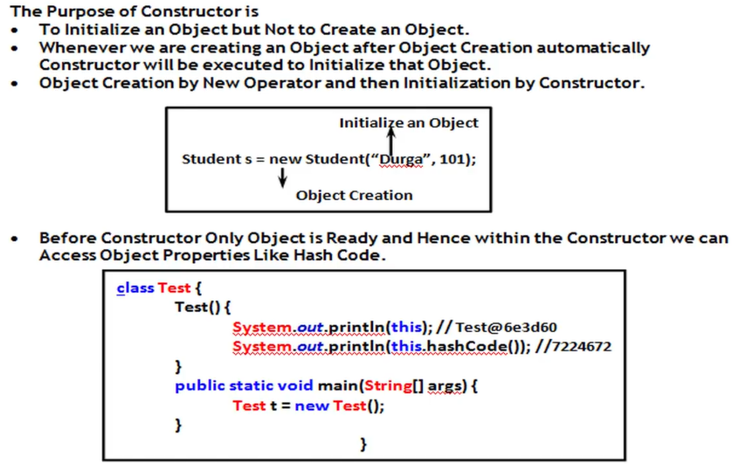

VIDEO 45:

Whenever we are creating child class object automatically parent constructor will be executed to perform initialization for the instance variables which are inheriting from parent.

Ex:

class Person{

String name;

int age;

Person(String name, int age){

this.name=name;

this.age=age;

}

}

class Student extends Person{

int rollno;

int marks;

Student(String name, int age, int rollno, int marks){

super(name,age);

this.rollno=rollno;

this.marks=marks;

}

}

Student s = new Student(“ABCD”,34,101,90);

This initialization is performed by Parent class constructor.

s This initialization is performed by child class constructor.

In the above program both parent and child constructor executed for child object initialization only.

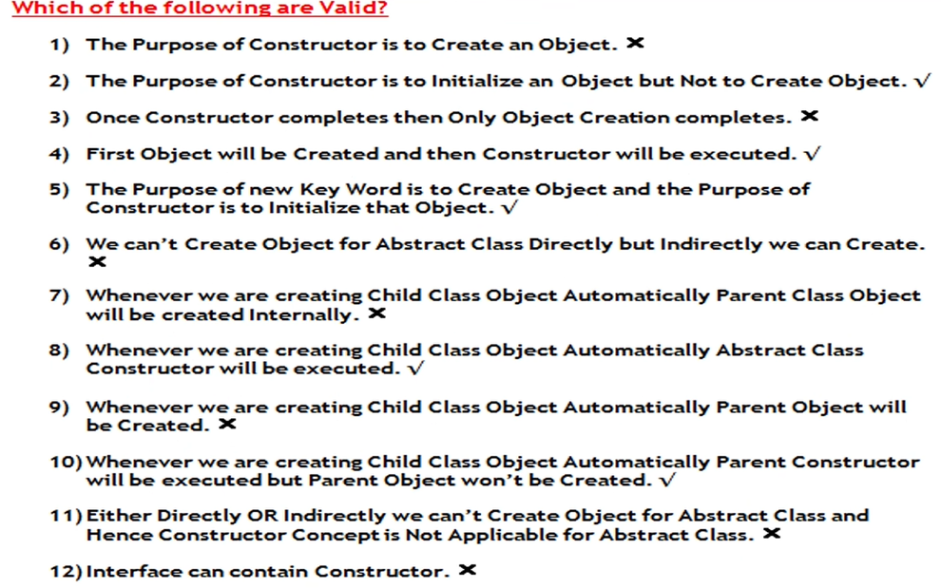VIDEO 50:

VIDEO 51:

OOPs Concepts:

Data Hiding: Outside person can’t access our internal data, or our internal data should not go out directly. This OOP feature is nothing but data hiding.

After validation or identification outside person can access our internal data.

Ex1: After providing proper username and password we can be able to access our Gmail inbox information.

Ex2: Even though we are valid customer of the bank we can be able to access our account information and we can’t access others account information.

By declaring data member (variable) as private we can achieve data hiding.

Ex:

public class Account {

private double balance;

public double getBalance(){

//validation

return balance;

}

}

The main advantage of data hiding is security.

Note: This is highly recommended to declare data member (variable) as private.

**Abstraction:**

Hiding internal implementation and just highlight the set of service that we are offering is a concept of abstraction.

Ex: Through bank ATM GUI screen bank people highlighting the set of service what they are offering without highlighting internal implementation.

The main advantage of abstraction are:

1. We can achieve security because we are not highlighting our internal implementation.

2. Without affecting outside person we can be able to perform any type of changes in our internal system hence enhancement will become easy.

3. It improves maintainability of the application.

4. It improves easiness to use our system.

By using interface and abstract class we can implement Abstraction.

**Encapsulation:**

The process of binding data and corresponding methods into a single unit is called encapsulation.

Ex:

class Student {

data members

+

Methods(behaviour)

}

If any component follows data hiding and abstraction such type of component is said to be encapsulated component.

Ex:

public class Account{

private double balance;

Balance enquiry

public double getBalance(){

//validation

return balance;

Update balance

}

public void setBalance(double balance){

this.balance = balance;

}

} GUI screen

The main advantage of encapsulation are:

1. we can achieve security.

2. enhancement will become easy.

3. It improves maintainability of the application.

The main advantage of encapsulation is we can achieve security, but the main disadvantage of encapsulation is it increase length of the code and slows down execution.

Tightly encapsulated class:

A class is said to be tightly encapsulated if and only if each and every variable is declared as private.  
Whether class contains corresponding getter and setter method or not and whether these methods declared as public or not these things we are not required to check.

public class Account{

private double balance;

public double getBalance(){

return balance;

}

}

VIDEO 52:

is-a relationship(inheritance) has-a relationship is known as compostion

1. It is also known as inheritance.

2. The main advantage of is-a relationship is code reusability.

3. By using extends keyword we can implement is-a relationship.

Ex: class P{

public void m1(){

sop(“Parent”);

}

}

class C extends P{

public void m2(){

sop(“Child”);

}

}

class Test{

psvm(String[] args){

P p = new P();

p.m1();//valid

p.m2()//invalid CE: cannot find symbol symbol: method m2() location: class P

C c = new C();

c.m1();

c.m2();

P p1 = new C();

p1.m1();

p1.m2(); //invalid CE: cannot find symbol symbol: method m2() location: class P

C c1= new P(); // CE: incompatible types found : P required C

}

}

Conclusions:

1. Whatever method parent has by default available to the child and hence child reference we can call both parent and child class methods.

2. Whatever method child has by default not available to the parent and hence the parent reference we can’t call child specific methods.

3. Parent reference can be used to hold child object but using the reference we can’t call child specific methods, but we can call the methods present in parent class.

4. Parent reference can used to hold child object, but child reference cannot be used to hold parent object.

Total Java API is implemented based on inheritance concept. The most common methods which are applicable for any java object are defined Object class and hence every class in java is a child class object either directly or indirectly. So that object class methods by default available to every java class without inheriting due to this object class acts as root class for all java class.

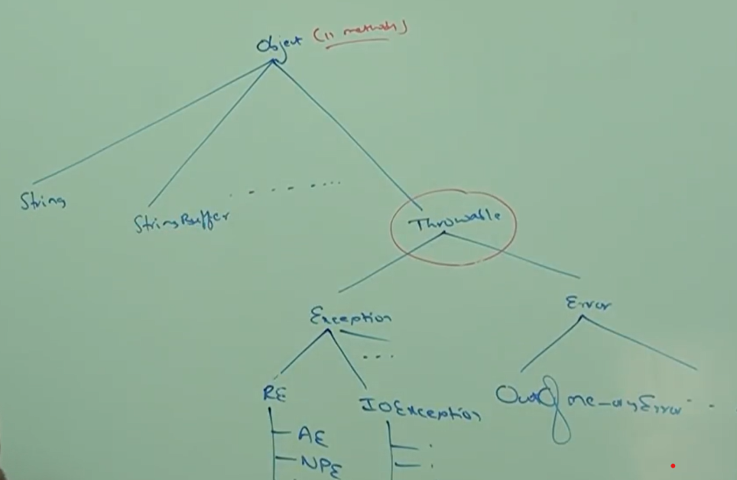Throwable class defines the most common method which are required for every exception and error class hence this class acts as root for java exception hierarchy.

Multiple inheritance:

A java class can’t extends more than one class at a time hence java won’t provide support for multiple inheritance in classes.

Ex:

class A extends B, C {

}

Note: If our class doesn’t extends any other class then only our class is direct child class of Object.

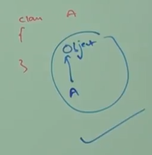

If our class extends any other class, then our class is indirect child class of object.

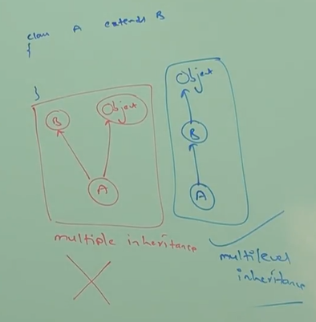

Either directly or indirectly java won’t provide support for inheritance w.r.t classes.

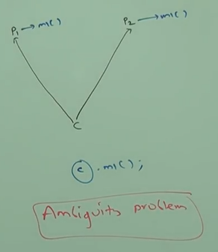

Why Java won’t provide support for multiple inheritance?

There may be a chance of ambiguity problem hence java won’t

provide support for multiple inheritance.

But interface can extends any number of interfaces

simultaneously.

Hence java provide support for multiple inheritance w.r.t

interfaces.

Ex:

interface A{

}

interface B{

}

interface C extends A, B{

}

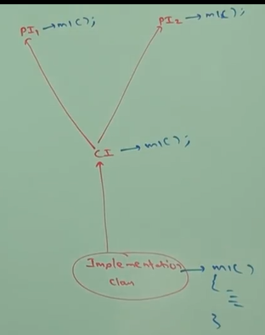

Why ambiguity problem won’t be there in interfaces?

Even though multiple method declarations are available but

implementation is unique and hence there is no chance of

ambiguity problem in interfaces.

Note: Strictly speaking through interfaces we won’t get any

inheritance.

Cyclic inheritance:

Cyclic inheritance is not allowed in java off course it is not required.

Ex1:

class A extends A {

}

Ex2:

class A extends B {

}

class B extends A {

}

CE: cyclic inheritance involving A

VIDEO 53:

Has-a relationship (composition/aggregation):

1. has-a relationship is also known as composition or aggregation.

2. There is no specific keyword to implement has-a relation but most of the time we are depending on new keyword.

3. The main advantage of has-a relationship is reusability of the code.

Ex:

class Engine {

//Engine specific functionality

}

Class Car {

Engine e = new Engine();

}

Car Has-a Engine reference.

Difference between composition and aggregation?

Composition:

Without existing container object if there is no chance of existing contained objects then container and contained objects are strongly associated and this strong association is composition.

Ex: University consists of several departments without existing university there is no chance of existing department hence university and department are strongly associated, and this strong association is composition.

EEE dept

CSE dept

ECE dept

Contained object.

Civil dept

Container object.

university

Aggregation:

Without existing container object if there is a chance of existing contained object then container and contained objects are weakly associated and this weak association is aggregation.

Ex:

Department consists of several professors without existing department there may be chance of existing professor objects hence department and professor objects are weakly associated, and this weak association is aggregation.

 Professor1



Professor2 contained object.



Professor3

Department (container object)

Note: In composition, container object holds directly contained objects whereas in aggregation container object holds just references of contained object.

Is-a vs has-a:

If we want total functionality of a class automatically then we should go for is-a relationship.

Ex: is-a relationship

If we want part of the functionality, then we should go for has-a relationship.

Has-a relationship

Method signature:

In java method signature consists of method names followed by argument types:

public static int m1(int i, float f)

here only m1(int i, float f) is a method signature.

Return type is not a part of method signature in java.

Compiler will use method signature to resolve method calls.

Ex:

class Test{

public void m1(int i){

m1(int i)

m2(String)

}

public void m2(String s){

}

}

Test t = new Test();

t.m1(12); class Test method table

t.m2(“ABCD”);

t.m3(10.5);//CE : cannot find symbol symbol:method m3(double) location : class Test

Within a class two methods with same signature not allowed.

class Test{

public void m1(int i){ 🡺 signature m1(int i)

}

public int m1(int x){ 🡺signature m1(int i)

return 10;

}

}

Test t = new Test();

t.m1(10) ;// CE: m1(int) is already defined in Test.

Overloading:

Two methods are said to be overloaded if and only if both methods having same name but different argument types.

In C language method overloading concept is not available hence we can’t declare multiple methods with same name but different argument types. If there is change in argument type compulsory, we should go for new method name which increase complexity of programming.

abs(int i);

labs(long l); C language is not having overloading concept

fabs(float f);

But in java we can declare multiple methods with same name but different argument types such type so of methods are called overloaded methods.

abs(int i);

abs(long l); java is having overloaded method

abs(float f);

Having overloaded concept in java reduces complexity of programming.

Ex: class Test{

public void m1(){

sop(“no-arg”);

}

public void m1(int i){

sop(“int-arg”);

}

public void m1(double d){

sop(“double-arg”);

}

}

Psvm(String[] args){

Test t = new Test();

t.m1();

t.m1(10);

t.m1(10.5);

}

In overloading method resolution (which method has to execute) is always take care by compiler based on reference type hence overloading is also considered as compile time polymorphism, or static polymorphism or early binding.

VIDEO 54:

Case1: Automatic promotion in overloading.

While resolving overloaded methods if exact matched method is not available then we won’t get any compile time error immediately. First it will promote argument to the next level and check whether matcher method is available or not if matched method is available then it will be considered, and if the matched is not available then compiler promotes argument once again to the next level this process will be continued until all possible promotion still if them matched method is not available then we will get compile time error.

The following are all possible promotions in overloading:



This process is called automatic promotion in overloading.

Ex:  
class Test {

public void m1(int i){

Sop(“int-arg”);

}

public void m1(float i){

Sop(“float-arg”);

}

}

psvm(String[] args){

Test t =new Test();

t.m1(10); //int-arg

t.m1(10.5f); //float-arg

t.m1(‘a’); //int-arg

t.m1(10L); //float-arg

t.m1(10.5); //CE : cannot find symbol symbol: method m1(double) location : class Test

}

Case 2:

class Test {

public void m1(String s){

Sop(“String version”);

}

public void m1(Object o){

Sop(“Object version”);

}

}

psvm(String[] args){

Test t = new Test();

t.m1(new Object());// object version

t.m1(“ABCD”); // String version

t.m1(null); //String version

}

While resolving overloaded methods compiler will always give precedence for child type argument when compared with parent type argument.

Object class

String class

Case 3:

class Test {  
public void m1(String s){  
Sop(“String version”);   
}  
public void m1(StringBuffer sv){  
Sop(“StringBuffer version”);   
}  
}  
psvm(String[] args){

Test t = new Test();

t.m1(“ABCD”);// String version

t.m1(new StringBuffer(“ABCD”)); // StringBuffer version

t.m1(null); // CE : reference to m1() is ambiguous

}

Object class(Parent class)

String class(child1 class) StringBuffer class(child2 class)

Case 4:

class Test {

public void m1(int i, float f){

Sop(“int-floatversion”);

}

public void m1(float f, int i){

Sop(“float-int version”);

}

}

psvm(String[] args){

Test t =new Test();

t.m1(10,10.5f); // int-float version

t.m1(10.5f, 10); // float-int version

t.m1(10,10); CE: reference to m1() is ambiguous

t.m1(10.5f, 10.5f);//CE: cannot find symbol symbol: method m1(float, float) location: class Test

}

Case 5:

class Test {

public void m1(int x){

Sop(“General method”);

}

public void m1(int… x){

Sop(“var-arg method”);

}

}

psvm(String[] args){

Test t =new Test();

t.m1(); // var-arg method

t.m1(10,20); // var-arg method

t.m1(10) ;//General method

}

In general, var-arg method will get least priority i.e., if not other matched then only var-arg method will get a chance it is exactly same as default case inside switch.

Case 6:

class Animal{

}

class Monkey extends Animal{

}

Class Test{

public void m1(Animal a){

sop(“Animal version”);

}

public void m1(Monkey m){

sop(“Monkey version”);

}

Psvm(String[] args){

Test t = new Test();

Animal a = new Animal();

t.m1(a); //Animal version

Monkey m = new Monkey();

t.m1(m); //Monkey version

Animal a1 = new Monkey();

t.m1(a1); //Animal version

}

}

In overloading method resolution is always takes care by compiler based on reference type. In overloading runtime object won’t play any role.

VIDEO 55:

Overriding:

Whatever method parent has by default available to the child through inheritance. if child class not satisfied with parent class implementation, then child is allowed to redefine that method based on its requirement. This process is called overriding. The parent class method which is overridden is called overridden method and the child class method which is overriding is called overriding method.

Ex:

class P{

public void property(){

sop(“cash + Land + Gold”);

}

public void marry(){

sop(“Subba laxmi”);

}

}

class C extends P{

public void marry(){

sop(“jane”);

}

}

class Test {

psvm(String[] args){

P p =new P();

p.marry(); // parent method

C c = new C():

c.marry();// child method

P p1 = new C();

p1.marry(); // child method

}

}

In overriding method resolution always takes care by JVM based on runtime object and hence overriding is also considered as runtime polymorphism/ dynamic polymorphism/ late binding.

Rules for overriding:

1. In overriding method names and argument types must be matched i.e. methods signature must be same.

2. In overriding return types must be same but this rule is applicable until 1.4 version only. From 1.5 version onwards we can take co-variant return types. According to this child class method return type need not be same as parent method return type but its child type also allowed.

Ex:

class P{

public Object m1(){

return null;

}

}

class C extends P{

public String m1(){

return null;

}

}

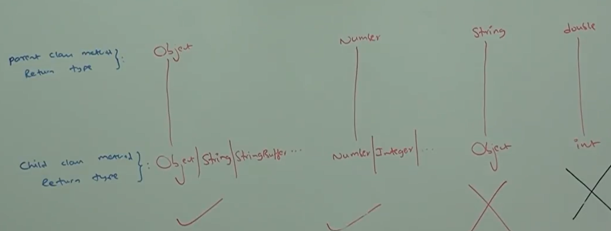

Covariant return type concept applicable only for object types but not primitive types.

3. Parent class private methods not available to the child and hence overriding concept not applicable for private methods.

Based on our requirement we can define exactly same private method in child class it is valid but not overriding.

Ex:

class P {

private void m1() {

}

}

class C extends P {

private void m1() {

}

}

4. We can’t override parent class final method in child classes if we are trying to override, we will get compile time error.

Ex:

class P {

public final void m1() {

}

}

class C extends P {

public void m1() {} // CE : m1() in C cannot override m1() in P; overridden method

}

5. Parent class abstract method we should override in child class to provide implementation.

Ex:  
abstract class P {

public abstract void m1();

}

class C extends P{

public void m1() {

}

}

6. We can override non abstract method as abstract.

Ex:

class P{

public void m1() {

}

}

abstract class C extends P {

public abstract void m1();

}

In overriding the following modifier won’t keep any restrictions:

1. synchronized

2. native

3. strictfp

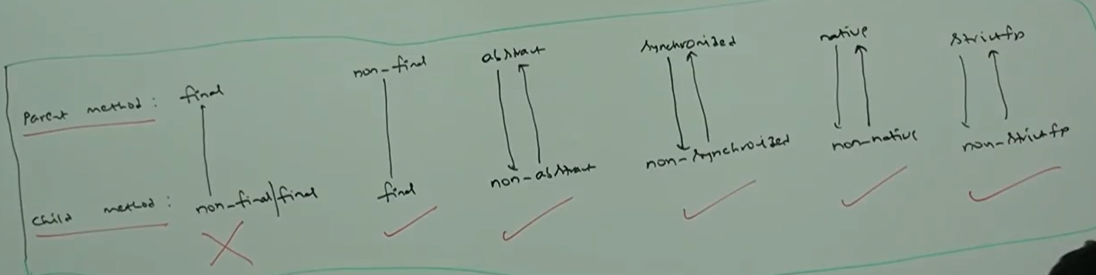

7. While overriding we can’t reduce scope of access modifier, but we can increase the scope.

Ex:

class P{

public void m1(){

}

}

class C extends P{

void m1(){

}

}

CE: m1() in C cannot override m1() in P; attempting to assign weaker access privileges; was public.

class P{

void m1(){

}

}

class C extends P{

public void m1(){

}

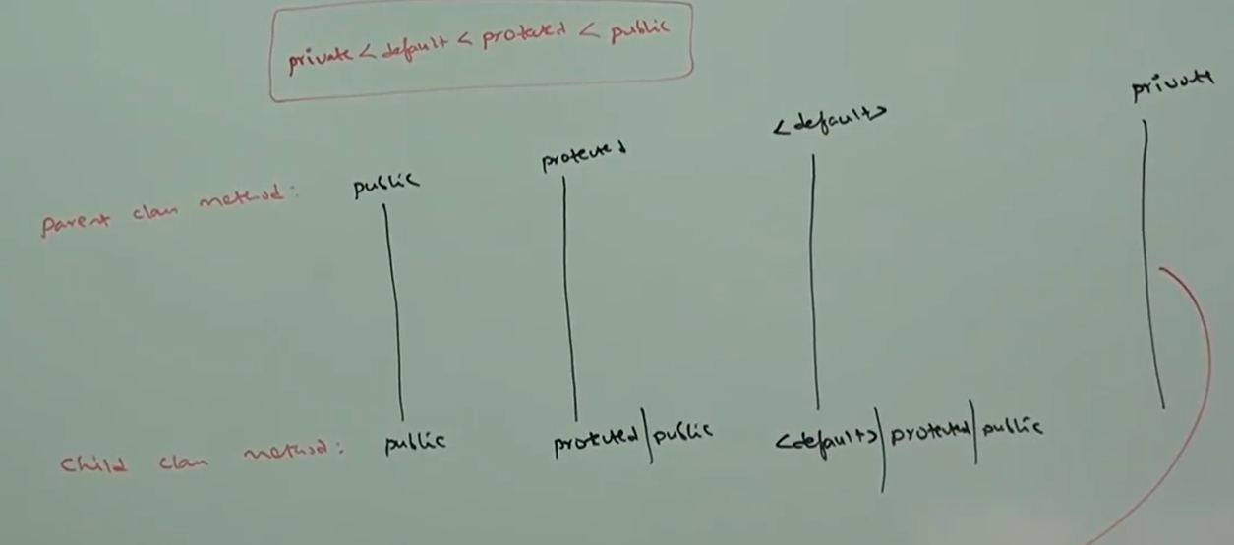}

overriding concept nor applicable for private methods.

VIDEO 56:

Overriding w.r.t var-arg methods:

We can override var-arg methods with another var-arg method only, if we are trying to override with normal method then it will become overloading but not overriding.

Ex:

class P {

public void m1(int… x){

sop(“Parent”);

}

}

class C {

public void m1(int x){

sop(“Child”);

}

}

class Test{

psvm(String[] args){

P p = new P();

p.m1(10); // parent method

C c = new C();

c.m1(10); //child method

P p1 = new C();

p1.m1(10);//parent method

}

}

In the above program if we replace child method with var-arg method then it will become overriding. In this case the output is parent, chid, child.

Overriding w.r.t to variables:

Variable resolution always takes care based on reference type irrespective whether the variable is static or non-static (overriding concept applicable only for method but not for variable).

Ex:  
class P{

int x = 888;

}

class C extends P{

int x = 999;

}

class Test{

psvm(String[] args){

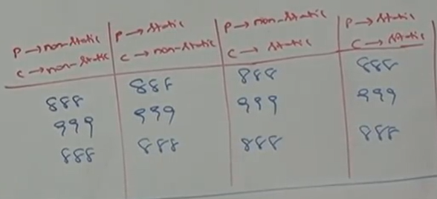 P p = new P();

Sop(p.x); // 888

C c = new C();

Sop(c.x); //999

P p1 = new C();

Sop(p1.x); //888

}

}

Difference between overloading and overriding?

|  |  |  |
| --- | --- | --- |
| Property | Overloading | Overriding |
| 1. method names | Must be same | Must be same |
| 2. argument type | Must be different (atleast order) | Must be same (including order) |
| 3. method signature | Must be different | Must be same |
| 4. return types | No restrictions | Must be same until 1.4 v but from 1.5 v onwards co-variant return types allowed. |
| 5. private, static, final methods | Can be overloaded | Cannot be overridden |
| 6. access modifiers | No restriction | The scope of access modifier cannot be reduced but we can increase. |
| 7. throws clause | No restrictions | If child class methods throws any checked exception compulsory parent class method should throw the same checked exception or its parent but no restriction for unchecked exception. |
| 8. method resolution | Always takes care by compiler based on reference type. | Always takes care by JVM based on runtime object. |
| 9. It is also known as | Compile time polymorphism/ static polymorphism/ early binding | Runtime polymorphism/ dynamic binding/ late binding |

Note: In overloading we must check only method names (must be same) and the argument type (must be different). We are not required to check remaining like return types, access modifiers etc.  
But in overriding everything we must check like method names, argument types, return types,  
access modifiers, throws class etc.

Consider the following method in parent class?  
In the child class which of the following methods we can take?

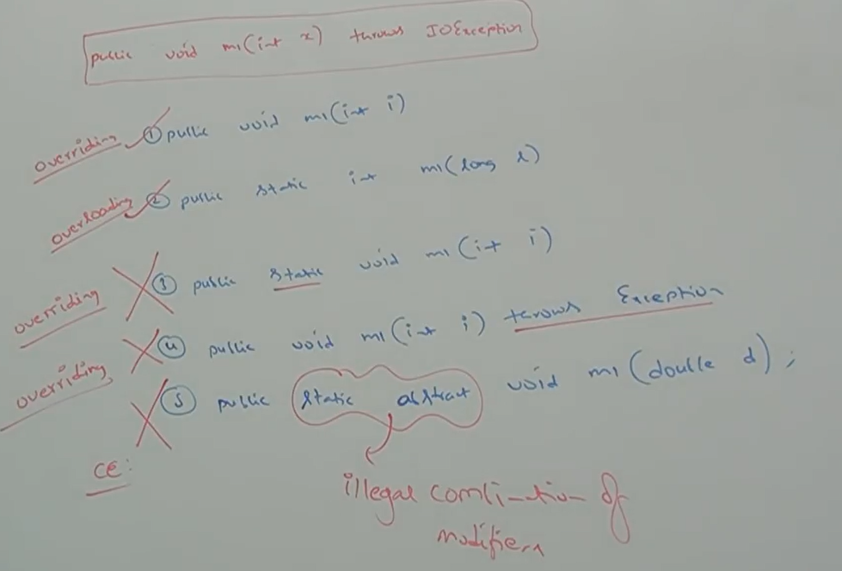

**Polymorphism:**

One name but multiple forms is a concept of polymorphism.

Ex1: Method name is the same, but we can apply for different types of arguments(overloading).

abs(int)

abs(long)

abs(float)

Ex2: Method signature is same but in parent class one type of implementation and in child class another type of implementation(overriding).

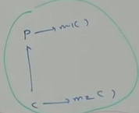Parent class reference can be used to hold child object but by using that reference we can call only the methods available in parent class and we can’t call child specific methods.

P p = new C();

p.m1();

p.m2(); // CE: cannot find symbol symbol : method m2() location : class P

But by using child reference we can call both parent and child class methods.

C c = new C();

c.m1();

c.m2();

When should we go for parent reference to hold child object?

If we don’t know exact runtime type of object, then we should go for parent reference.

For ex: the first element present in the array list can be any type it can be student object, customer object, String object or StringBuffer object. Hence the return type of get method is object which can hold any object.

|  |  |  |  |
| --- | --- | --- | --- |
| Student object | Customer object | String Object | StringBuffer object |

Object o = l.get(0); l

|  |  |
| --- | --- |
| C c = new C() | P p = new C() |
| Ex: ArrayList l = new ArrayList(); | Ex: List l = new ArrayList(); |
| 1. we can use this approach if we know the exact runtime type of object. | 1. we can use this approach if we don’t know exact runtime type of object. |
| 2. By using child reference we can call both parent class and child class method. This is the advantage of this approach. | 2. By using parent reference we can call only methods available in parent class and we can’t call child specific methods. This is the disadvantage of this approach. |
| 3. we can use child reference to hold only particular child class object. This is the  disadvantage of this approach. | 3. we can use parent reference to hold any child class object. This is the advantage of this approach. |

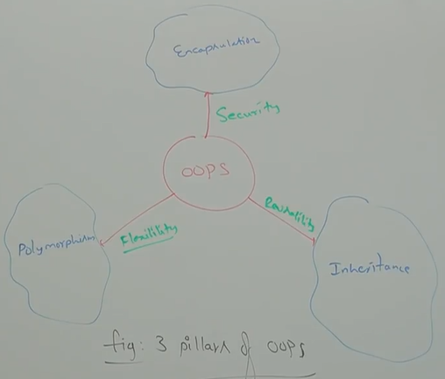

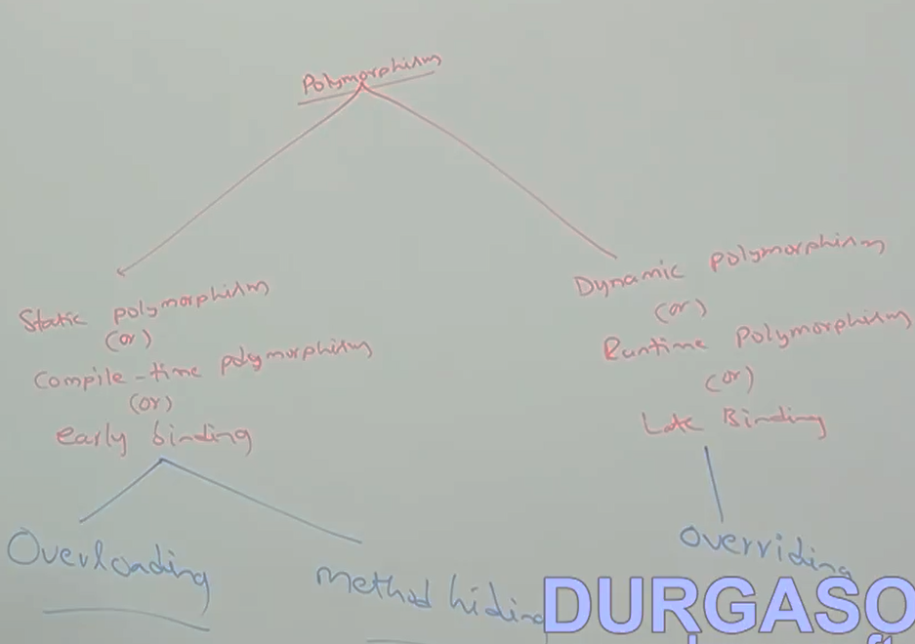

VIDEO 57:

**Coupling:**

The degree of dependency between the components is called coupling. If dependency is more then it is considered as tightly coupling and if dependency is less, then it is considered as loosely coupling.

Ex:

class A{

static int i=B.j;

}

class B{

static int j = C.k;

}

class C{

static int k = D.m1();

}

class D{

public static int m1(){

return 10;

}

}

The above components are said to be tightly coupled with each other because dependency between the components is more.

Tightly coupling is not a good programming practice because it has several serious disadvantages:

1. Without affecting remaining components we can’t modify any component and hence enhancement will become difficult.

2. It suppress reusability.

3. It reduces maintainability of the application.

Hence, we have to maintain dependency between the component as less as possible i.e. loosely coupling is a good programming practice.

**Cohesion:**For every component, a clear well-defined functionality is defined then that component is said to be follow high cohesion.

Low Cohesion:

TotalServlet

Login Page Display

Validation

Inbox page

Reply page

Compose page

Error page

.

.

.

.

70 lakh LOC

reply.jsp

inbox.jsp

High cohesion:

compose.jsp

error.jsp

validation.jsp

Login.jsp

High cohesion is always good programming practice because it has several advantages:

1. Without affecting remaining components we can modify any components hence enhancement will become easy.

2. It promotes reusability of the code (wherever validation is required we can reuse the same validation servlet without rewriting).

3. It improves maintainability of the application.

**Note: loosely coupling and high cohesion are good programming practice.**

**Object typecasting:**

We can use parent reference to hold child object.

Ex:

Object o = new String(“ABCD”);

We can use interface reference to hold implemented class object.

Ex:

Runnable r = new Thread ();

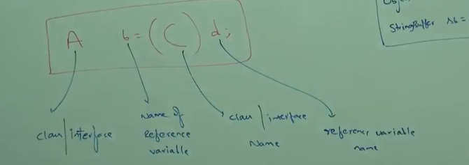

**Compile time checking 1:** the type of ‘d’ and ‘C’ must have some relation (either child to parent or parent to child or same type) otherwise we will get compile time error: inconvertible types found: d type required: C

Ex:

Object o = new String(“ABCD”);

StringBuffer sb = (StringBuffer)o; // o and StringBuffer having parent child relation

Ex:

String s = new String(“ABCD”);

StringBuffer sb = (StringBuffer)s; // CE: inconvertible types found: java.lang.String required : java.lang.StringBuffer

**Compile time checking 2:** ‘C’ must be same or derived type of ‘A’ otherwise we will get compile time error saying incompatible type found : C required : A

Ex:  
Object o = new String(“ABCD”);  
StringBuffer sb = (StringBuffer)o;

Ex:  
Object o = new String(“ABCD”);  
StringBuffer sb = (String)o;// CE : incompatible type found : java.lang.String required : java.lang.StringBuffer

**Runtime checking:** Runtime object type of ‘d’ must be either same or derived type of ‘C’ otherwise we will get runtime exception saying ClassCastException.

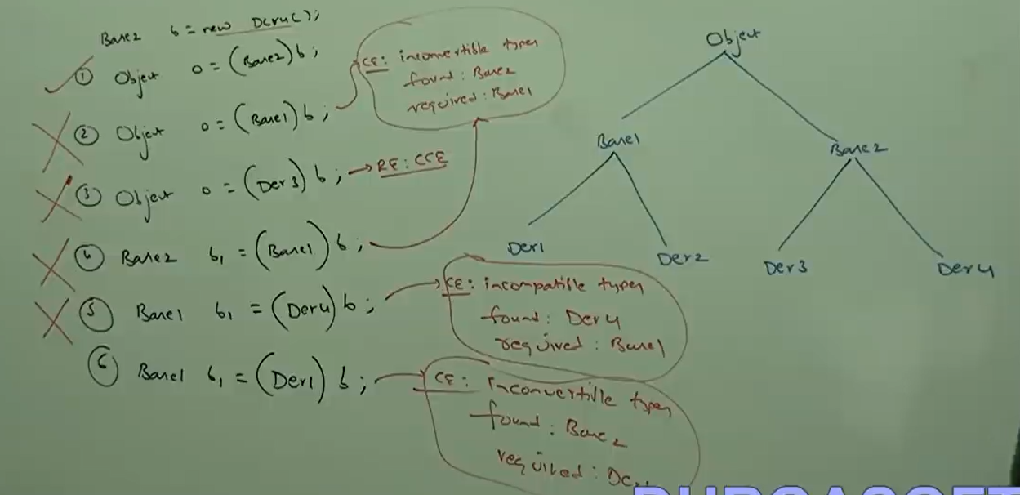Ex;  
Object o = new String(“ABCD”);  
StringBuffer sb = (StringBuffer)o; // Here there is no relation between String and StringBuffer   
RE : ClassCastException : java.lang.String cannot be cast to java.lang.StringBuffer  
Ex:  
Object o = new String(“ABCD”);  
Object o1 = (String)o;

VIDEO 58:

Typecasting:

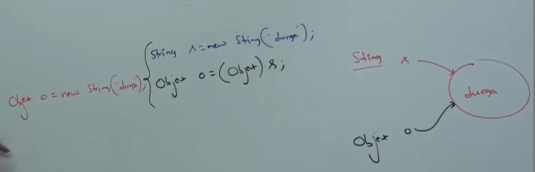Strictly speaking through typecasting we are not creating any new object for the existing object, we are providing another type of reference variables i.e. we are performing typecasting but not object casting.

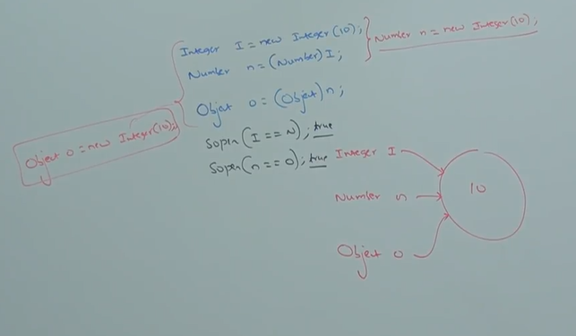

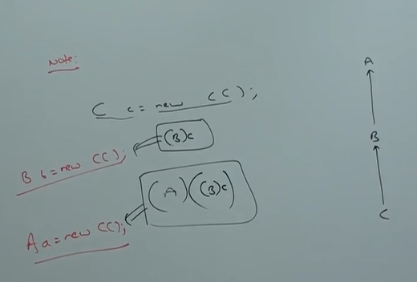

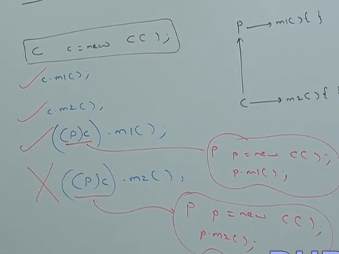

Reason: parent reference can be used to hold child object but by using that reference we can’t call child specific method and we can call only methods available in parent class.

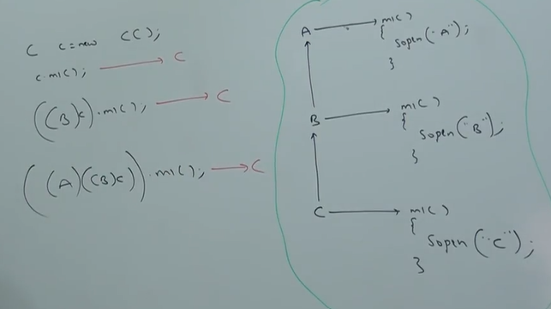

It is overriding and method resolution is always based on runtime object.

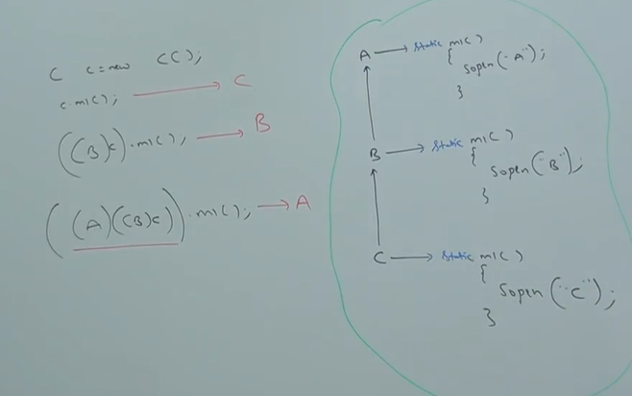

It is method hiding and method resolution is always based on reference type.

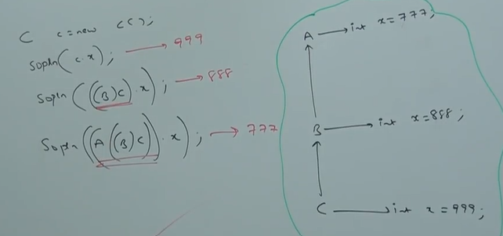

Variable resolution is always based on reference type but not based on runtime object.

VIDEO 60:

Static control flow:

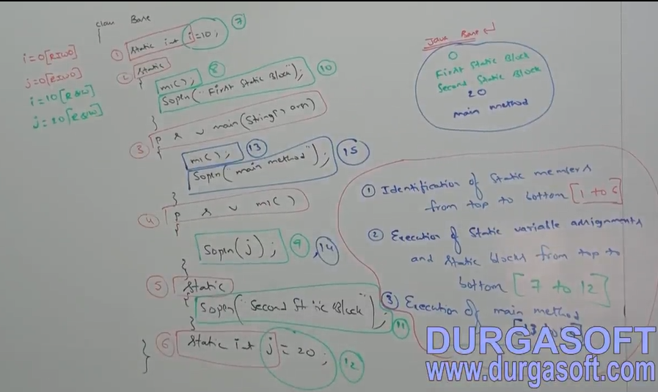Whenever we are executing a java class the following sequence of steps will be executed as the part of static control flow:

Read indirectly write only (RIWO):

Inside static block if we are trying to read a variable that read operation is called direct read.

If we are calling method and within that method if we are trying to read variable that read operation is called indirect read.

Ex:

class Test {

static int i = 10;

static {

m1();

sop(i); //Direct Read

}

psv m1() {

sop(i); //Indirect Read

}

}

If a variable is just identified by the JVM and the original value not yet assigned then the variable is said to be in read indirectly and write only state (RIWO).

If a variable is in read indirectly write only state then we can’t perform direct read but we can perform indirect read.

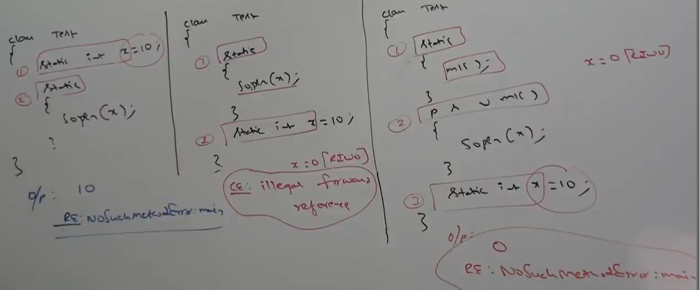If we are trying to read directly then we will get compile time error saying illegal forward reference.

VIDEO 61:

Static block:

Static block will be executed at the time of class loading hence at a time of class loading if we want to perform any activity, we have to define that inside static block.

Ex1: At the time of java class loading the corresponding native library should be loaded hence we have to define this activity inside static block.

class Test {

static {

System.loadLibrary(“native library path”);

}

}

Ex2: After every database driver class we have to register driver class with driver manager but inside database driver class there is a static block to perform this activity and we are not responsible to register explicitly.

class DbDriver{

static{

Register this Driver with DriverManager

}

}

Note: within a class we can declare any number of static block but all these static blocks will be executed from top to bottom.

Without writing main method is it possible to print some statements to the console?

Yes, by using static block.

Class Test {

static{

sop(“Hello I can print”);

System.exit(0);

}

}

Output: Hello I can print

Without writing main method and static block is it possible to print some statements to the console?

Yes, there are multiple ways:

1. class Test{

static int x = m1();

public static int m1(){

System.out.println(“Hello I can print”);

System.exit(0);

return 10;

}

}

2. class Test{

static Test t = new Test();

{

Sop(“Hello I can print”);

System.exit(0);

}

}

3. class Test{

static Test t = new Test();

Test(){

Sop(“Hello I can print”);l

System.exit(0);

}

}

Note: From 1.6 Version onwards, main method is mandatory to start a program execution hence from 1.7 version onwards without writing main method it is impossible to print some statements to the console.

Static control flow in parent to child relationship:  
Whenever we are executing child class the following sequence of events will be executed automatically as the part of static control flow.  
1. Identification of static members starts from parent to child. [Steps 1 to 11]  
2. Execution of static variable assignments and static blocks from parent to child. [Steps 12 to 22]  
3. Execution of only child class main method (If we run the child class). [Steps 23 to 25]

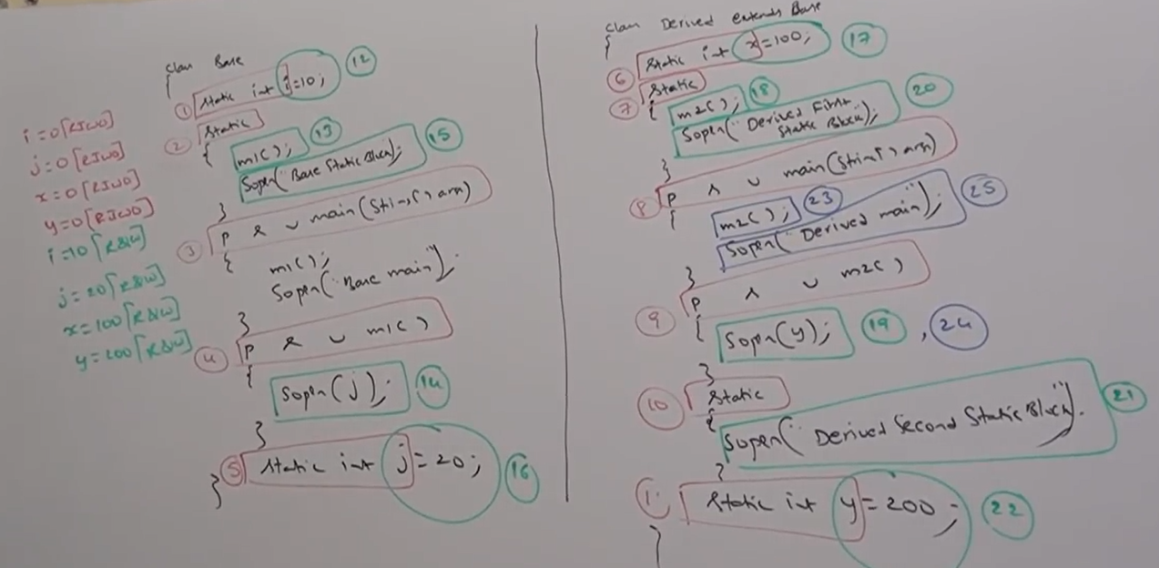

Whenever we are executing child class only child class main method will be executed if the child class doesn’t contains main method then parent class main method will be executed.

Output: Java Derived

0

Base Static Block

0

Derived First Static Block

Derived Second Static Block

200

Derived main

Output: Java Base

0

Base Static Block

20

Base main

Whenever we are loading child class, automatically parent class will be loaded but whenever we are loading parent class child class won’t be loaded because parent class member by default available to child class whereas child class members by default won’t be available to the parent.

VIDEO 62:

Instance control flow:

Whenever we are executing a java class first static control flow will be executed in the static control flow if we are creating an object the following sequence of events will be executed as a part of instance control flow:

1. Identification of static member from top to bottom first then instance members from top to bottom. [3 to 8]

2. Execution of instance variable assignments and instance blocks from top to bottom. [9 to 14]

3. Execution of constructor. [15]

Output: 0

First Instance Block

Second Instance Block

Constructor

main

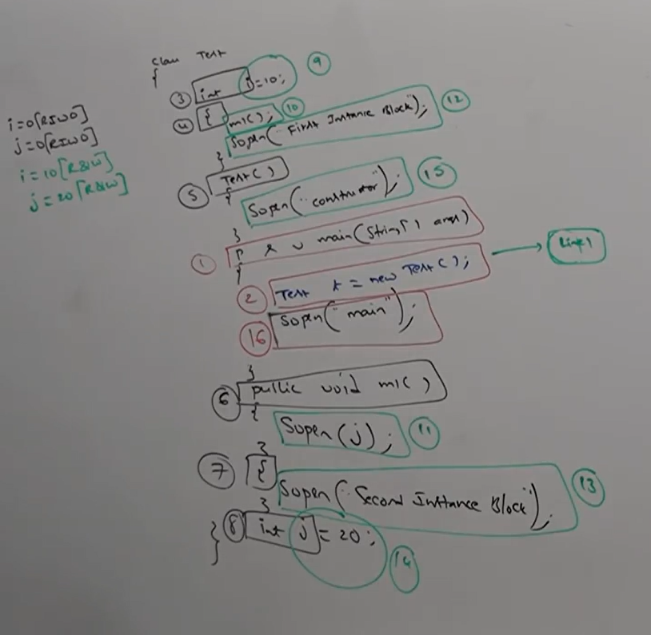

If we comment line 1 then the output: main (because only static block will execute but not instance block as the instance is not created).

Static control flow is one time activity which will be performed at the time of class loading but instance control flow is not one time activity, and it will performed for every object creation.

Object creation is most costly operation if there is no specific requirement then it is not recommended to create object.

Instance control flow in parent to child relationship:

Whenever we are creating child class object the following sequence of events will be performed automatically as the part of instance control flow.

1. Identification of first static member then instance members from parent to child. [4 to 14]

2. Execution of instance variable assignments and instance blocks only in parent class. [15 to 19]

3. Execution of parent constructor. [20]

4. Execution of instance variable assignments and instance blocks in child class. [21 to 26]

5. Execution of child constructor. [27]

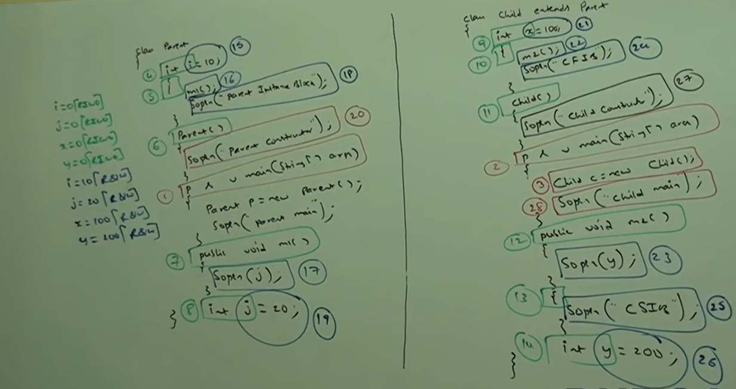

Output:

Javac Parent.java

Java child

0

Parent Instance Block

Parent Constructor

0

Child first Instance Block

Child Second Instance Block

Child constructor

Child main

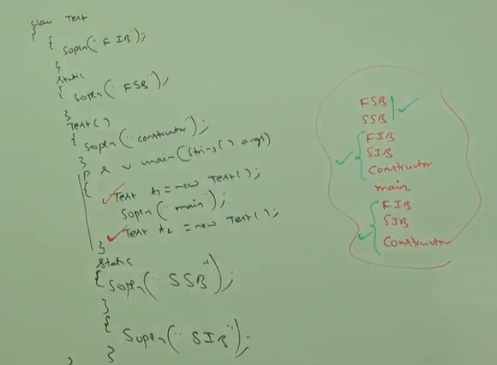VIDEO 63:

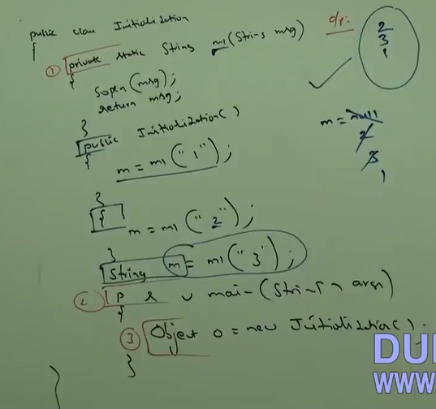

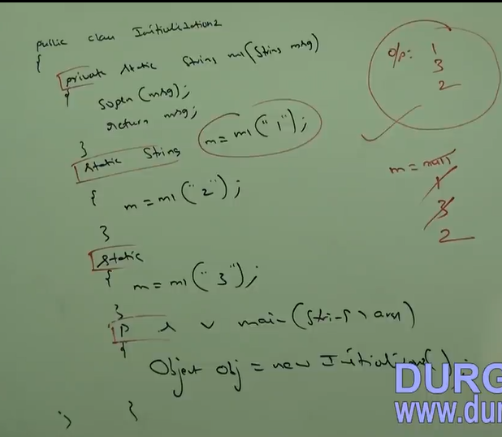

From static area we can’t access instance members directly because while executing Static area JVM may not identify instance members.

Ex: class Test {

int x = 10;

psvm(String[] args){

sop(x); //CE : non-static variable x cannot be referenced from a static context

Test t = new Test();

Sop(t.x);

}

}

In how many ways we can create an object in JAVA or in how many ways we can get object in JAVA?

1. By using new operator:

Test t = new Test();

2. By using newInstance() method:

Test t = (Test)Class.forName(“Test”).newInstance();

3. By using Factory method

Runtime r = Runtime.getRuntime();

DataFormat df = DateFormatgetInstance();

4. By Using clone() method:

Test t1 = new Test();

Test t2 = (Test)t1.clone();

5. By using Deserialization:

FileInputStream fir= new FileInputStream(“abc.ser”);

ObjectInputStream oir = new ObjectInputStream (FileInputStream);

Dog d2 =(Dog)ois.readObject();

VIDEO 64:

Constructor:

Once we create an object compulsory, we should perform initialization then only the object is in position to respond properly.

Wherever we are creating object, some peace of the code will be executed to perform initialization of the object this peace of the code is constructor. Hence the main purpose of constructor is to perform initialization of object.

Ex:

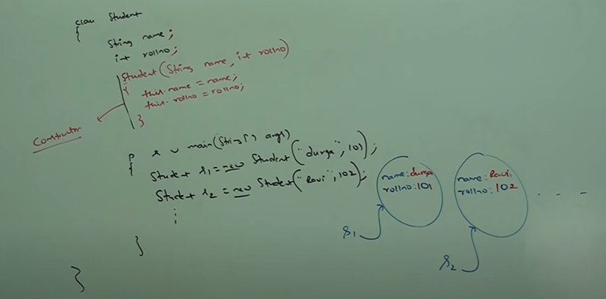

Note: The main purpose of constructor is to perform initialization of an object but not to create object.

Difference between constructor and instance block?

The main purpose of constructor is to perform initialization of an object. But other than initialization if we want to perform any activity for every object creation then we should go for instance block (like updating one entry in the database for every object creation or incrementing count value for every object creation).

Both constructor and instance block have their own different purposes and replacing one concept with another concept may not work always.

Both constructor and instance block will be executed for every object creation, but instance block first followed by constructor.

Demo program to print number of objects created for a class:

class Test {

static int count = 0;

{

count++;

}

Test(){

//count++;

}

Test(int i){

//count++;

}

Test (double d){

//count++;

}

Psvm(String[] args){

Test t1 = new Test();

Test t2 = new Test(10);

Test t3 = new Test(10.5);

Sop(“The number of objects created” + count);

}

}

Rule of constructor:

1. Name of the class and name of the constructor must be matched.

2. Return type concept not applicable for constructor even void also.

3. By mistake if we are trying to declare return type of the constructor then we won’t get any compile time error because compiler treats it as a method.

Ex: class Test {

void Test () //It is a method but not constructor.

{

}

}

Hence it is legal (but stupid) to have a method whose name is exactly same as class name.

class Test {

void Test () {

sop(“Method but not constructor”);

}

Psvm(String[] args){

Test t = new Test();

t.Test();

}

}

4. The only applicable modifier for constructor are public, private, protected, default if we are trying to use any other modifier, we will get compiler timer error.

Ex:

class Test {

static Test(){

}

}

CE: modifier static not allowed here

Default constructor:

Compiler is responsible to generate default constructor but not JVM.

If we are not writing any constructor, then only compiler will generate default constructor i.e. if we are writing atleast one constructor then compiler won’t generate default constructor hence every class in JAVA can contain constructor it may be default constructor generated by compiler or customized constructor explicitly provided by programmer but not both simultaneously.

VIDEO 65:

Prototype of default constructor:

1. Is always no-arg constructor.

2. The access modifier of default constructor is exactly same as access modifier of class (public, default).

3. It contains only one line super(). It is a no argument call to super class constructor.

|  |  |
| --- | --- |
| Programmer’s code | Compiler generated code |
| class Test {  } | class Test {  Test (){  super();  }  } |
| public class Test{  } | public class Test{  public Test(){  super();  }  } |
| public class Test{  void Test(){  }  } | public class Test{  pubic Test(){  super();  }  void Test(){  }  } |
| class Test {  Test(){  }  } | class Test{  Test(){  super();  }  } |
| class Test{  Test(int i){  super();  }  } | class Test{  Test(int i){  super();  }  } |
| class Test{  Test(int i){  this(10);  }  Test(int i){  }  } | class Test{  Test(int i){  this(10);  }  Test(int i){  super();  }  } |

The first line inside every constructor should be either super () or this() and if we are not writing then compiler will always place super().

Case1:

We can take super () or this() only in first line of constructor if we are trying to take anywhere else then we will get compile time error.

Ex:

class Test{

Test(){

Sop(“Constructor”);

super();

}

}

CE: call to super must be first statement in constructor

Case2:

Within the constructor we can take either super or this but not both simultaneously.

Ex:

class Test{

Test(){

super();

this();

}

}

CE: call to this must be first statement in constructor

Case3:

We can use super() or this() only inside constructor if we are trying to use outside of constructor we will get compile time error i.e. we can call a constructor directly from another constructor only.

class Test{

public void m1(){

super();

sop(“Hello”);

}

}

CE: call to super must be first statement in constructor

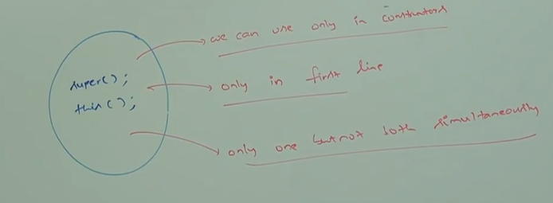

|  |  |
| --- | --- |
| super(),this() | super,this |
| 1. These are constructor calls to call super class and current class constructor. | 1. These are keywords to refer super class and current class instance members. |
| 2. We can use only in constructor as first line. | 2. We can use anywhere except static area. |
| 3. We can use only once in constructor. | 3. We can use any number of times |
| 4. Ex: class Test {  Test(){  super();  }  } | 4. Ex: class P{  int x = 100;  }  class C extends P{  int x = 200;  public void m1(){  sop(this.x); //200  sop(super.x); //100  }  } |

VIDEO 66:

**Overloaded constructors:**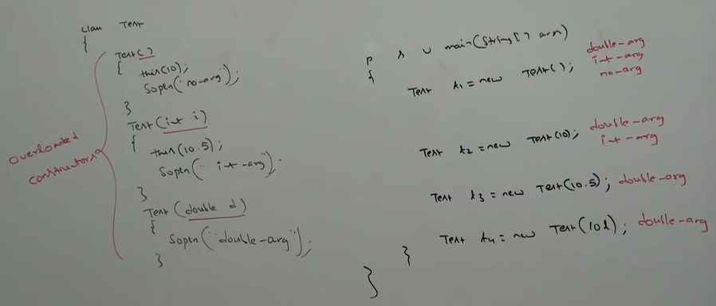 Within a class we can declare multiple constructors and all these constructors having same name but different types of arguments hence all these constructors are considered as overloaded constructor hence overloading concept applicable for constructor.

For constructor inheritance and overriding concept are not applicable but overloading concept is applicable.

Every class in JAVA including abstract class can contain constructor but interface cannot contains constructor.

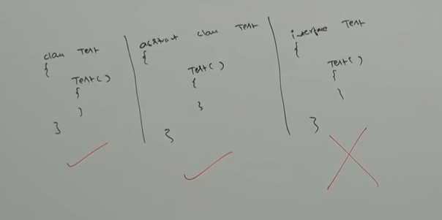

Case 1:

Recursive method call is a runtime exception saying stack overflow error.

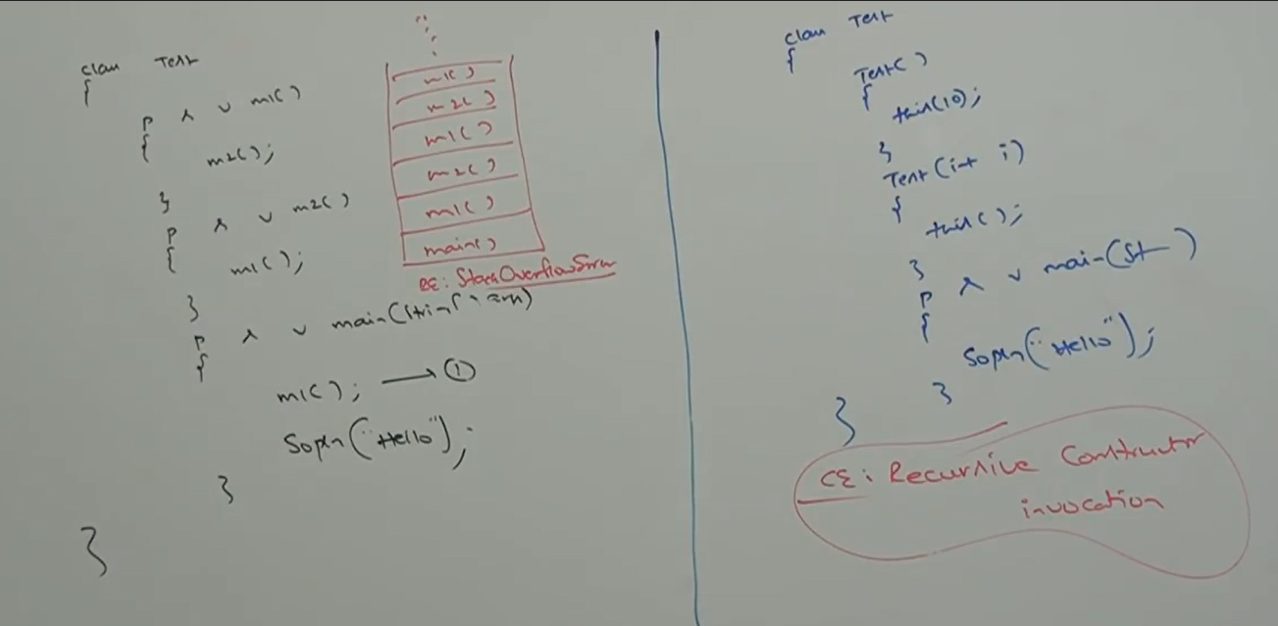But in our program if there is a chance of recursive constructor invocation then the code won’t compiler and we will get compile time error.

Case 2:

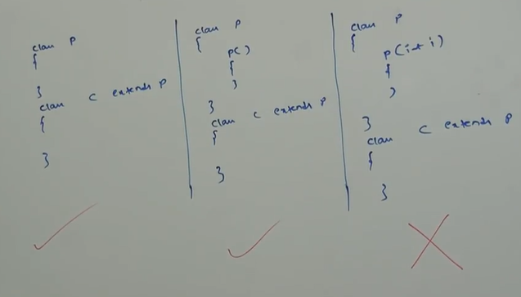

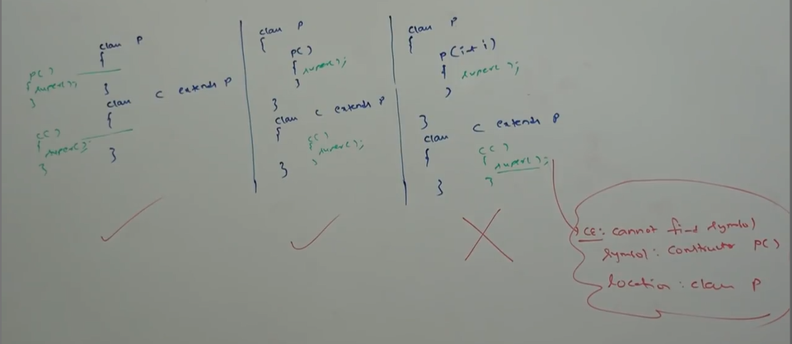

Note1: If parent class contains any argument constructor then while writing child classes, we have to take special care w.r.t constructors.

Note2: Whenever we are writing any argument constructor it is highly recommended to write no-arg constructor also.

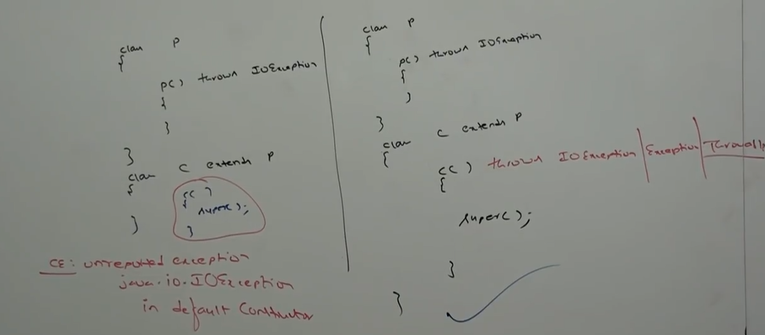Case 3:

If parent class constructor throws any checked exception, compulsory child class constructor should throw the same checked exception or its parent otherwise the code won’t compiler.

Which of the following statement is valid?

1. The main purpose of constructor is to create an object. //invalid

2. The main purpose of constructor is to initialize an object. //valid

3. The name of constructor need not be same as class name. //invalid

4. return type concept applicable for constructor but only void. //invalid

5. we can apply any modifier for constructor. //invalid

6. Default constructor generated by JVM. //invalid

7. Compiler is responsible to generate default constructor. //valid

8. Compiler will always generate default constructor. //invalid

9. If we are not writing no-arg constructor then compiler will generate default constructor. //invalid

10. Every no-arg constructor is always default constructor. //invalid

11. Default constructor is always no-arg constructor. //valid

12. The first line inside every constructor should be super() or this() if we are not writing anything then compiler will generate this().//invalid

13. For constructor both overloading and overriding concept applicable. //invalid

14. For constructor inheritance concept applicable but not overriding. //invalid

15. Only concrete classes can contain constructor but abstract classes cannot. //invalid

16. Interface can contain constructors. //Invalid

17. Recursive constructor invocation is a runtime exception. //invalid

18. If parent class constructor throws some checked exception, then compulsory child class constructor should throw the same checked exception or its child. //invalid.

VIDEO 67:

Singleton classes: For any java class if we are allowed to create only one object such type of class is called singleton class.

Ex:  
Runtime, BusinessDelegate, ServiceLocator.

Advantage of singleton class:

If several people have same requirement, then it is not recommended to create a separate object for every requirement. We must create only one object and we can reuse same object for every similar requirement so that performance and memory utilisation will be improved. This is the central idea of singleton classes.

Ex:

Runtime r1=Runtime.getRuntime() ; r1

Runtime r2=Runtime.getRuntime() ; r2

Runtime r3=Runtime.getRuntime() ; r3

. . Object

. .

. .

. .

Runtime r10000000=Runtime.getRuntime(); r100000000

Note: singleton classes we can’t create by using new operator or constructor because if anyone calls constructor, he/she may create as many objects therefore we use factory method to create object.

How to create our own singleton classes?  
We can create our own singleton classes for this we have to use private constructor and private static variable and public factory method.

Approach 1:

class Test {  
 private static Test t = new Test ();  
 private Test () {  
 }

public static Test getTest () {

return t;  
 }

}

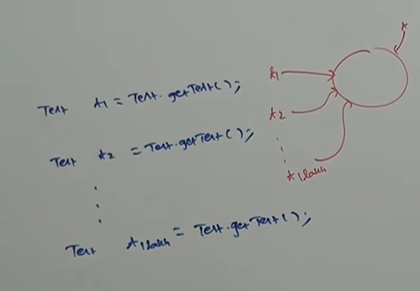

Note: Runtime class is internally implemented by using this approach.

Approach 2:

class Test{

private static Test t = null;

private Test() {

}

public static Test getTest(){

if(t == null){

t = new Test();

}

return t;

}

}

At any point of time, for Test class we can create only one object hence Test class is singleton class.

Class is not final, but we are not allowed to create child classes how it is possible?

By declaring every constructor as private we can restrict child class creation. Because if we do so then in child class constructor there is a super keyword (put by JVM) which tries to call private constructor of its immediate parent (which is not possible).

Ex:

class P{

private P(){

}

}

For the above class it is impossible to create child class.

VIDEO 70:

**Exception:** An unexpected unwanted event that disrupts the normal flow of the program is called exception.

It is highly recommended to handle exceptions and the main objective of exception handling is graceful termination of the program.

**Exception handling** doesn’t mean repairing an exception we have to provide alternative way to continue rest of the program normally is the concept of exception handling.

For ex: Our programming requirement is to read the data from remote file locating at London. At runtime if London file is not available our program should not be terminated abnormally, we must provide some local file to continue rest of the program normally. This way of defining alternative is exception handling.

try{

read data from remote file locating at London

}

catch(FileNotFoundException e){

use local file and continue rest of the program normally

}

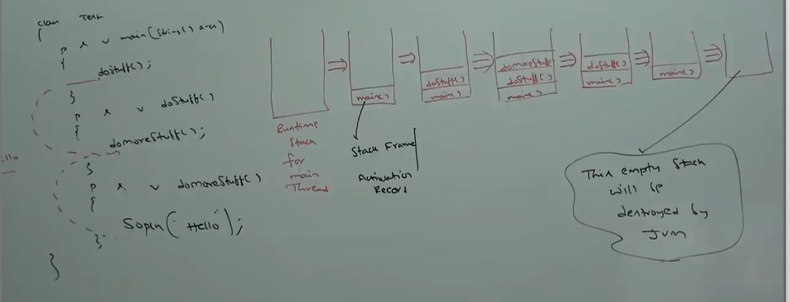**Runtime Stack mechanism:** For every thread JVM will create a Runtime Stack. Each and every method call performed by that thread will be stored in corresponding stack. Each entry in the stack is called stack frame/ activation record. After completing every method call the corresponding entry from the stack will be removed. After completing all methods call the stack will become empty and that empty stack will be destroyed by the JVM just before terminating the thread.

VIDEO 71:

**Default exception Handling in JAVA:**

1. Inside a method if any exception occurs the method in which it is raised is responsible to create exception object by including the following information:

Name of exception

Description of exception

Location at which exception occurs [Stack Trace]

2. After creating exception object method handover that object to JVM.

3. JVM will check whether the method contains any exception handling code or not if the method doesn’t contain exception handling code, then JVM terminates that method abnormally and removes corresponding entry from the stack.

4. JVM identifies Caller method and checks whether caller method contains any handling code or not.

5. If the caller method doesn’t contain handling code, then JVM terminates that caller method also abnormally and removes corresponding entry from the stack.

6. This process will be continued until main method and if the main method also doesn’t contain handling code JVM terminated main method also abnormally and removes corresponding entry from the stack.

7. Then JVM handovers responsibility of exception handling to default exception handler, which is the part of JVM.

8. Default exception handler prints exception information in the following format and terminates program abnormally:

Exception in thread “XXX” Name of Exception: Description

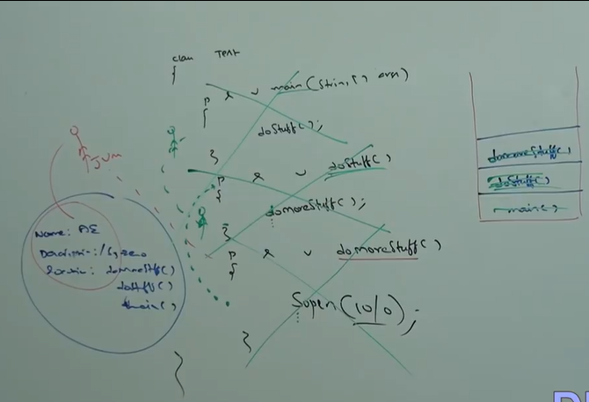Stack Trace

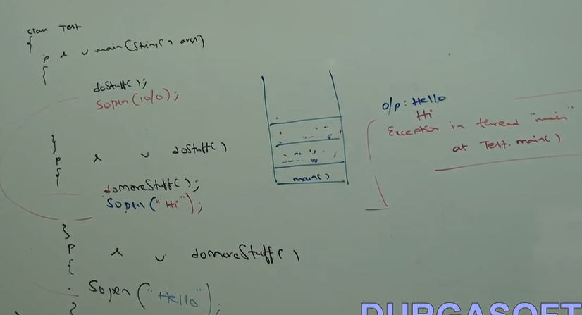

Note: In a program, if atleast one method terminates abnormally then the program termination is abnormal termination. If all method methods terminated normally then only program termination is normal termination.

**Exception class Hierarchy:**

Throwable class acts as root for java exception hierarchy.

Throwable class defined two child classes:

1. Exception 2. Error

**1. Exception**: Most of the times exception are caused by our program and these are recoverable.

For Ex: If our programming requirement is to read the data from remote file locating at London. At runtime if remote file is not available then we will get runtime exception saying FileNotFound Exception. If exception FileNotFound occurs, we can provide local file and continue rest of the program normally.

**2. Error**: Most of times errors are not caused by our program and these are due to lack of system resources. Errors are non-recoverable.

For Ex: If OutOfMemoryError occurs being a programmer we can’t do anything, and the program will be terminated abnormally.

System admin or server admin is responsible to increase heap memory.

Exceptions:

1.Runtime exception:

1.1. Arithmetic Exception

1.2. NullPoniterException

1.3. ClassCastException

1.4. IndexOutOfBoundsException

1.4.1. ArrayIndexOutOfBoundsException

1.4.2. StringIndexOutOfBoundsException

1.5. IllegalArgumentException

1.5.1. NumberFormatException

2. IOException

2.1. EOFException

2.2. FileNotFoundException

2.3. InterruptIOException

3. ServletException

4. RemoteException

5. InterruptedException

….

Errors:

1. VMError

1.1. StackOverFlowError

1.2. OutOfMemoryError

2. AssertionError

3. ExceptionInInitializerError

….

VIDEO 72:

Checked exception vs unchecked exception:

The exception which are checked by compiler for smooth execution of the program are called checked exception.

Ex: FileNotFoundException

In our program if there is a chance of rising checked exception then compulsory, we should handle the checked exception (either by try, catch, or throws keyword) otherwise we will get compile time error.

The exception which are not checked by compiler whether programmer handling or not such type of exceptions are called unchecked exception.

Ex: AritmeticException

Note: whether it is checked and unchecked every exception occurs at runtime only. There is no chance of occurring any exceptional at compile time.

Note: Runtime exception and its child classes, error and its child classes are unchecked excepts these remaining all checked.

Fully checked and partially checked:

A checked exception is said to be fully checked if and only if all its child classes also checked.

Ex: IOException, InterruptedException

A checked exception is said to be partially checked if and only if some of its child classes are unchecked.

Ex: Exception, Throwable

The only possible partially checked in java are Exception, Throwable.

Describe the behaviour of following exceptions:

IOException//checked (fully checked)

RuntimeException//unchecked

InterruptedException//checked(fully)

Error//unchecked

Throwable//checked(partially)

ArithmeticException//unchecked

NullPointerException//unchecked

Exception//checked (partially checked)

FileNotFoundExcpetion//checked(Fully checked)

VIDEO 73:

Customized exception handling by using try catch:

It is highly recommended to handle exceptions. The code which may rise an exception is called risky code and we have to define that code inside try block and corresponding handling code we have to define inside catch block.

Ex: try{

Risky code

}

catch(Exception e){

Handling code

}

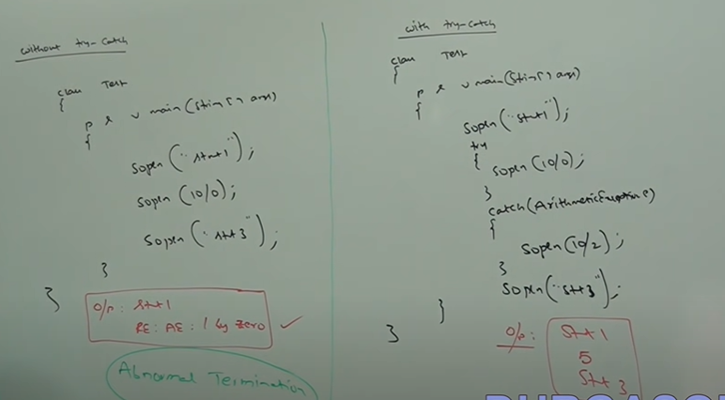

Case1: If there is no exception.

try{

stmt1;

stmt2;

stmt3;

}

catch(Exception e){

stmt4;

}

Stmtt5;

Stmt1,2,3,5, Normal Termination

Case2: exception at stmt2.

try{

stmt1;

stmt2;// exception occurs

stmt3;

}

catch(Exception e){

stmt4;

}

Stmtt5;

Stmt1,4,5, Abnormal Termination

Case 3: if exception rise at stmt2 and corresponding catch block not matched

Stmt 1, Abnormal termination

Case4: exception at stmt4 or stmt5 then it is abnormal termination.

Methods to print exception information:

Throwable class defines the following methods to print exception information.

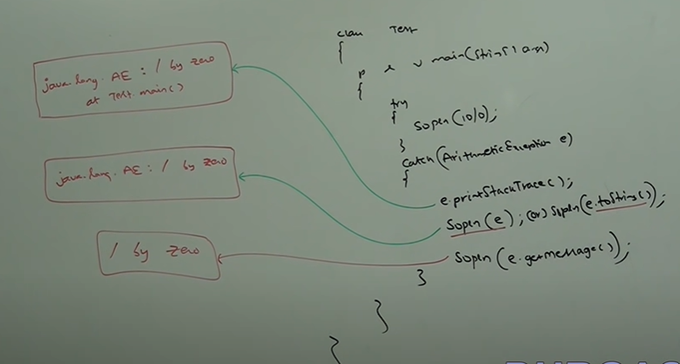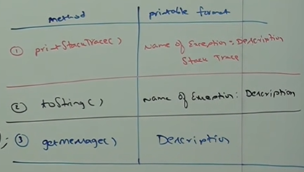

Note: Internally default exception handler will use printStackTrace() method to print exception information to the console.

try with multiple catch blocks:

The way of handling an exception is varied from exception to exception hence for every exception type it is highly recommended to take separate catch block i.e., try with multiple catch block is always possible and recommended to use.

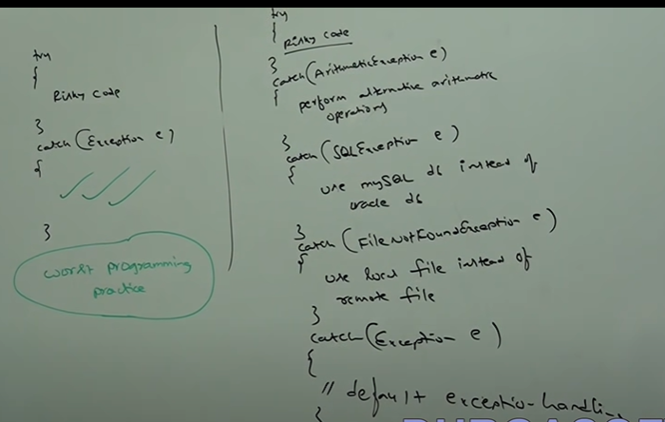

If try with multiple catch block present, then the order of catch block is very important we have to take child first then parent otherwise we will get compile time error Exception XXX has already been caught.

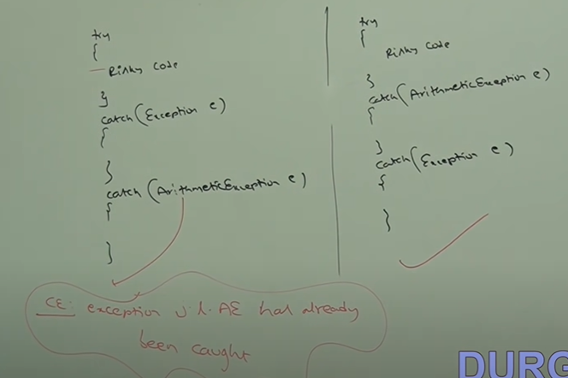

We can’t declare two catch blocks for the same exception otherwise we will get compile time error.

try{

Risky Code

}

catch(AE e){

}

catch(AE e){

}

CE : exception java.lang.AE has already been caught

VIDEO 74:

Final is a modifier applicable for classes, methods and variables. If a class declared as final, then we can’t extend that class i.e., we can’t create child class for that class (inheritance is not possible for final classes).

If a method is final, then we can’t override that method in the child class.

If a variable declared as final, then we can’t perform reassignment for that variable.

Finally:

Finally, is a block always associated with try catch to maintain clean code.

Ex:

try {

Risky code

}

catch (Exception e) {

Handling code

}

finally {

clean-up code

}

The speciality of finally block is it will be executed always irrespective of whether exception raised or not or whether exception is handled or not.

Finalize():

Finalize is a method always invoked by garbage collector just before destroying object to perform clean-up activities. Once finalize method completes immediately garbage collector destroys that object.

Note: Finally block is responsible to perform clean-up activities related to try block i.e. whatever resource we open at the part of try block will be closed inside finally block.

Whereas finalize method is responsible to perform clean-up activities related to object i.e., whatever resource associated with object will be deallocated before destroying object by using finalize method.

Various possible combination of try, catch, finally:

In try, catch, finally order is important.

Whenever we are writing try compulsory, we should write either catch or finally otherwise we will get compile time error i.e., try without catch or finally is invalid.

whenever we are writing catch block, compulsory try block must be required i.e., catch without try is invalid.

Whenever we are writing finally block, compulsory we should write try block i.e., finally without try is invalid.

Inside try, catch, and finally blocks we can declare try, catch, and finally blocks i.e., nesting of try, catch, finally is allowed.

For try, catch, and finally block curly braces are mandatory. 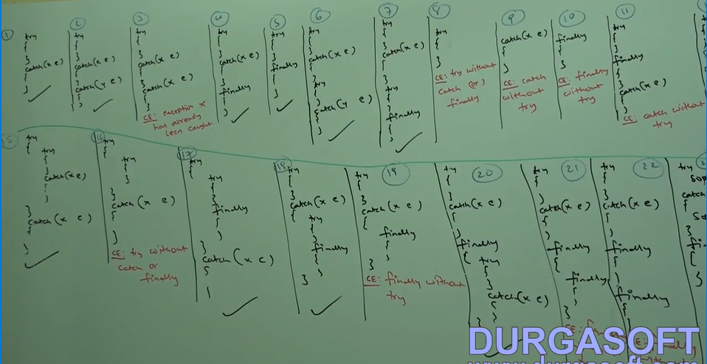

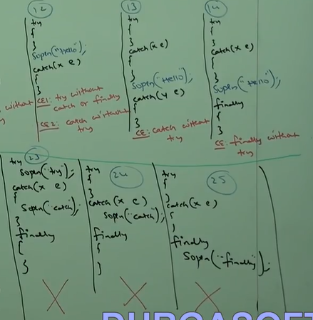

VIDEO 75:

throw keyword:   
Sometimes we can create exception object explicitly we can handover this exception object to the JVM manually for this we have to use throw keyword.

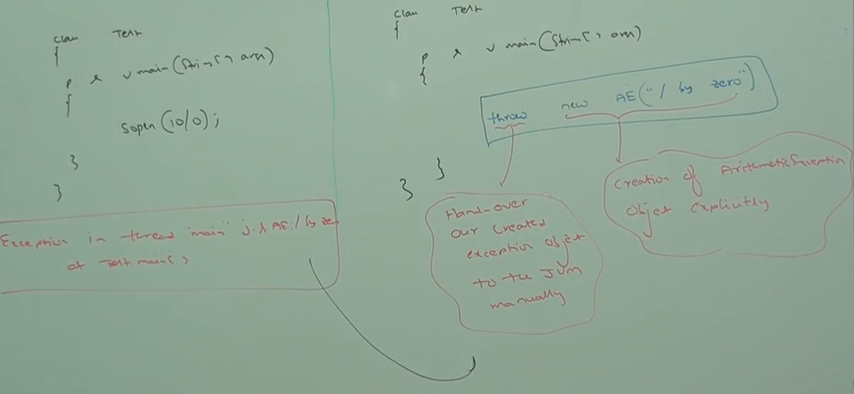

Hence, the main objective of throw keyword is to handover our created exception object to the JVM manually. And the result of the above two program is same.

In first program main method is responsible to create exception object and handover to the JVM. In the second program programmer is creating exception object explicitly and handover to the JVM manually.

Best use of throw keyword is for user defined exception and customized exception.

Case 1: throw e, if e refers to null then we will get NullPointerException

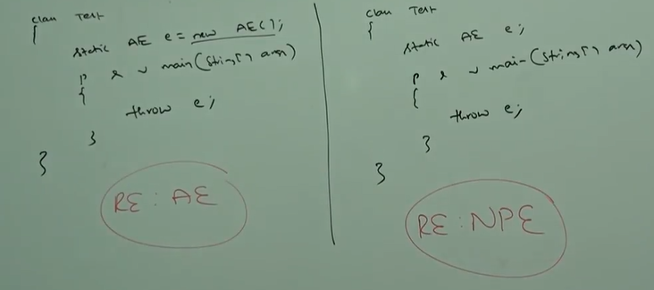

Case 2: after throw statement we are not allowed to write any statement directly otherwise we will get compile time error saying unreachable statement. 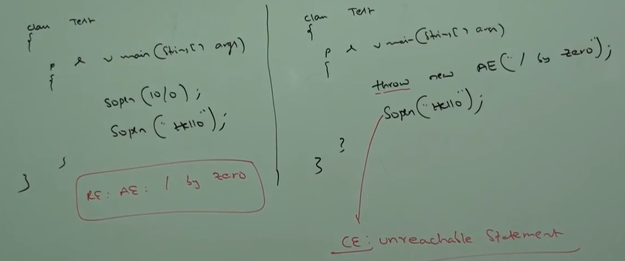

Case 3: we can use throw keyword only for throwable types if we are trying to use of normal java objects, then we will get compile time error saying incompatible types.

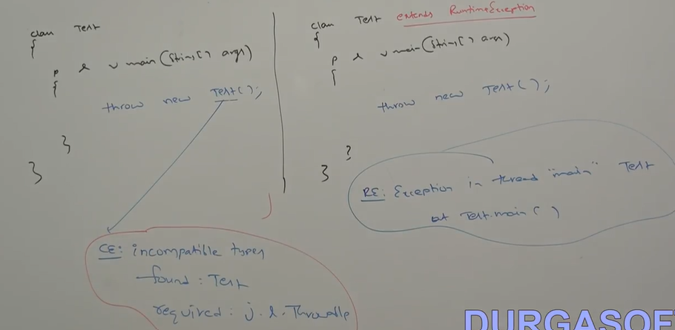

VIDEO 76:

throws:

In our program if there is possibility of rising checked exception then compulsory, we should handle that checked exception otherwise we will get compile time error saying unreported exception XXX; must be caught or declared to be thrown.

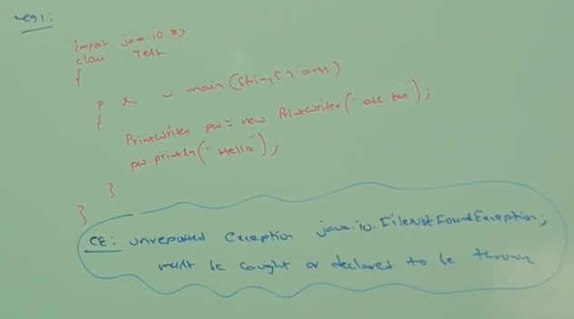

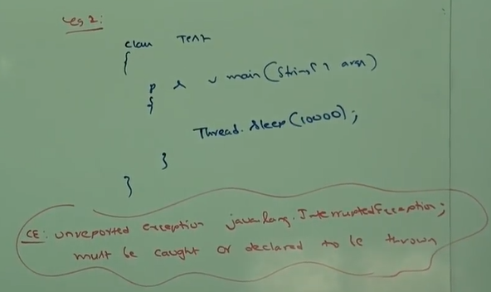

We can handle this compile time error by following two ways:

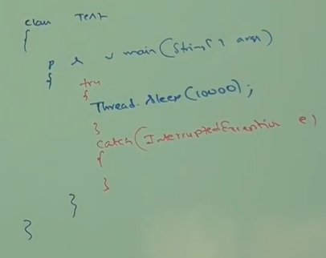1. By using try, catch.

2. By using throws: we can use throws keyword to delegate responsibility of exception handling to the caller (it may another method or JVM) then caller method is responsible to handle that exception.

Ex:

class Test {

psvm(String[] args) throws InterruptedException

{

Thread.sleep(10000);

}

}

Throws keyword required only for checked exception and usage of throws keyword for unchecked exception there is no use or any impact.

Throws keyword required only to convince compiler and usage of throws keyword doesn’t prevent abnormal termination of the program.

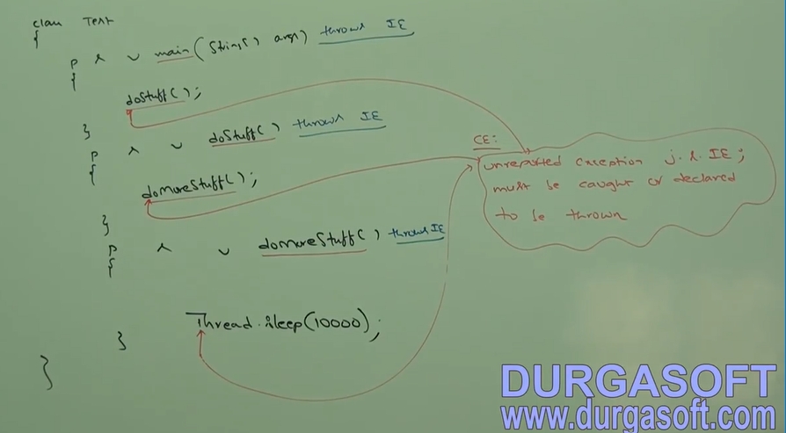

In the above program if we remove at least, one throws statement then code won’t compile.

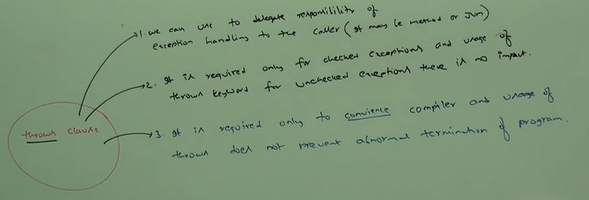

Case 1: we can use throws keyword for methods and constructors but not for classes.

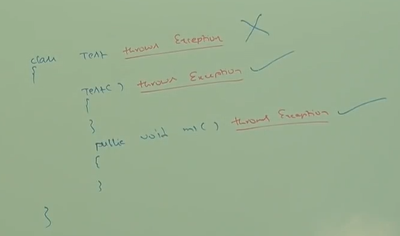

Case 2: we can use throws keyword only for throwable types if we are trying to use for normal java classes then we will get compile time error saying incompatible type.

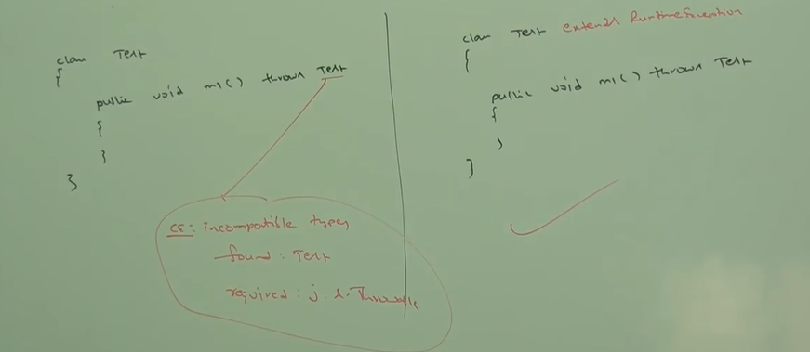

Case 3:

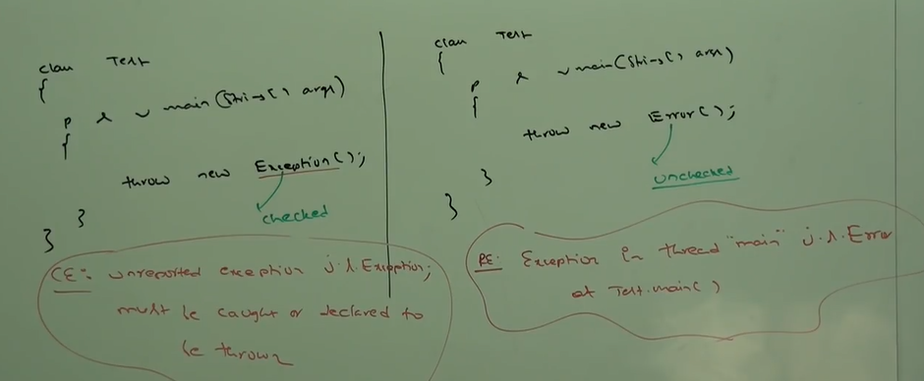

Within a try block if there is no chance of rising exception then we can’t write catch block for that exception otherwise we will get compile time error saying Exception XXX is never thrown in body of corresponding try statement. But this rule is applicable only for fully checked exceptions.

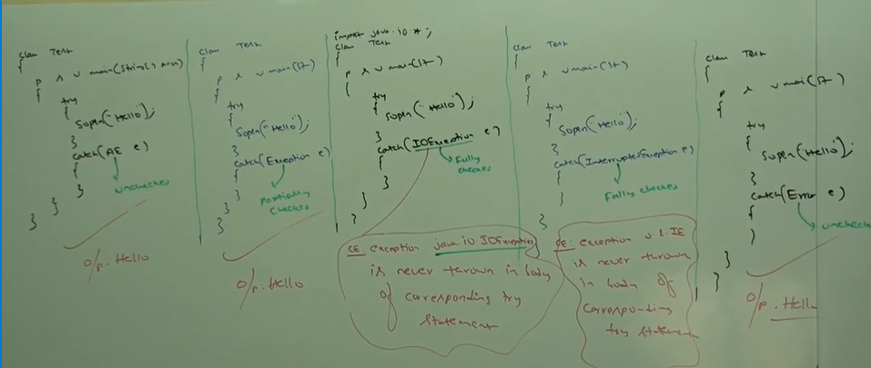

VIDEO 77:

Various possible compile time error in exception handling:

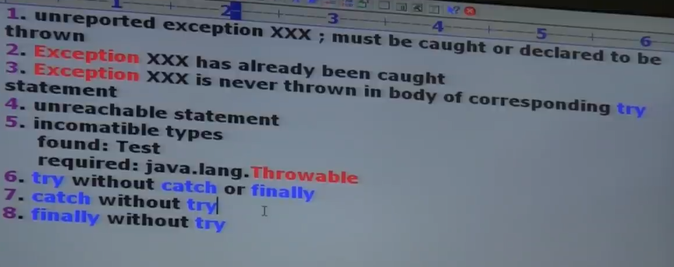

Customized or user defined exceptions:

Sometimes to meet programmer requirements we can define our own exceptions such type of exceptions is called customized or user defined exception.

Ex: TooYoungException, TooOldException

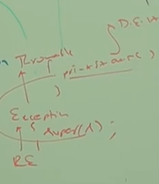class TooYoungException extends RuntimeExceptions{

TooYoungException(String s){

super(s);

}

}

class TooOldException extends RuntimeException{

TooOldException(String s){

super(s); //To make description available to default exception handler

}

}

Class CustException{

public static void main(String[] args){

int age = Integer.parseInt(args[0]);

if(age>60){

throw new TooYoungException(“please wait some more time”);

}

else if(age<18){

throw new TooOldException(“Your age is already crossed marriage age”);

}

else{

System.out.println(“You will get match details soon by email”);

}

}

}

Note1: throw keyword is best suitable for user defined or customized exceptions but not for predefined exceptions.

Note2: It is highly recommended to define customized exceptions as unchecked i.e. we have to extends RuntimeException but not Exception.

Video 78:

Top ten exceptions:

Based on the person who is rising an exception all exceptions are divided into two types:

1. JVM exceptions

2. Programmatic exceptions

JVM exceptions:

The exceptions which are raised automatically by JVM when a particular event occurs are called JVM exceptions.

Ex: ArithmeticException, NullPointerExceptions etc.

Programmatic exceptions:

The exceptions which are raised explicitly either by programmer or by API developer to indicate that something goes wrong are called programmatic exceptions.

Ex: TooOldException, IllegalArgumentException etc.

ArrayIndexOutOfBoundException : It is the child class of RuntimeException and hence it is unchecked. Raised automatically by JVM whenever we are trying to access array element with out of range index.

Ex:

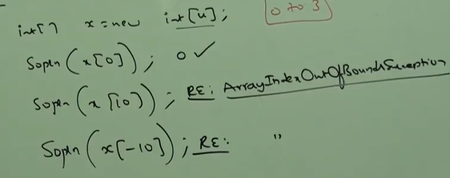

NullPointerException: It is the child class of RuntimeException and hence it is unchecked. Raised automatically by JVM whenever we are trying to perform any operation on null.

Ex:

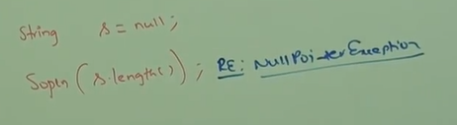

ClassCastException: It is the child class of RuntimeException and hence it is unchecked. Raised automatically by JVM whenever we are trying to typecast to parent object to child type.

Ex:

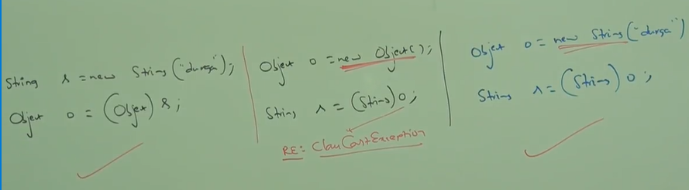

StackOverflowError: It is the child class of Error and hence it is unchecked. Raised automatically by JVM whenever we are trying to perform recursive method call.

Ex:

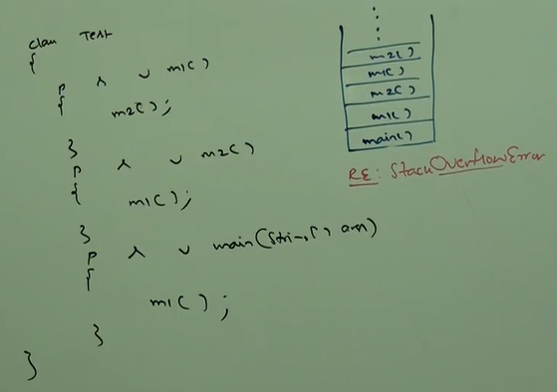

NoClassDefFoundError : It is the child class of Error and hence it is unchecked. Raised automatically by JVM whenever JVM unable to find required .class file .

Ex:

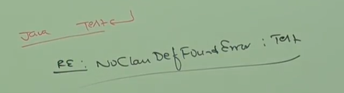

If Test.class file is not available, then we will get RuntimeException saying NoClassDefFoundError: Test

ExceptionInInitializerError: It is the child class of Error and hence it is unchecked. Raised automatically by JVM if any exception occurs while executing static variable assignment and static blocks.

Ex:

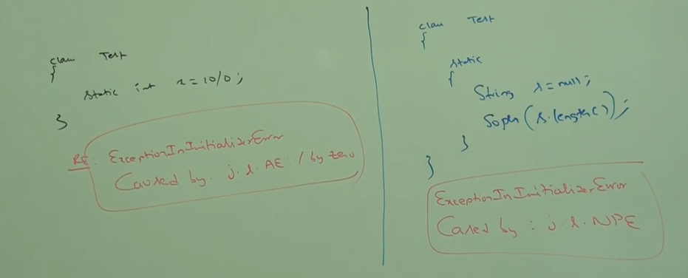

VIDEO 79:

IllegalArgumentException: it is the child class of Runtime exception and hence it is unchecked. Raised explicitly either by programmer or by API developer to indicate that a method has been invoked with illegal argument.

Ex: The valid range of thread priority is 1 to 10 if we are trying to set the priority with any other value then we will get runtime exception saying illegal argument exception.

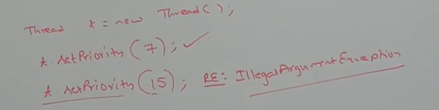

NumberFormatException: It is a direct child class of IllegalArgumentException which is the child class of Runtime exception and hence it is unchecked. Raised explicitly either by programmer or by API developer to indicate that we are trying to convert string to number and the string is not properly formatted.

Ex:

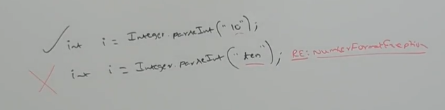

IllegalStateException: It is the child class of Runtime exception and hence it is unchecked. Raised explicitly either by programmer or by API developer to indicate that method has been invoked at wrong time.

After starting of thread, we are not allowed restart the same thread once again otherwise we will get runtime exception saying IllegalThreadStateException

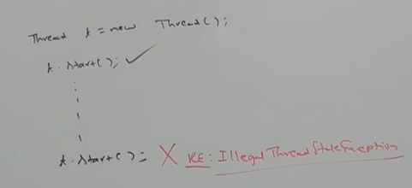

AssertionError: : It is the child class of Error and hence it is unchecked. Raised explicitly by the programmer or by API developer to indicate assert statement fails.

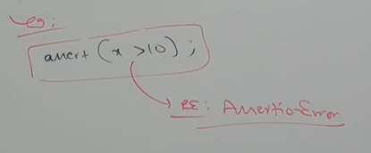

If x is not greater than 10 then we will get runtime exception saying AssertionError.

Summary:

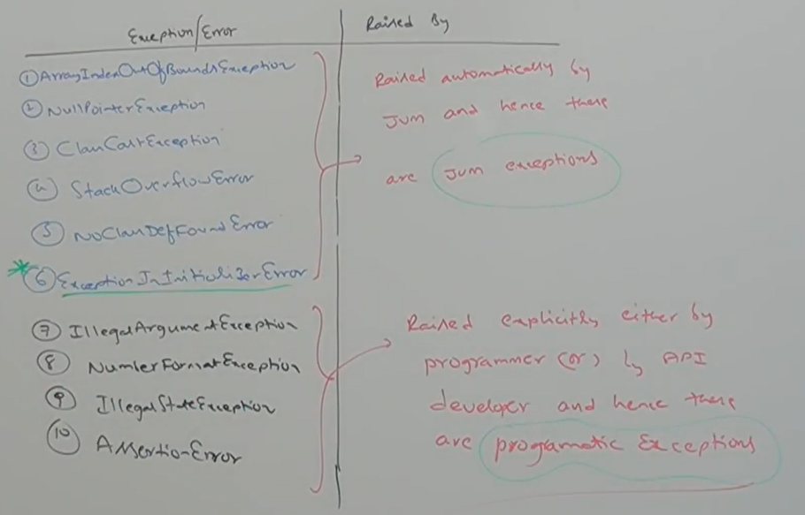

1.7 V enhancement w.r.t exception handling:  
As a part of 1.7 v in exception handling the following two concept introduces:  
1. try with Resources  
2. multi-catch block

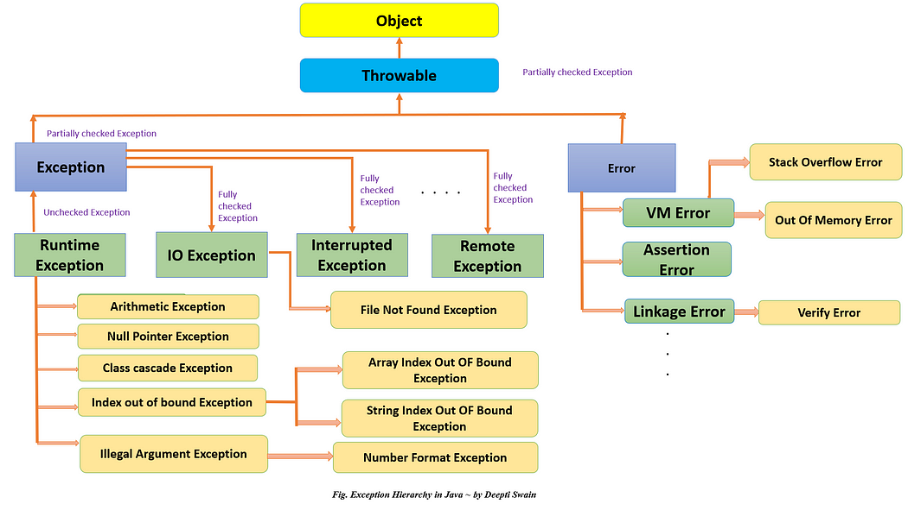

Try with Resources:

Until 1.6 V it is highly recommended to write to finally block to close resources which are open as a part of try block.

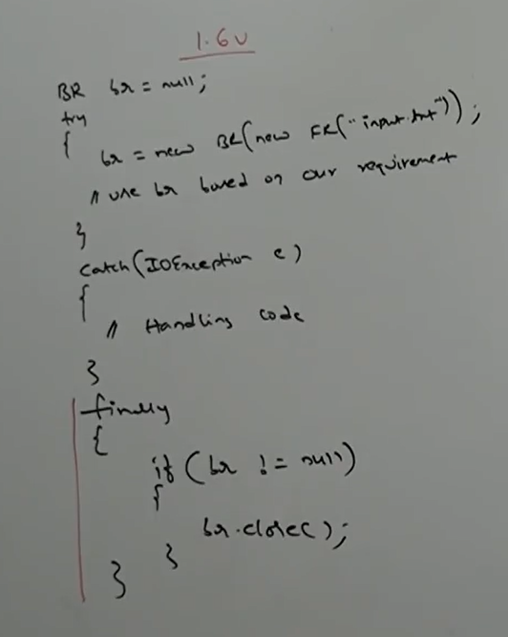

The problem in this approach compulsory the programmer should require to close the resources inside finally block. It increases complexity of programming.  
we have to write finally block compulsory and hence it increases the length of code and reduces the readability. To overcome these problems some people introduced try with resources in 1.7 V. The main advantage of try with resources is whatever resources we open as a part of try block will be closed automatically once the control reaches end of try block either normally or abnormally and hence, we are not required to close explicitly so that complexity of programming will be reduced.  
we are not required to write finally block so that length of the code will reduced and readability will be improved.

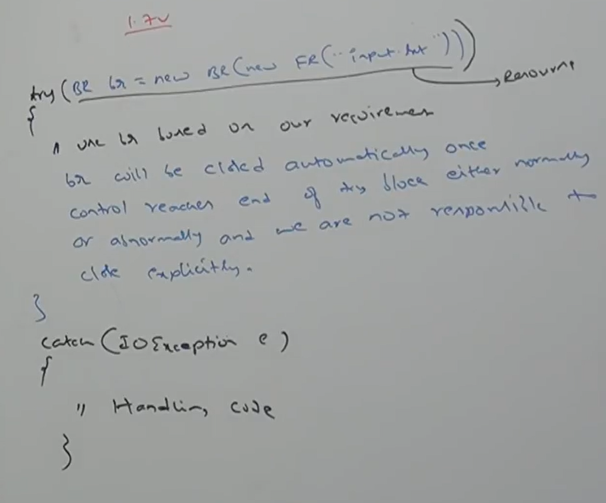

We can declare multiple resources, but these resources should be separated by semi colon.

Ex: try (R1 ; R2 ; R3){  
  
}

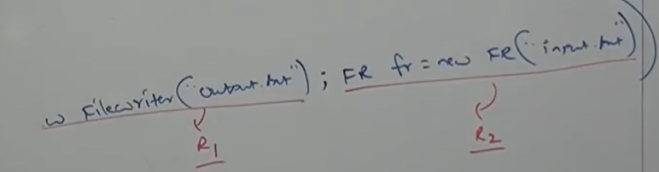

All resources should be auto closeable resource. The resources said to be auto closeable if and only if corresponding class implements java.lang.AutoCloseable interface.  
All IO related resources , database related resources and network related resource are already implemented auto closeable interface. Being a programmer we are not required to do anything just we should aware the point. AutoCloseable interface came in 1.7V and it contains only one method close (public void close() ).

All resource reference variable are implicitly final and hence within the try block we can’t perform reassignment otherwise we will get CE: auto-closeable resource br may not be assigned.

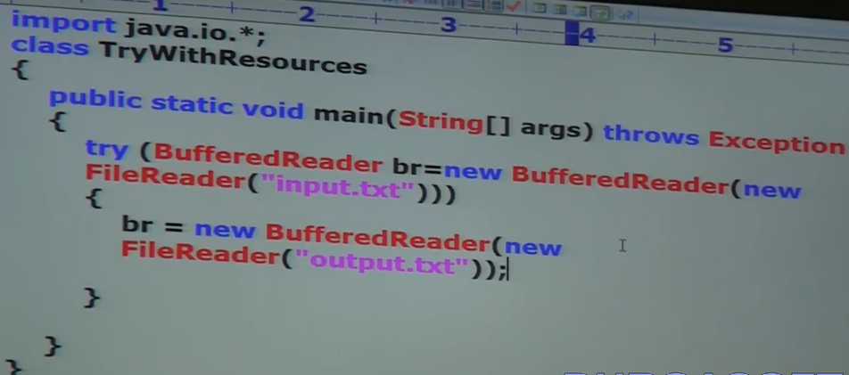

Until 1.6 V try should be associated with either catch or finally but from 1.7 V onwards, we can take inly try with resource without catch or finally.

Ex: try(R){

}

Multi-catch block:  
Until 1.6 V even though multiple different exceptions having same handling code for every exception type we have to write a separate catch block. It increases the length of code and reduces the readability.

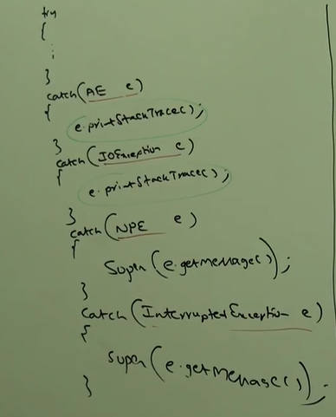

To overcome this problem some people introduced multi-catch block in 1.7 V. According to this we can write a single catch block that can handle multiple different types of exception.

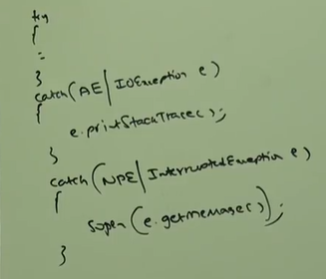

The main advantage of this approach length of the code is reduced and readability will be improved.

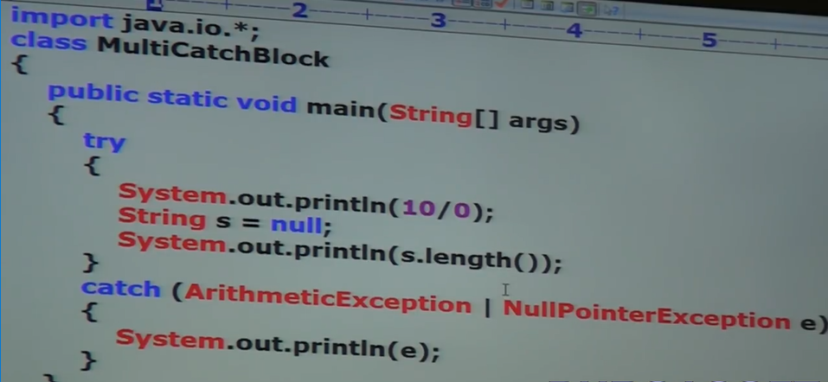

In the above example whether raised exception is either arithmetic exception or null pointer exception same catch will be listened.

In multi-catch block there should not be any relationship exception types (either parent to child or vice versa or same type) otherwise we will get CE: alternatives in a multi-catch statement cannot be related by subclassing.

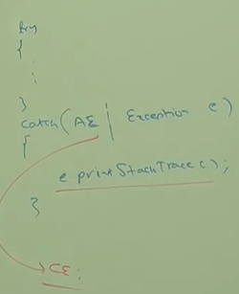

Exception propagation:

Inside a method if an exception is raised and if we are not handling that exception then exception object will be propagated to called then caller method is responsible to handle exception. This process is called exception propagation.

Rethrowing exception:

We can use this approach to convert one exception to another exception type.

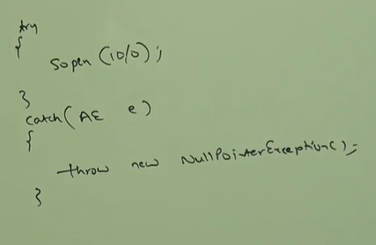

VIDEO 81:

**Multithreading**:

Multitasking:

Executing several tasks simultaneously is a concept of multitasking. There are two types of multitasking:

1. Process based multitasking

2. Thread based multitasking

Process based multitasking:

Executing several tasks simultaneously where each task is a separate independent program(process) is called process-based multitasking.

Ex:

While typing a Java program in the editor we can listen audio song from same system at the same time we can download the file from internet, all these tasks will be executed simultaneously and independent of each other hence it is process based multitasking. Process based multitasking is best suitable at OS level.

Thread based multitasking:

Executing several tasks simultaneously where each task is a separate independent part of the same program is called thread-based multitasking. And each independent part is called the thread. Thread based multitasking is best suitable at programmatic level.

Whether it is process based or thread based, the main objective of multitasking is to reduce response time of the system and to improve performance.

The main application area of multithreading to develop multimedia graphics, to develop animations, to develop video games, to develop web server and application servers etc.

VIDEO 82:

Defining a thread:

We can define a thread is the following two ways:

1. By extending the thread class

2. By implementing Runnable interface

By extending the thread class:

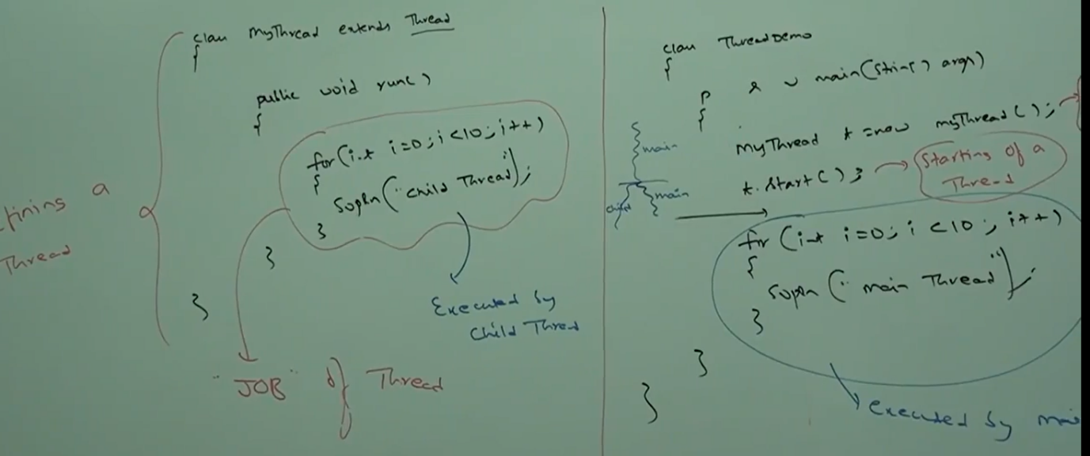

Case1:

Thread Scheduler:

It is part of JVM. It is responsible to schedule threads i.e., if multiple threads are waiting to get the chance of execution, then in which order threads will be executed is decided by thread schedular. We can’t expect exact algorithm followed by thread schedular. It is varied from JVM to JVM hence we can’t expect thread execution order and exact output. Hence whenever situation comes to multithreading there is no guarantee for exact output, but we can provide several possible output.

Case2:

**Difference between t.start() and t.run() :**

In the case of t.start() a new thread will be created which is responsible for the execution of run method, but in the case t.run() a new thead won’t be created and run method will be executed just like a normal method call by main thread. Hence in the above program if we replace t.start() with t.run() then output is :

Child Thread  
Child Thread  
.  
.  
.  
Main Thread  
Main Thread  
.  
.  
.

This total output is produced by main thread.

Case3:

Importance of thread class start method:

Thread class start method is responsible to register a thread with thread scheduler and all other mandatory activities hence without executing thread class start method there is no chance of starting a new thread in JAVA due to this thread class start method is considered as heart of multithreading.

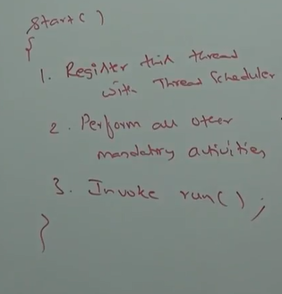

Case4: Overloading of run method:

Overloading of run method is always possible but thread class start method can invoke no argument run method, the other overloaded method we have to call explicitly like a normal method call.

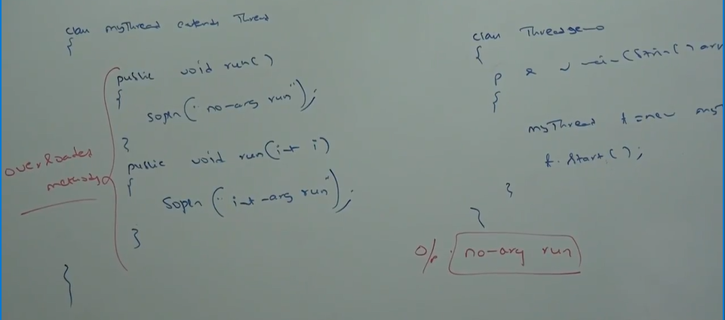

Case5: If we are not overriding run method:

If we are not overriding run method then thread class run method will be executed which has empty implementation hence we won’t get any output.

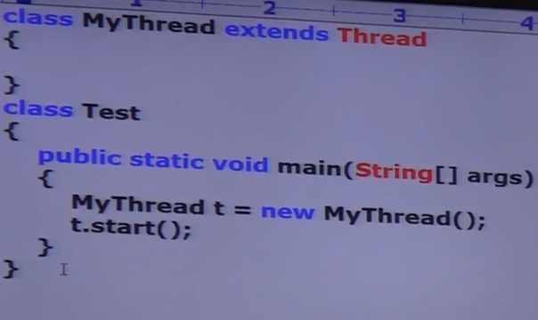

Note: It is highly recommended to overwrite run method otherwise don’t go for multithreading concept.

Case6: Overriding of start method:

If we override start method, then our start method will be executed just like a normal method call and new thread won’t be created.

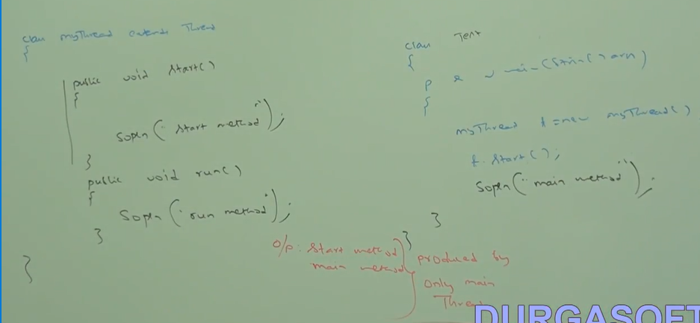

Note: it is not recommended to override start method otherwise don’t go for multithreading concept.

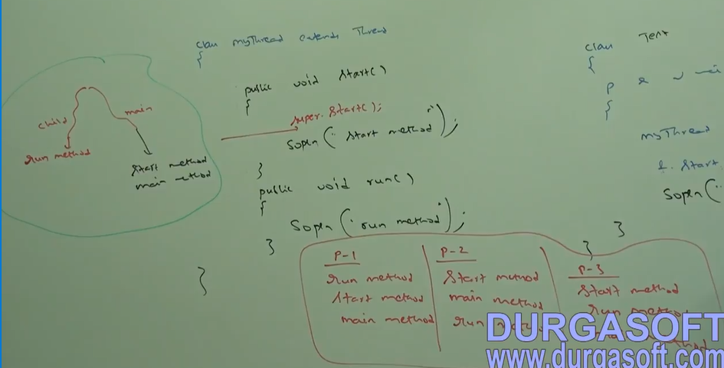

Case8: Thread life cycle:

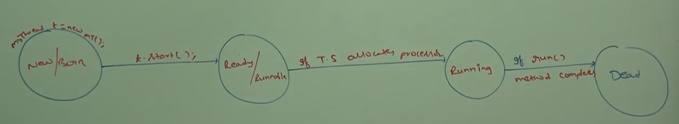

Case9: After starting a thread if we are trying to restart the same thread then we will get runtime exception saying IllegalThreadStateException.

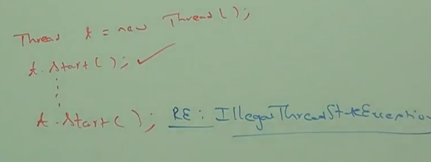

VIDEO 83:

Defining a thread by implementing Runnable Interface:

We can define a thread by implementing runnable interface.

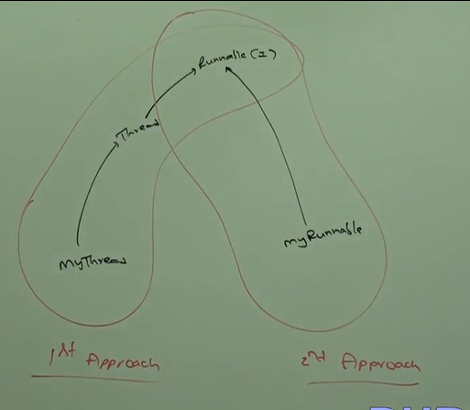

Runnable interface present in java.lang package and it contains only one method run() method.

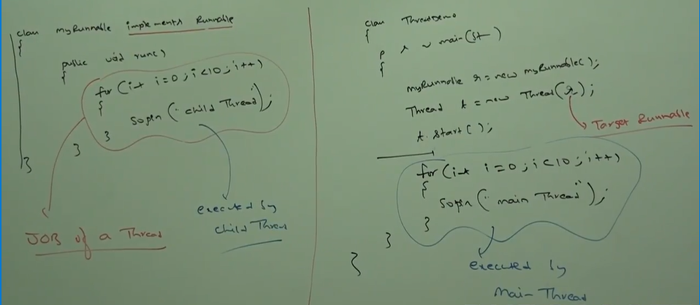

We will get mixed output and we can’t tell exact output.

Case study:

myRunnable r = new myRunnable();

Thread t1= new Thread();

Thread t2= new Thread(r);

Case1: t1.start();

A new thread will be created which is responsible for the execution of thread class run() method which has empty implementation.

Case2: t1.run();

No new thread will be created and thread class run method will be executed just like a normal method call.

Case3: t2.start();

A new thread will be created which is responsible for the execution of myRunnable class run() method.

Case4: t2.run();

A new thread won’t be created and myRunnbale will be executed just like a normal method call.

Case5: r.start();

We will get CE saying myRunnable class doesn’t have start capability. CE: cannot find symbol symbol method start() location class myRunnable.

Case6: r.run();

No new thread will be created and myRunnable run() method will be executed like normal method call.

**Which approach is best to define a thread?**

Among two ways of defining a thread implements runnable approach is recommended.  
In the first approach our class always extends Thread class, there is no chance of extending other class hence we are missing inheritance benefits.   
But in the second approach while implementing runnable interface we can extend any other class hence we won’t miss any inheritance benefits. Because of above reason implementing runnable interface approach is recommended then extending Thread class.

**Thread class constructors:**

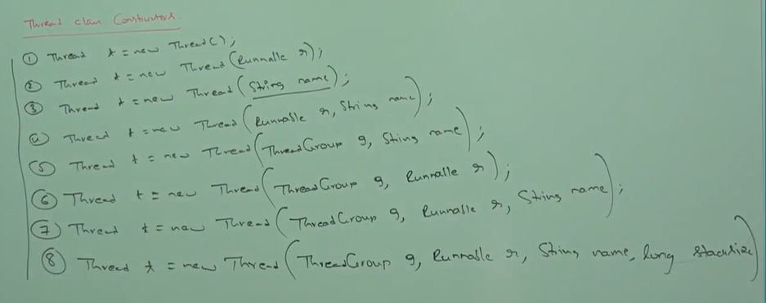

Getting and setting name of a thread:

Every thread in java has some name it may be default name generated by JVM or customized name provided by programmer. We can get and set name of thread by using following the two methods of thread class:

public final String getName()  
public final void setName(String name)

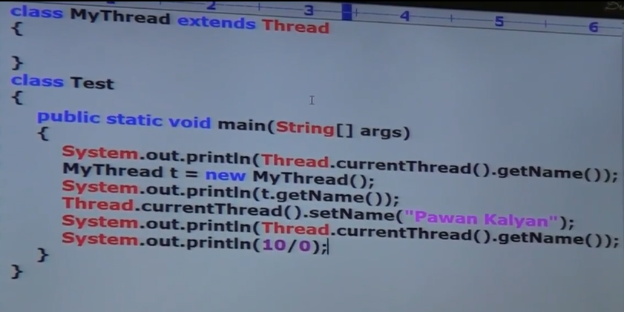

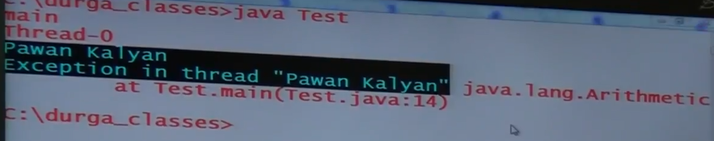

Note: we can get current executing thread object by using Thread.currentThread().getName()

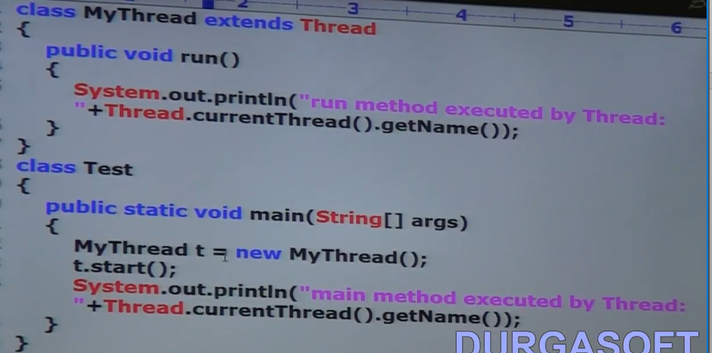

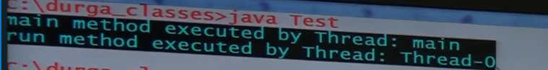

VIDEO 84:

**Thread priorities:**Every thread in java has some priority, it may be default priority generated by JVM or customized priority provided by programmer. The valid range of thread priorities is 1 to 10 where 1 is MIN_PRIORITY and 10 is MAX_PRIORITY. Thread class defines the following constants to represent some standard priorities:

Thread.MIN_PRIORITY --------------🡪 1

Thread.NORM_PRIORITY ------------🡪5

Thread.MAX_PRIORITY ---------------🡪10

Thread scheduler will use priorities while allocating processors. The thread which is having highest priorities will get a chance first. If two thread having same priorities then we can’t expect exact execution order, it depends on thread schedular.

Thread class defines the following methods to get and set priority of a thread.

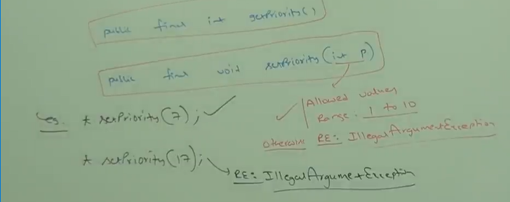

Default priority:  
The default priority only for main thread is 5 but for all remaining thread default priority will be inherited from parent to child i.e., whatever parent thread has the same priority will be there for the child thread.

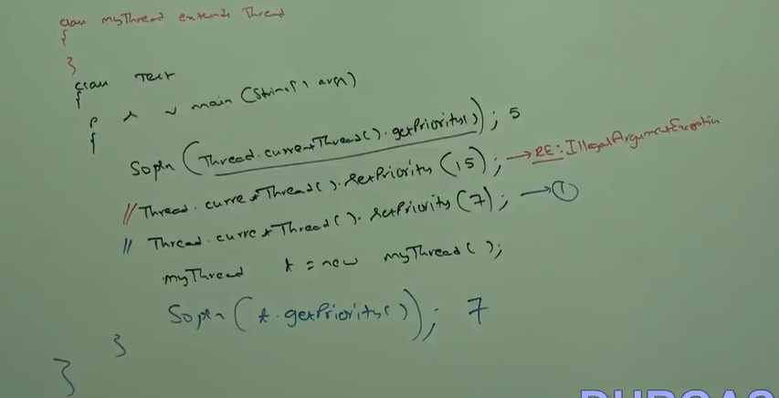

If we comment line 1 then child thread priority will become 5.

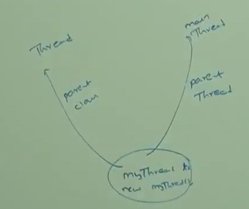

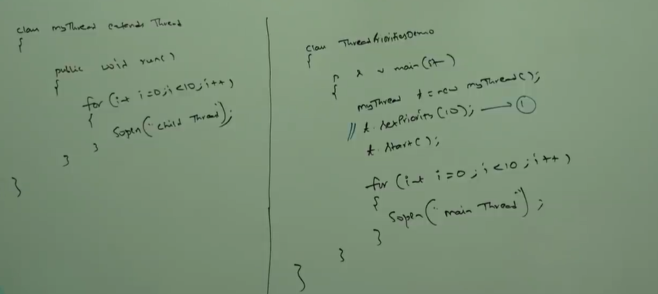

If we are commenting line 1 then both main and child thread have the same priority 5 and hence, we can’t expect execution order and exact output. If we are not commenting line 1 then main thread has a priority 5 and child priority has a priority 10 hence child thread will get the chance first followed by main thread.   
child Thread  
child Thread  
.  
.  
.  
main thread  
main thread  
.  
.  
.

Note: some platform won’t provide proper support for thread priorities.

VIDEO 85:

We can prevent a thread execution by using the following methods:  
1. yield()

2. join()

3. sleep()

**Yield method** causes to pause current executing thread to give the chance for waiting thread of same priority. If there is no waiting thread or all waiting threads have low priority, then same thread can continue its execution. If multiple threads are waiting with same priority, then which waiting thread will get the chance we can’t expect it depends on thread schedular.  
The thread which is yielded when it will get the chance once again it depends on thread schedular and we can’t expect exactly.

public static native void yield();

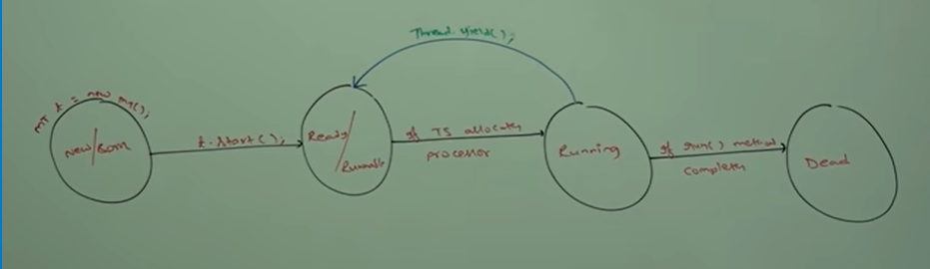

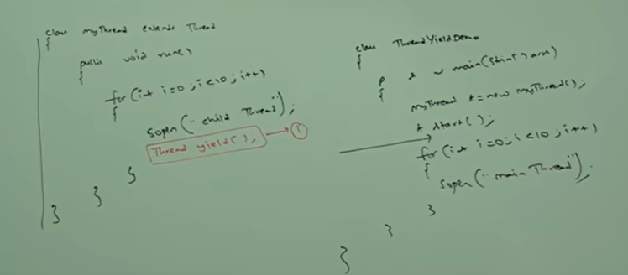

If we are commenting line 1 then both threads will be executed simultaneously and we can’t expect which thread will complete first. If we are not commenting line 1 the child thread always calls yield method because of that main thread will get a chance more number of times and the chance of completing main thread is high.

Note: some platform won’t provide support for yield method.

**Join method:**

If a thread wants to wait until completing some other thread then we should go for join method.  
for ex: if a thread t1 wants to wait until completing t2 then t1 has to call t2.join() , if t1 executes t2.join() then immediately t1 will be entered into waiting state until t2 completes. Once t2 completes then t1 can continue its execution.

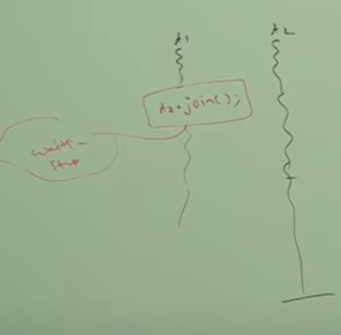

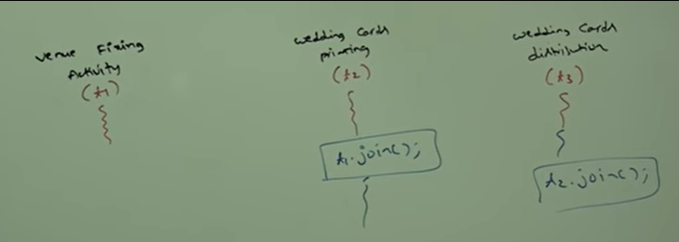

Wedding cards printing thread(t2) has to wait until venue fixing thread(t1) completion hence t2 has to call t1.join(), wedding cards distribution thread(t3) has to wait until wedding cards printing thread(t2) completion hence t3 has to call t2.join().

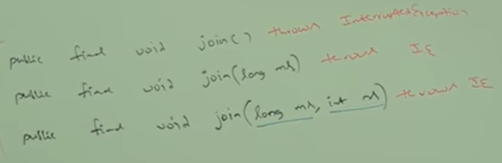

Note: every join method throws InterruptedException which is checked exception hence compulsory we should handle this exception either by using try catch or by throws keyword otherwise we will get CE.

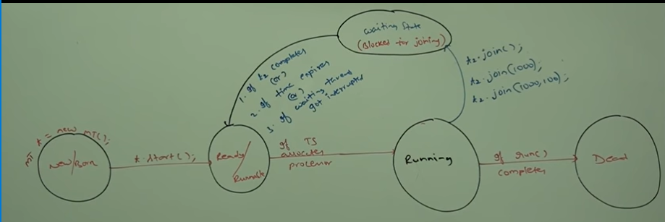

Case1: main Thread has to wait until completion of child thread.

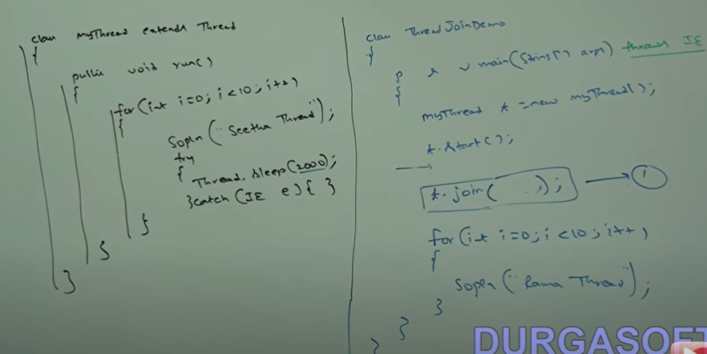

If we comment line 1 then both main and child class will be executed simultaneously, and we can’t expect exact output.  
If we are not commenting line 1 then main thread calls join method on child thread object hence main thread will wait until completing child thread. In this case output is:

Seetha Thread  
Seetha Thread  
.  
.  
.  
Rama Thread  
Rama Thread  
.  
.  
.

|  |  |  |  |
| --- | --- | --- | --- |
| property | yield() | join() | sleep() |
| 1. purpose | If a thread wants to paused its execution to give the chance for remaining thread of same priority then we should go for yield() method. | If a thread wants to wait until completing some other threads then we should go for join method. | If a thread don’t want to perform any operation for a particular amount of time then we should go for sleep method. |
| 2. is it overloaded | no | yes | yes |
| 3. is it final? | no | yes | no |
| 4. is it throws IE? | no | yes | Yes |
| 5. it is native? | yes | no | sleep(long ms) 🡪native  sleep(long ms,int ns) 🡪 non native |
| 6. is it static? | yes | no | yes |

VIDEO 87:

Synchronization:  
synchronized is a modifier applicable only methods and blocks but not for classes and variables.  
If multiple threads are trying to operate simultaneously on the same java object, then there may be chance of data inconsistency problem, to overcome this problem we should go for synchronized keyword. If a method or block declared as synchronized then at a time only one thread is allowed to execute that method or block on the given object so that data inconsistency problem will be resolved,  
The main advantage of synchronized keyword is we can resolve data inconsistency problems but the main disadvantage of synchronized keyword is it increases waiting times of thread and creates performance problems hence if there is no specific requirement then it is not recommended to use synchronized keyword.

Internally synchronization concept is applicable using lock. Every object in java has a unique lock. Whenever we are using synchronization keyword then only lock concept will come into the picture.  
If a thread wants to execute synchronized method on the given object first it has to get lock of that object once thread got the lock it is allowed to execute any synchronized method on that object. Once method execution completes automatically thread releases the lock. Acquiring and releasing lock internally takes care by JVM and programmer is not responsible for this activity.

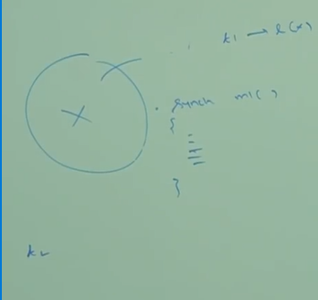

While a thread executing synchronized method on the given object. The remaining threads are not allowed to execute any synchronized method simultaneously on the same object, but remaining threads are allowed to execute non-synchronized methods simultaneously.

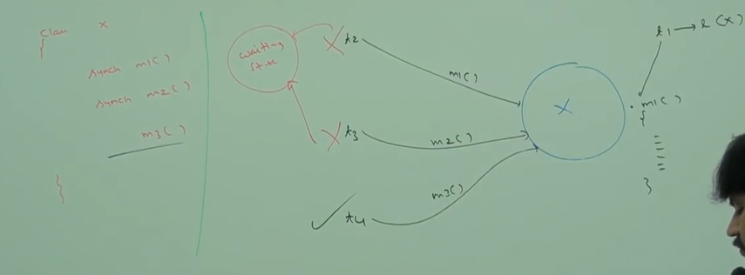

Lock concept is implemented based on object but not based on method.

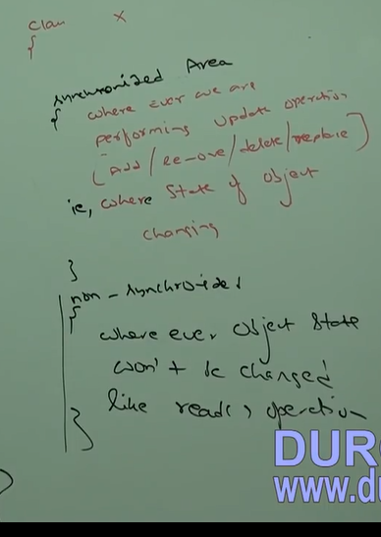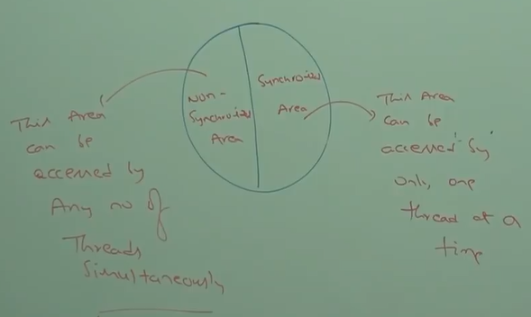

Ex:

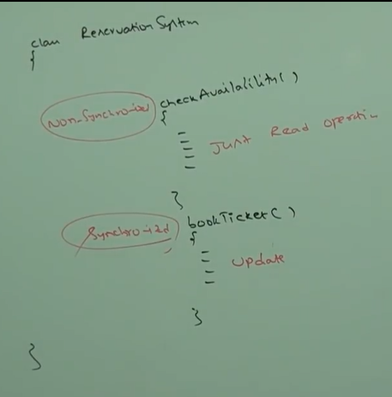

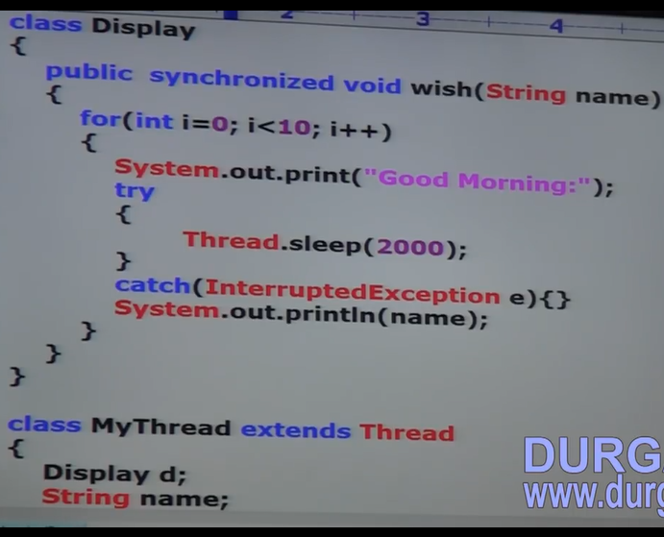

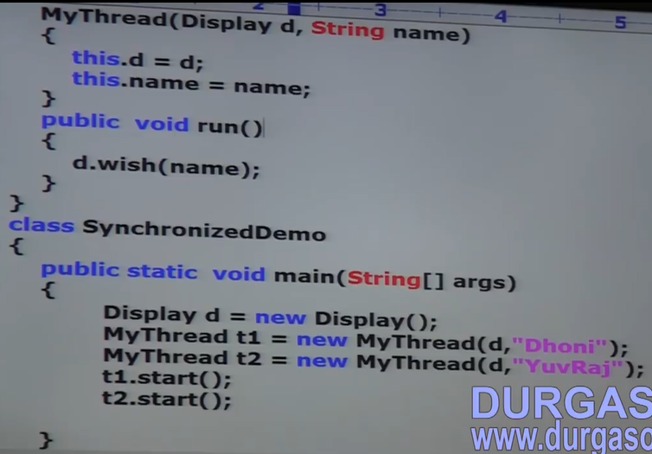



If we are not declaring wish method as synchronized, then both threads will be executed simultaneously hence we will get irregular output.

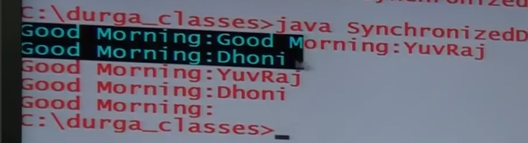

If we declare wish method as synchronized, then at a time only one thread is allowed to execute wish method on the given display object hence we will get regular output.

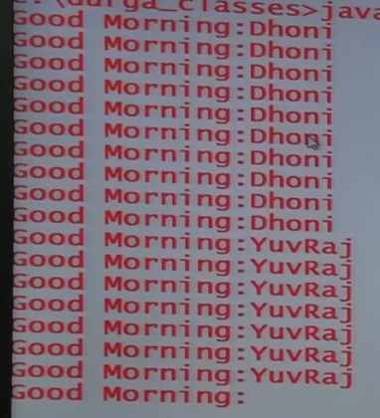

VIDEO 88:

Case study:

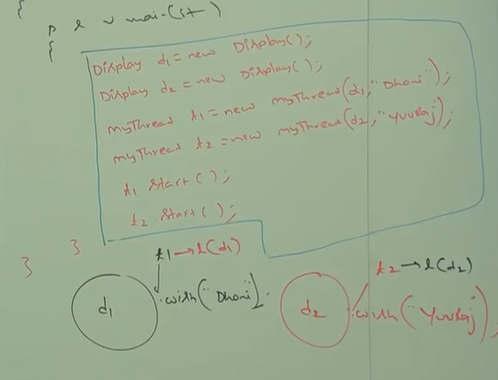

Even though wish method is synchronized we will get irregular output because threads are operating on different java objects.

Conclusion:  
If multiple threads are operating on same java object, then synchronization is required. If multiple threads are operating on multiple java objects, then synchronization is not required.

Class level lock:  
Every class in java has unique lock which is also known as class level lock. If a thread wants to execute a static synchronized method, then thread required class level lock, once thread got class level lock then it is allowed to execute any static synchronized of that class. Once method execution completes automatically thread releases the lock.

While a thread executing static synchronized method the remaining threads are not allowed to execute any static synchronized method of that class simultaneously, but remaining threads are allowed to execute the following methods simultaneously:  
normal static method, synchronized instance method, normal instance method.

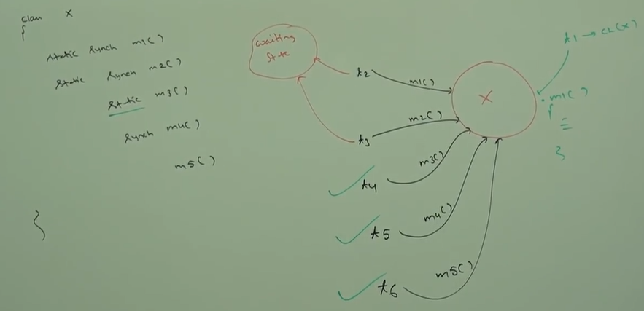

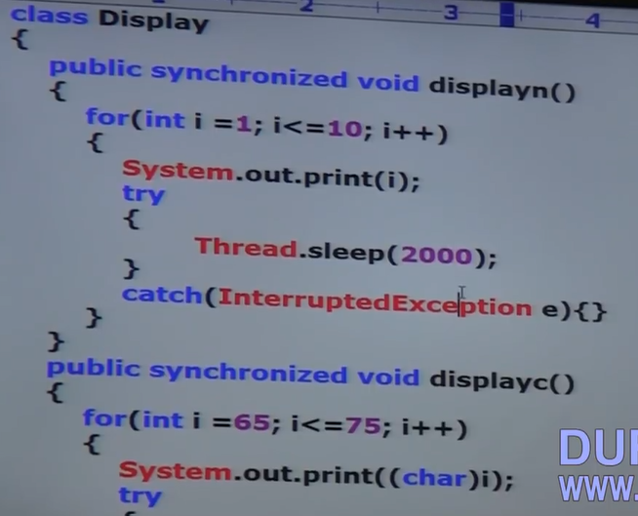

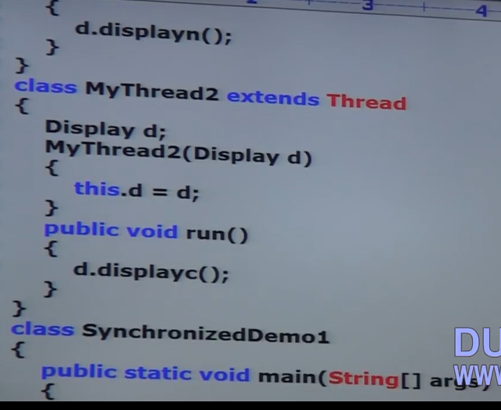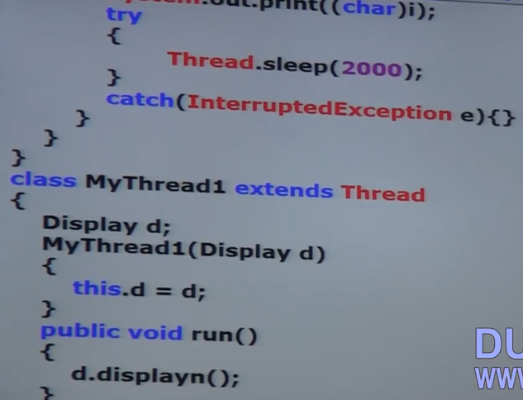



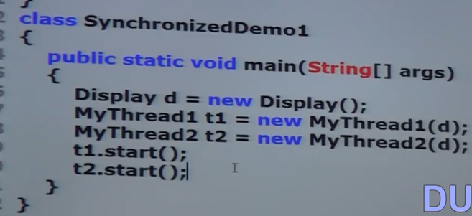

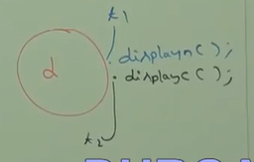

VIDEO 89:

**Synchronized Block:**  
If very few lines of the code required synchronization, then it is not recommended to declare whole method as synchronized, we have to enclose those few lines of the code by using synchronized block. The main advantage of synchronized block is over synchronized method is it reduces waiting time of thread and improves performance of the system.

we can declare synchronized block as follows:  
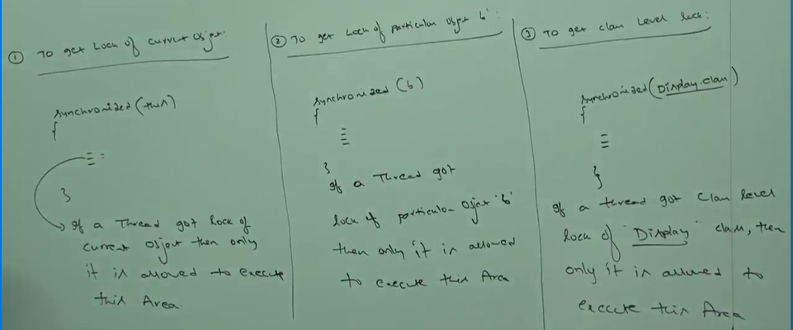

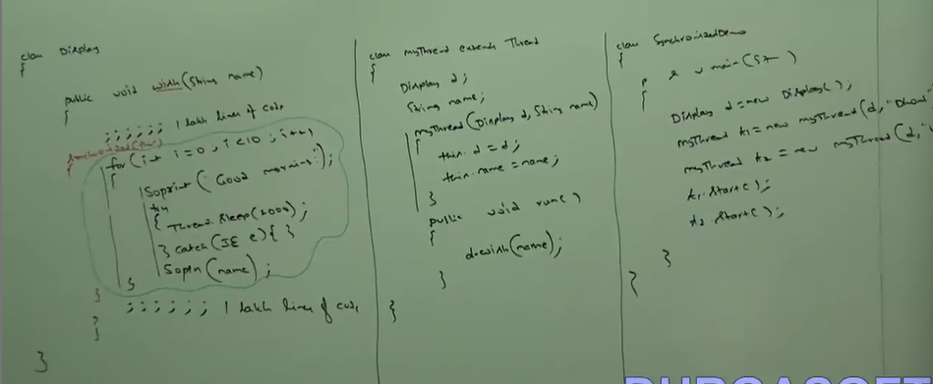

Lock concept applicable for object type and class type but not for primitive hence we can’t pass primitive type as argument to synchronized block otherwise we will get CE.

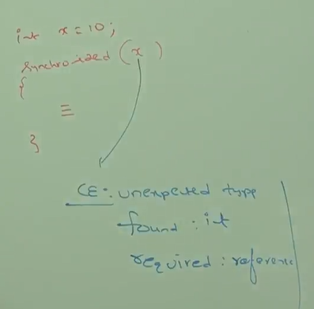

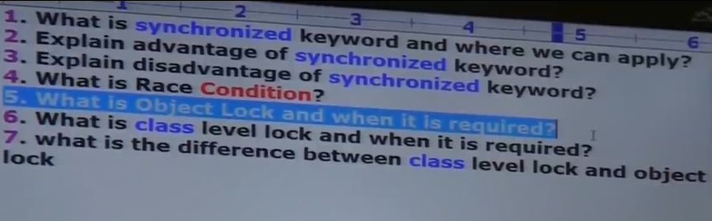

4. If multiple threads are operating simultaneously on same java object, then there may be chance data inconsistency problem this is called race condition. We can overcome this problem by using synchronized keyword.

VIDEO 92:

Deadlock:  
If two threads are waiting for each other forever such type of infinite waiting is called deadlock.  
Synchronized keyword is the only reason for deadlock situation hence while using synchronized keyword we have to take special care. There is no resolution technique for deadlock, but several prevention techniques are available.

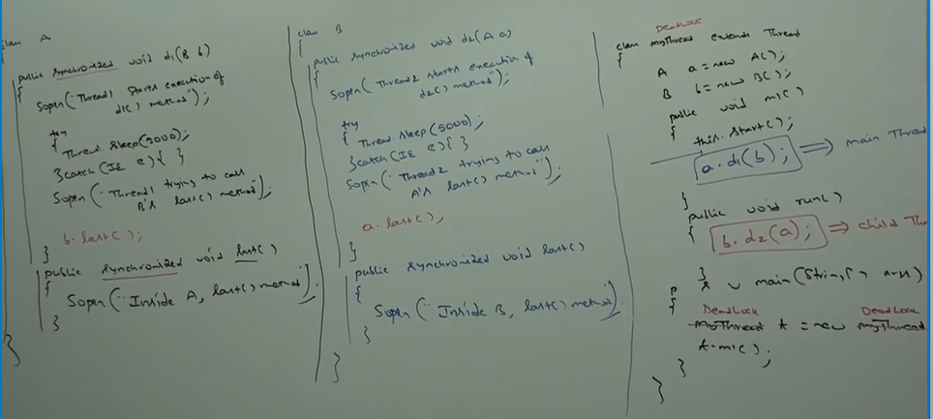

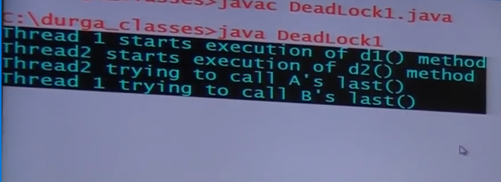

In the above program if we remove atleast one synchronized keyword then the program won’t entered into deadlock hence synchronized keyword is the only reason for deadlock situation due to this while using synchronized, we have to take special care.

Deadlock vs Starvation:  
Long waiting of a thread where waiting never ends is called deadlock whereas long waiting of a thread where waiting ends at certain point is called starvation for example low priority thread has to wait until completing all high priority threads it may be long waiting but ends at certain point, which is starvation.

VIDEO 93:

**Daemon Threads:**  
The threads which are executing in the background are called Daemon Threads.  
Ex: Garbage collector, signal dispatcher, attach listener.

The main objective of daemon Threads is to provide support for non-daemon threads (main thread).  
for ex: if main thread runs with low memory, then JVM runs Garbage collector to destroy useless objects so that number of bytes of free memory will be improved. With this free memory main thread can continue its execution.  
Usually daemon threads having low priority but based on our requirements daemon threads can run with high priority also.

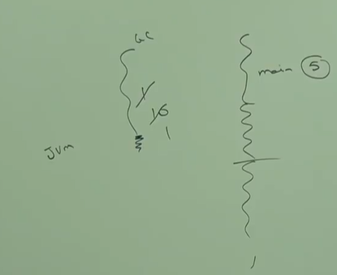

We can check daemon nature of thread by using isDaemon() method of thread class:  
public Boolean isDaemon()

We can change Daemon nature of thread by using setDaemon() method:  
public void setDaemon(boolean b)

But changing daemon nature is possible before starting of a thread only, after starting a thread if we are trying to change daemon nature then we will get Runtime exception saying IllegalThreadException.

By default, main thread is always non-daemon and for all remaining threads daemon nature will be inherited from parent to child i.e., if a parent thread is daemon, then automatically child thread is also daemon and if a parent thread is non-daemon, then automatically child thread is also non-daemon.

Note: It is impossible to change daemon nature of main thread because it is already started by JVM at beginning.

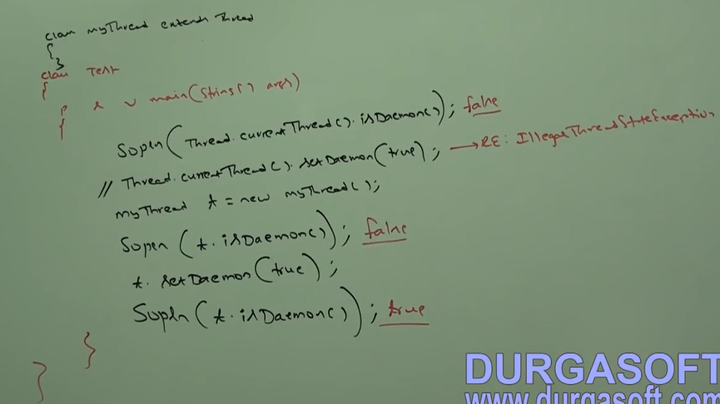

Whenever last non-daemon thread terminates, automatically all daemon threads will be terminated irrespective of their positions.

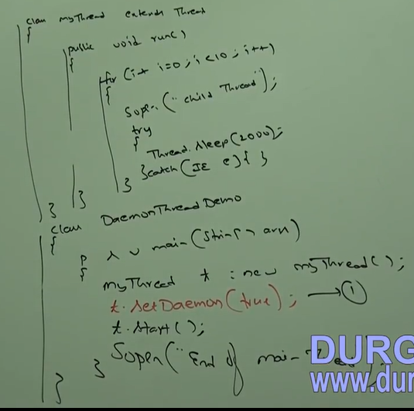

If we are commenting line 1 both main and child thread are non-daemon and hence both thread will be executed until their completion. If we are not commenting line 1 then main thread is non-daemon and child thread is daemon and hence whenever main thread terminates, automatically child thread will be terminated.

In this case output is:

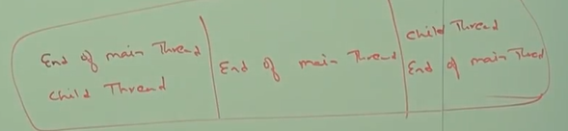

VIDEO 94:

Java multithreading concept is implemented by using the following two models:

1. Green Thread model  
2. Native OS model

Green Thread Model:  
The thread which is managed completed by JVM without taking underlying OS support is called Green Thread.  
Very few OS like SUN Solaris provide support for green thread model. Anyway, green thread model is deprecated and not recommended to use.

Native OS Model:  
The thread which is managed by JVM with the help of underlying OS is called native OS model. All windows-based OS provide support for native OS model.

We can stop a thread execution by using stop method of thread class:  
public void stop()  
If we call stop method then immediately the thread will enter into dead state. Anyway, stop is deprecated and not recommended to use.

How to suspend and resume of a thread?  
We can suspend a thread by using suspend method of thread class then immediately thread will enter into suspended state. We can resume a suspended thread by using resume method of thread class then suspended thread can continue its execution.  
public void suspend()  
public void resume()

Anyway, these methods are deprecated and not recommended to use.

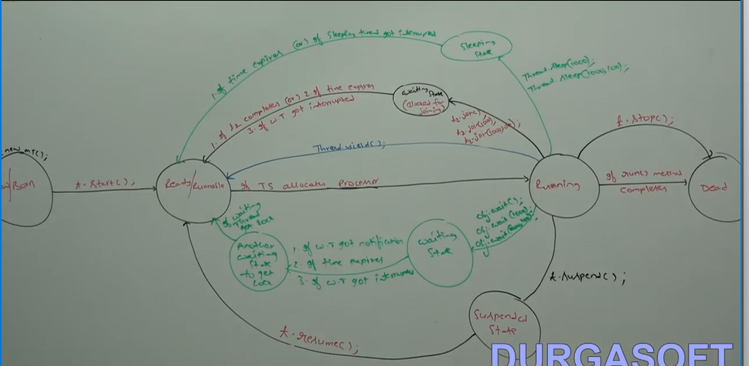

VIDEO 105:

For writing any java program whether it is simple or complex, the most commonly required classes and interfaces are grouped into a separate package which is java.lang package .  
we are not required to import java.lang package explicitly because all classes and interfaces present in lang package by default available to every java program.

java.lang.object:  
The most commonly required methods for every java class (whether it is predefined class or customized class) are defined in a separate class which is Object class. Every class in Java is the child class of object either directly or indirectly so that object class method by default available to every java class. Hence Object class is considered as root of all java classes.

Note: If our class doesn’t extend any other class then only our class is the direct child class of object.

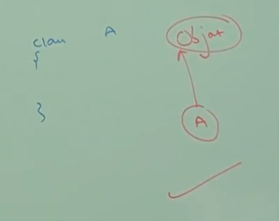

If our class extends any other class then our class is indirect child class of object.

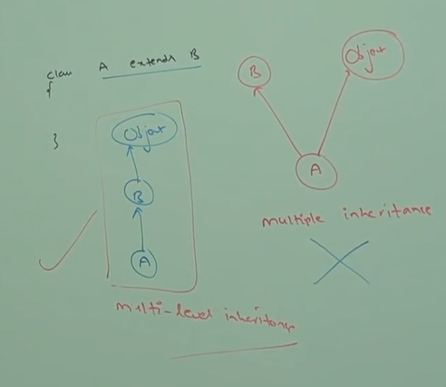

Conclusion: Either directly or indirectly java won’t provide support for multiple inheritance w.r.t classes.

Object class defines the following 11 methods:  
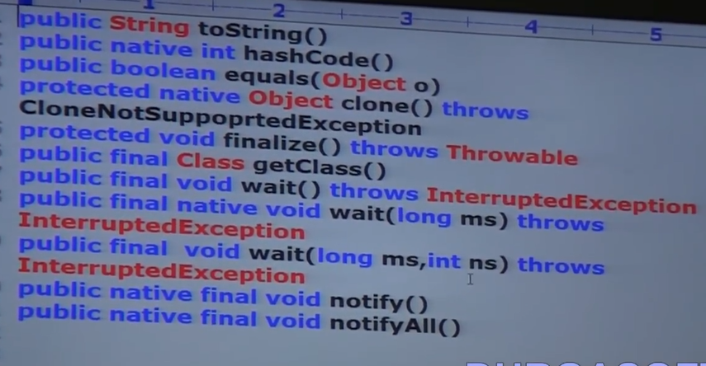

Note: Object class contains 12 methods, the extra method is register native:  
private static native void registerNatives();

This method internally required for object class and not available to the child classes hence we are not required to consider this method.

toString():  
we can use toString method to get string representation of an object.  
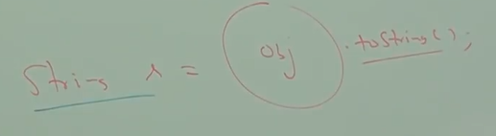

whenever we are trying to print object reference internally toString method will be called.

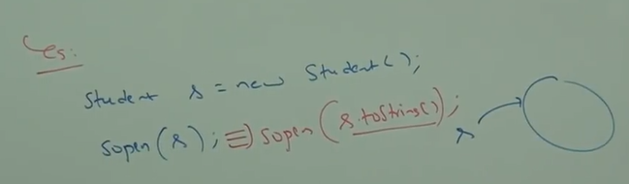

If our class doesn’t contain toString method then Object class toString method will be executed.  
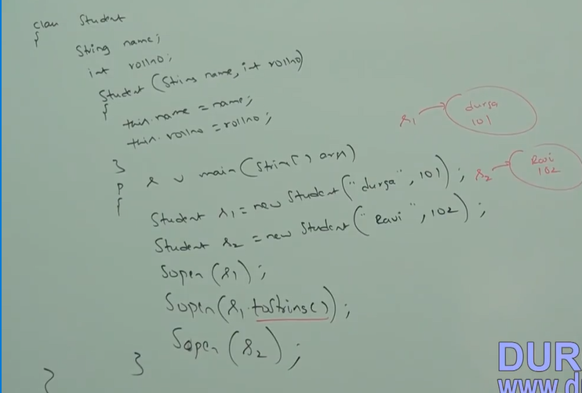

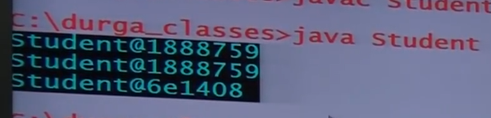

In the above example object class toString method got executed which is implemented as follows:



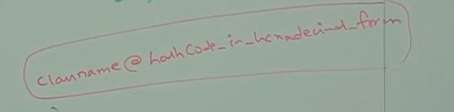

Based on our requirement we can override toString method to provide our own String representation.

For ex: whenever we are trying to print student object reference, to print his name and roll number we have to override toStirng method as follows:  
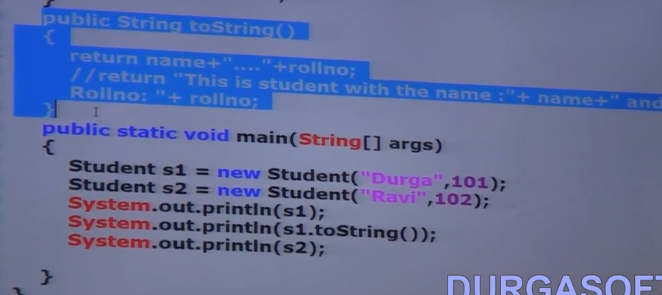

In all wrapper classes, in all collection classes, String class, StringBuffer and StringBuilder classes toString() method is overridden for meaningful string representation hence it is highly recommended to override toString() method in our class also.

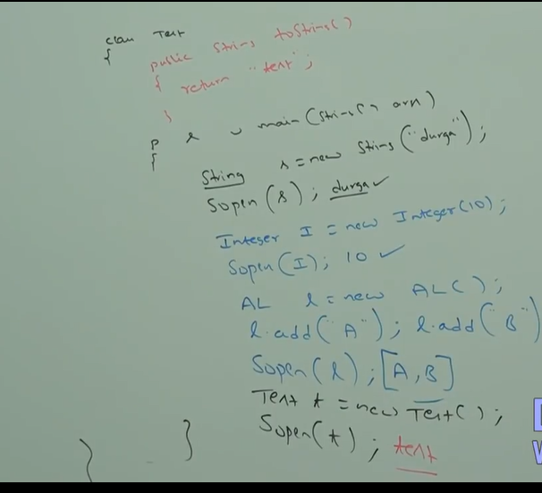

VIDEO 106:

Hashcode:  
For every object unique number generated by JVM which is Hashcode. Hashcode won’t represent address of object. JVM will use Hashcode while saving object into hashing related data structure like hashtable, hashmap, hashset. The main advantage of saving objects based on hashcode is search operation becomes easy (the most powerful search algorithm up to today is Hashing).  
If we are giving the chance to object class hashcode method, it will generate hashcode based on the address of object it doesn’t mean hashcode represent address of the object. Based on our requirement we can override hashcode method in our class to generate our own hashcode.

Overriding hashcode method is said to be proper if and only if for every object we have to generate a unique number as hashcode.

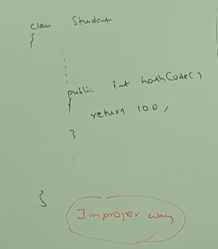

This is improper way of overriding hashcode method because for all students object we are generating same number as hashcode.

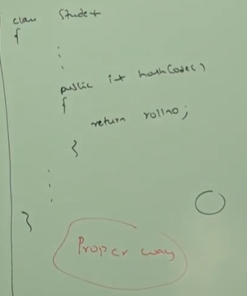

This is proper way of overriding hashcode method because we are generating a different hashcode for every object.

toString() vs hashCode()  
If we are giving the chance to object class toString method it will internally calls hashCode method. If we are overriding toString() method then our toString() method may not call hashCode() method.

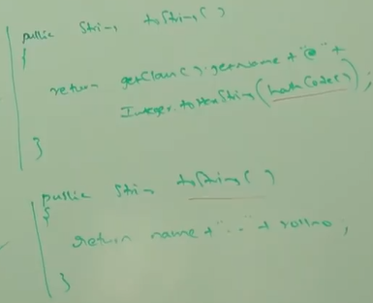

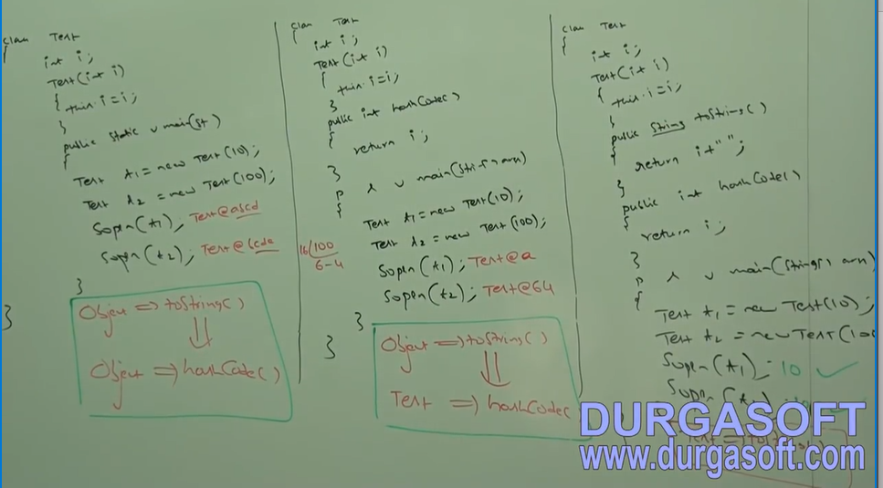

VIDEO 107:

We can use equal method to check equality of two objects.  
ex: obj1.equals(obj2);

If our class doesn’t contain equals method, then object class equals method will be executed.  
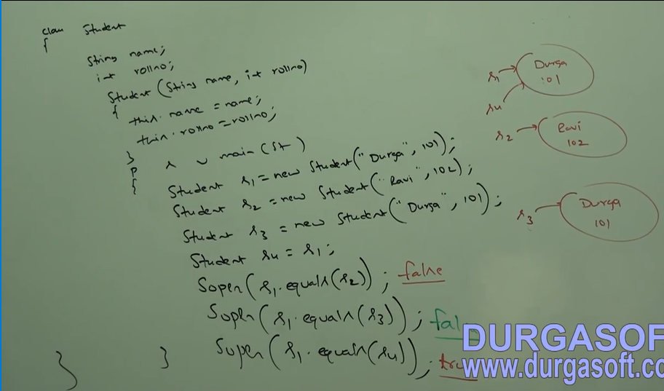

In the above example object class equals method get executed which is meant for reference comparison (address comparison) i.e. if two references pointing to same object then only .equals() method return true. Based on our requirements we can override equals method for content comparison.

While overriding equals method for content comparison we have to take care about the following:  
1. What is the meaning of equality(whether we have to check only names or only number or both)  
2. If we are passing different types of object our equals should not rise class cast exception i.e. we have to handle ClassCastException to return false.  
3. If we are passing null argument then our equals method should not rise NullPoniterException i.e. we have to handle NullPointerexception to return false.

The following is a proper way of overriding equals method for student class content comparison:  
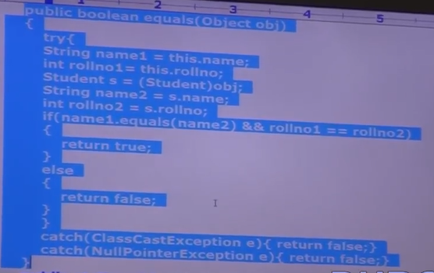

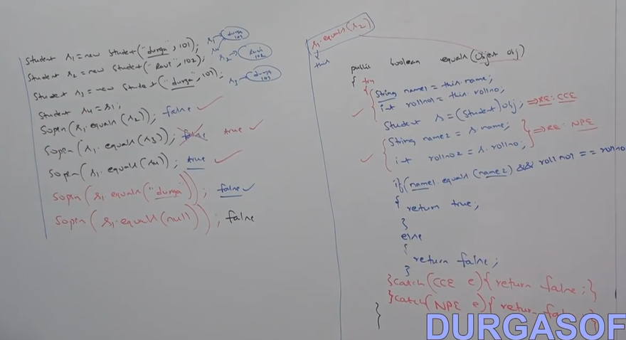

VIDEO 108:

getClass():  
We can use getClass() method to get Runtime class definition of an object.  
public final Class getClass()

By using this Class class object we can access class level properties like fully qualified name of the class, method information, constructors information etc.  
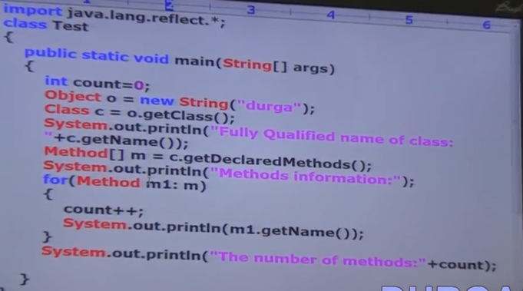

To display database vendor specific connection interface implemented class name.  
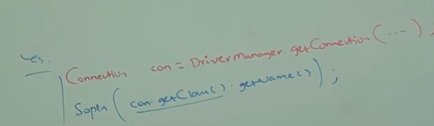

Note:  
1. After loading every .class file JVM will create an object of the type java.lang.Class in a heap area. Programmer can use this class object to get class level information.  
2. We can use getClass() method very frequently in reflections.

finalize():  
Just before destroying object, garbage collector calls finalize method to perform clean-up activities. Once finalize() method completes automatically garbage collector destroys that object.  
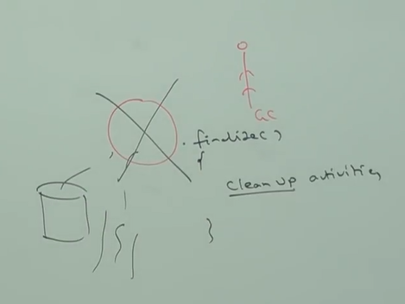

wait(), notify(), notfiyAll():  
we can use these methods for interthread communication. The thread which is expecting updation, it is responsible to call wait() method then immediately the thread will enter into waiting state. The thread which is responsible to perform updation, after performing updation the thread can call notify() method. The waiting thread will get that notification and continue its execution with those updates.

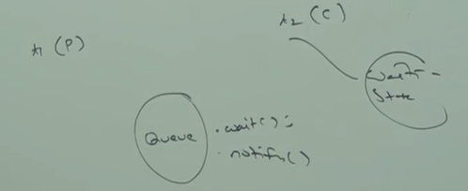

VIDEO 109:

**Java.lang.String:**

Case1:  
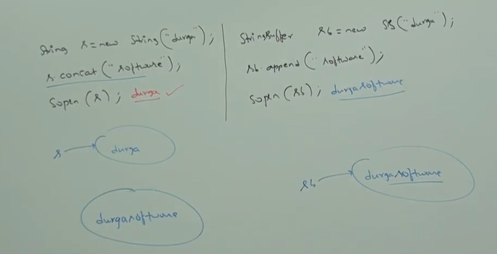

Once we create a string object, we can’t perform any changes in the existing object. If we are trying to perform any changes with those changes a new object will be created, this non-changeable behaviour is immutability of a string.

Once we create StringBuffer Object, we can perform any change in the existing object. This changeable behaviour is mutability of StringBuffer Object.

Case2:  
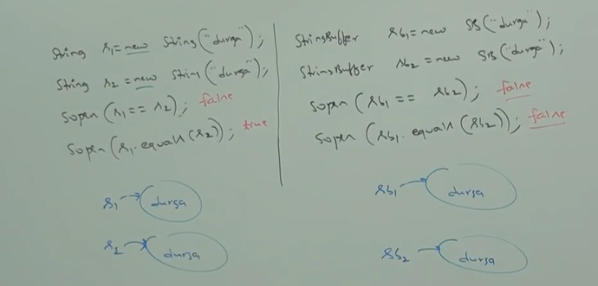

In a string class .equal method is overridden for content comparison hence even though objects are different if content is same .equal method return true.

In StringBuffer class .equals method is not overridden for content comparison hence object class .equals method got executed which is meant for reference comparison(address comparison) due to this if objects are different .equals method return false even though content is same.

Case3:  
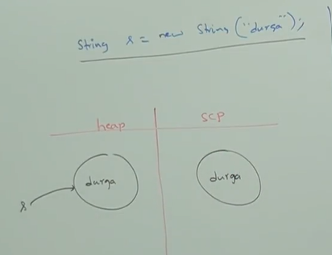

In this case two objects will be created one in the heap area and other in the string constant pool area and s is always pointing to heap object.

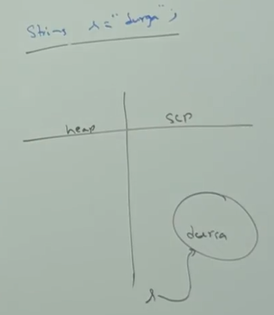

In this case only one object will be created in String constant pool and s is always pointing to that object.

Note1: Object creation in String constant pool is optional, first it will check is there any object already present in string constant pool with required content if object already exists then existing object will be reused. If Object not already exists, then only the new object will be created. But this rule is applicable only for String constant pool area but not for heap.

Note2: Garbage collector is not allowed to access String constant pool area hence even though object doesn’t contain reference variable it is not eligible for Garbage collector if it is present in String constant pool area.

All string constant pool object will be destroyed automatically at the time of JVM shutdown.

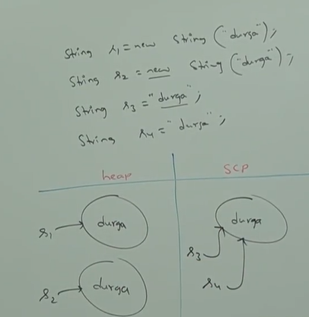

Whenever we are using new operator compulsory a new object will be created in the heap area hence there may be a chance of existing two object with same content in the heap area but not in string constant pool i.e., duplicate objects are possible in the heap area but not in string constant pool.

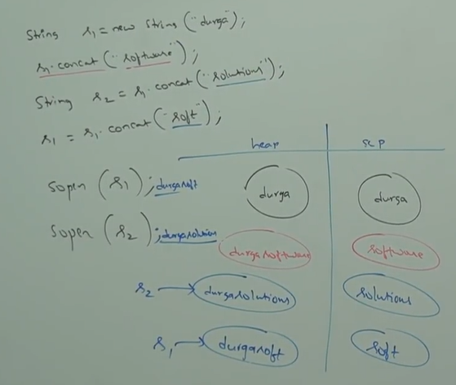

Note1: for every string constant one object will be placed in string constant pool area.

Because of some runtime operation if an object is required to create, that object will be placed only in the heap area but not in String constant pool area.  
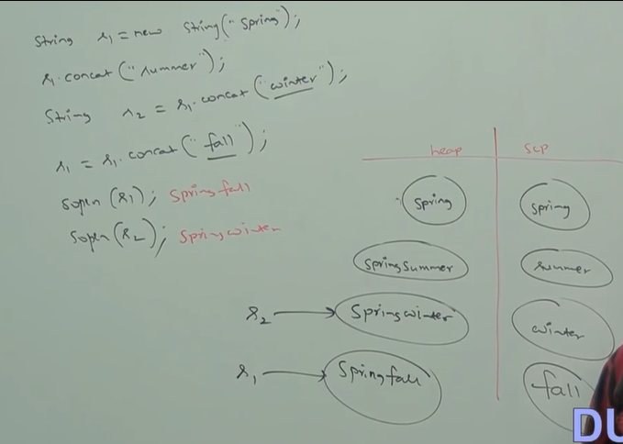

VIDEO 110:

Constructors of string class:  
**String s= new String()** creates an empty string object.

**String s = new String(String literal**) creates a String object on the heap for the given String literal.

**String s = new String(StringBuffer sb)** creates an equivalent string object for the StringBuffer.

**String s = new String(char[] ch)** creates an equivalent string object for the given char array.  
for ex: char[] ch ={‘a’,’b’,’c’,’d’};  
 String s = new String(ch);  
 Sop(s); abcd

**String s = new String(byte[] b);** that creates equivalent string object for the given byte array.  
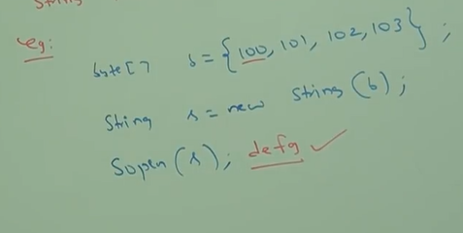

Important methods of string class:  
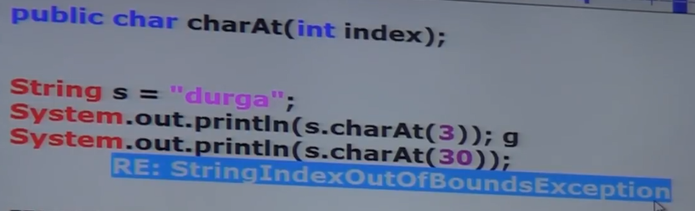

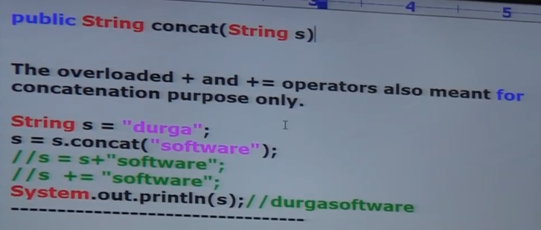

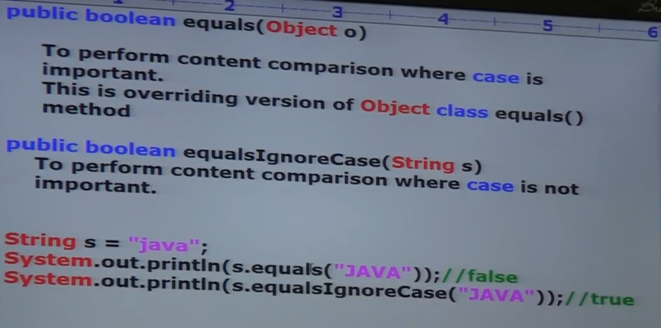

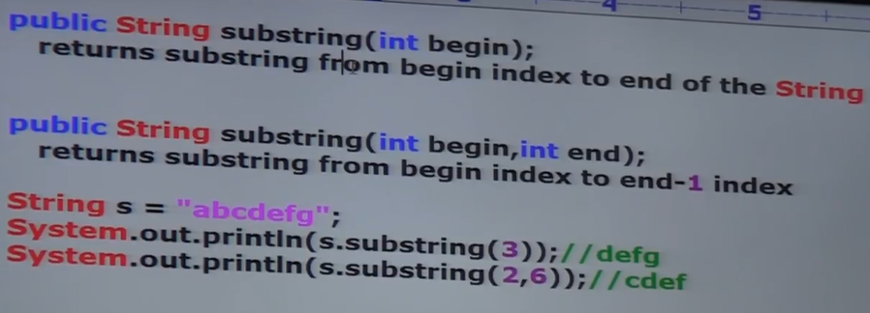

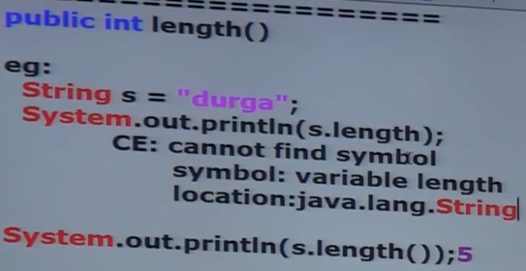

length variable applicable for arrays but not String objects whereas length() method applicable for String Object but not for arrays.

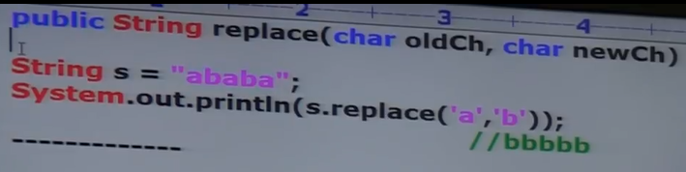



public String trim(); to remove blank space present at beginning and end of the String but not middle blank space.

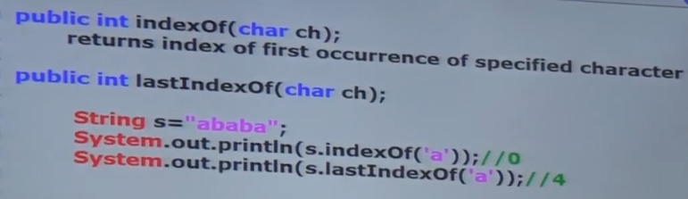

Note: because of runtime operation if there is a change in the content then with those changes a new object will be created on the heap, if there is no change in the content then existing object will be reused and the new object won’t be created. Whether the object is present in heap or string pool constant the rule is same.

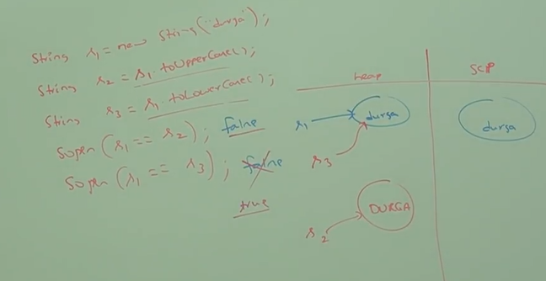

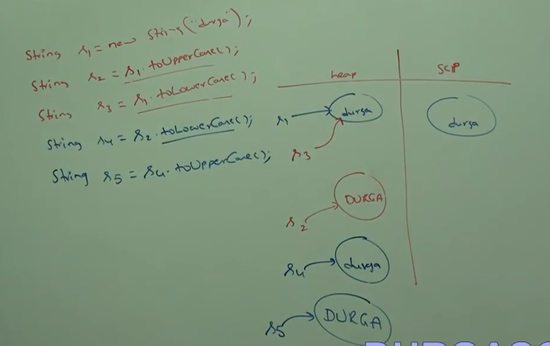

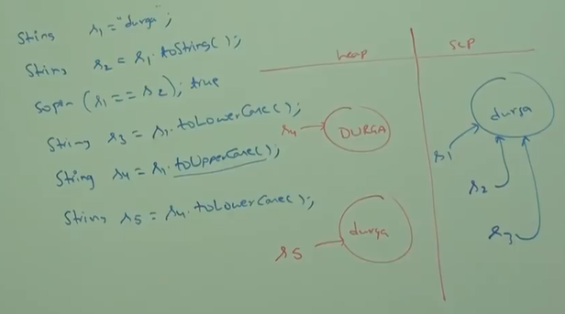

VIDEO 111:

**StringBuffer:**  
If the content is fixed and won’t change frequently then it is recommended to go for String. If the content is not fixed and keep on changing then it is not recommended to use String because for every change a new object will be created which effects performance of the system, to handle this requirement we should go for StringBuffer. The main advantage of StringBuffer over String is all required changes will be performed in the existing object only.

**Constructors:**  
**StringBuffer sb = new StringBuffer();** creates an empty StringBuffer object with default initial capacity 16. Once StringBuffer reaches its max capacity then a new StringBuffer Object will be created with new capacity as:  
NewCapacity =(CurrentCapacity + 1) *2 ;

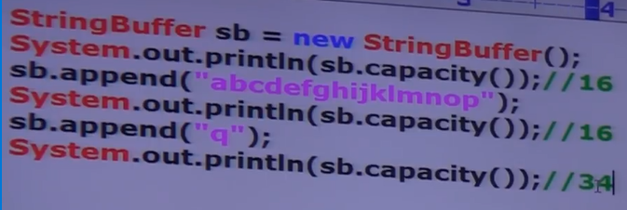

**StringBuffer sb = new StringBuffer(int initialcapacity);** creates an empty StringBuffer object with specified initial capacity.

**StringBuffer sb = new StringBuffer(String s);**  
ex: StringBuffer sb = new StringBuffer(“durga”);  
 sop(sb.capacity()) ; //21 capacity = s.length() + 16

Important methods of StringBuffer:  
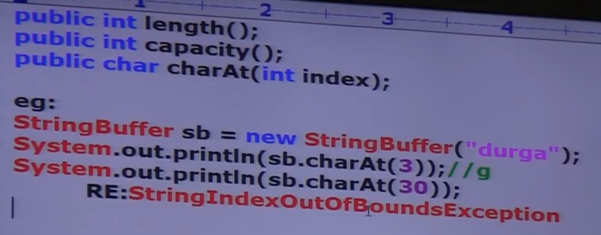

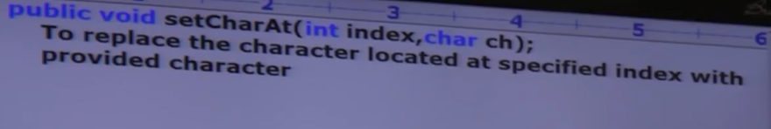

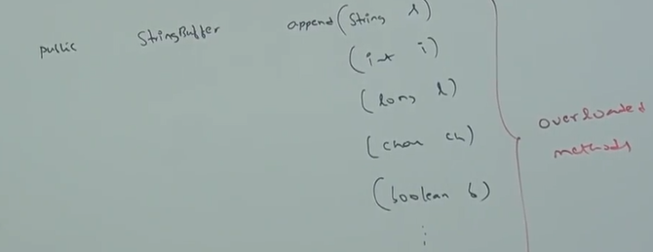

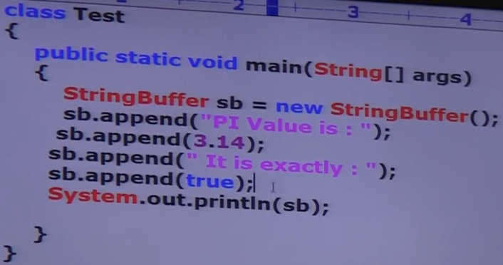



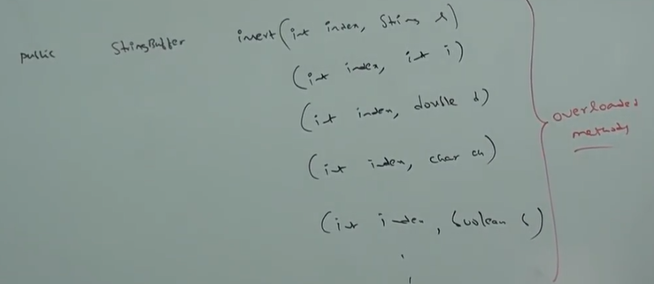

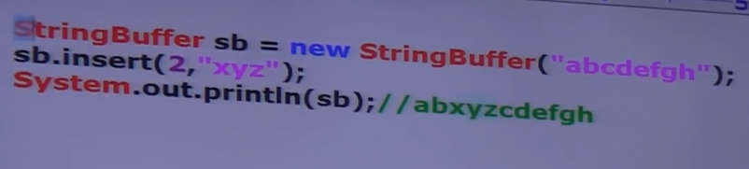

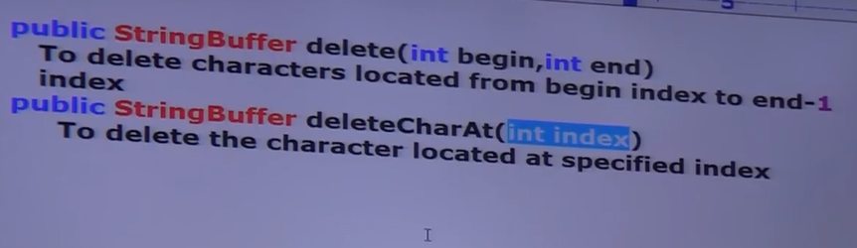

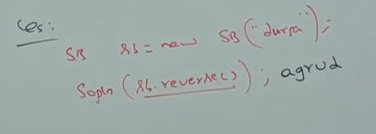

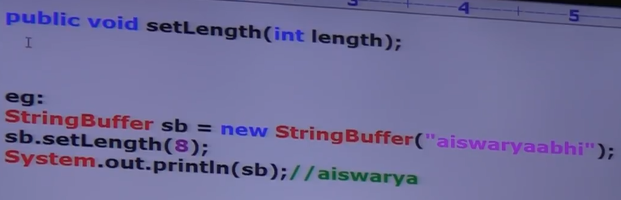

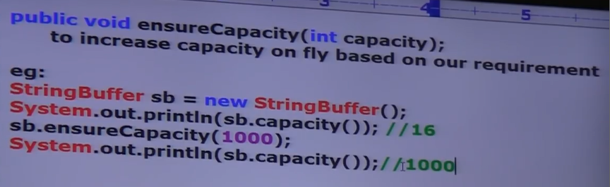

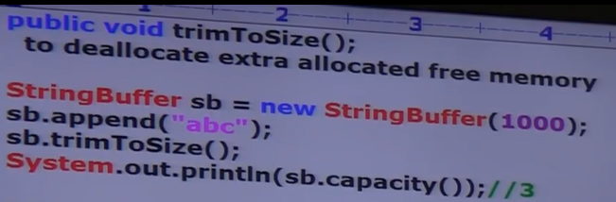

**StringBuilder:**

Every method present in StringBuffer is synchronized hence only one thread is allowed to operate on StringBuffer object at a time which may create performance problems, to handle this requirement SUN people introduces StringBuilder concept in 1.5 Version.

StringBuilder is exactly same as StringBuffer except the following differences:

|  |  |
| --- | --- |
| **StringBuffer** | **StringBuilder** |
| 1. Every method present in StringBuffer is synchronized. | 1. Every method present in StringBuffer is non-synchronized. |
| 2. At a time only one thread is allowed to operate on StringBuffer Object and hence StringBuffer Object is thread safe. | 2. At a time multiple thread is allowed to operate on StringBuilder Object and hence StringBuilder Object is not thread safe. |
| 3. Threads are required to wait to operate on StringBuffer Object and hence relatively performance is low. | 3. Threads are not required to wait to operate on StringBuilder Object and hence relatively performance is high. |
| 4. Introduced in 1.0 version. | 4. Introduced in 1.5 version. |

Note : except the above differences everything is same in StringBuffer and StringBuilder(including methods and constructors)

**String vs StringBuffer vs StringBuilder:**1. If the content is fixed and won’t change frequently then we should go for String.  
2. If the content is not fixed and keep on changing but thread safety required, then we should go for StringBuffer.  
3. If the content is not fixed and keep on changing but thread safety is not required, then we should go for StringBuilder.

**Method chaining:**For most of the methods in String, StringBuffer and StringBuilder returns types are same type hence after applying a method and the result we can call another method which forms method chaining.

Sb.m1().m2().m3().m4()………………………….

In method chaining method calls will be executed from left to right.  
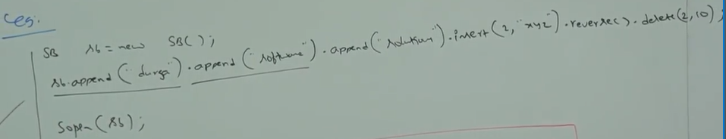

VIDEO 112:

Wrapper classes:  
The main objectives of wrapper classes are:  
1. To wrap primitive into object form so that we can handle primitives also just like objects.  
2. To define several utility methods which are required for the primitives.

Constructors:  
Almost all wrapper classes contain two constructor one can take primitive as argument and the other can take string as argument.  
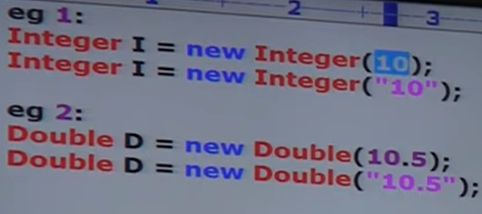

If String argument not represented a number then we will get RE saying NumberFormatException



Float class contains 3 constructors with float, double, and String arguments.  
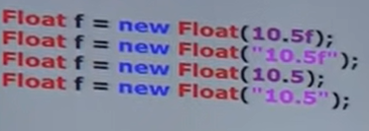

Character class contains only one constructor which can take char argument.

Boolean class contains two constructors one can take primitive as argument and the other can take string argument. If we pass Boolean primitive as argument, the only allowed values are true and false where case is important, and content is also important.

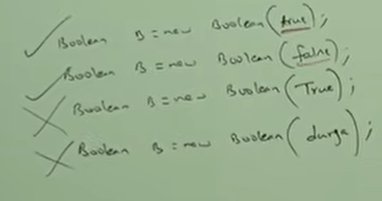

If we are passing string type as argument, then case and content both are not important. If the content is case insensitive string of “true” then it is treated as true otherwise it is treated as “false”.  
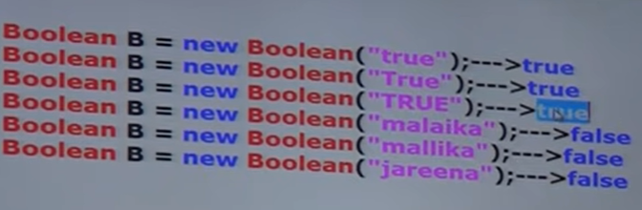

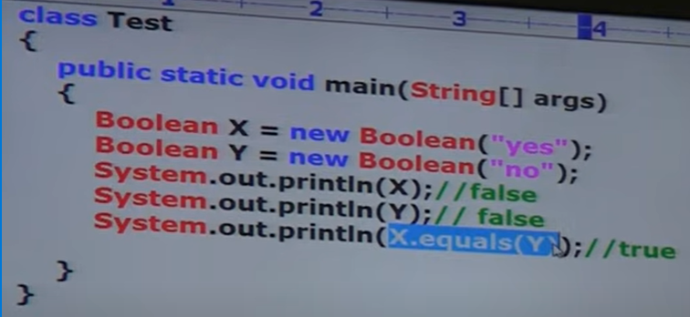

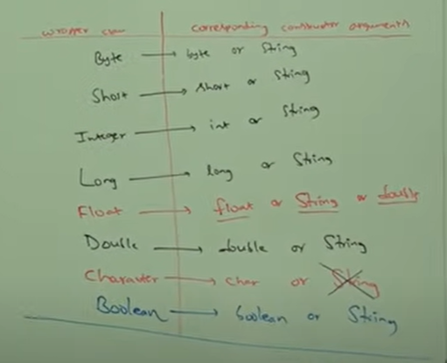

Note: In all wrapper classes toString() method is overridden to return content directly. In all wrapper classes .equals method is overridden for content comparison.

Utility methods:  
1. valueOf()  
2. xxxValue()  
3. parseXxx()  
4. toString()

1. valueOf():  
we can use valueOf() methods to create wrapper object for the given primitive or string.  
every wrapper class except character class contains static valueOf method to create wrapper object for the given String.

Form1:  
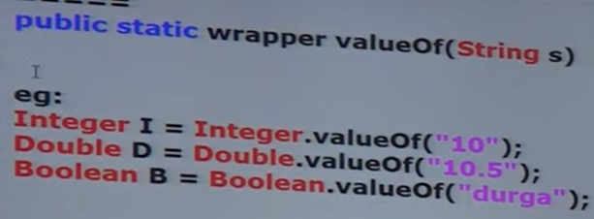

Form2:  
Every Integral type wrapper class (Byte, Short, Integer, Long) contains the following value of method to create wrapper object for the given specified radix string.

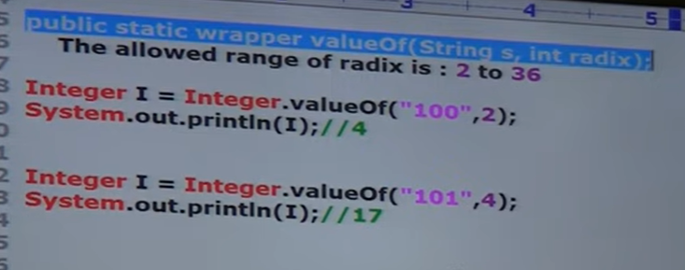

Form3:  
Every wrapper class including character class contains a static valueOf() method to create wrapper object for the given primitive.  
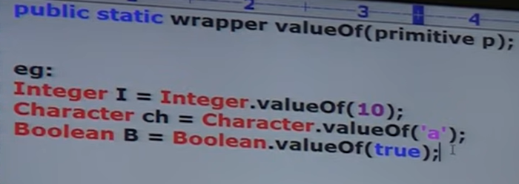

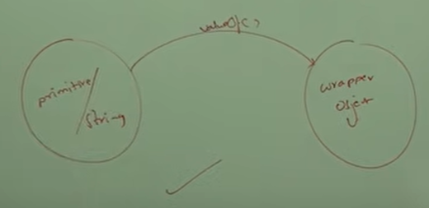

2. xxxValue():  
We can use xxxValue() method to get primitive for the given wrapper object.

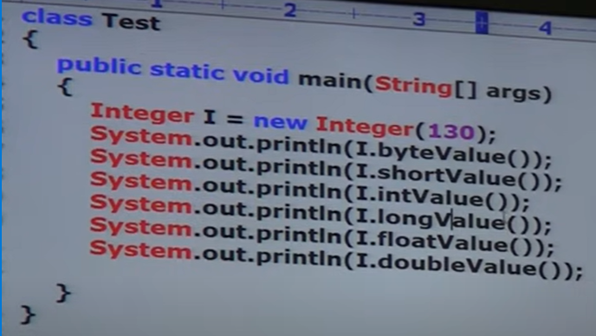



Every number type wrapper class(Byte, Short, Integer, Long, Float, Double) contains the following 6 method to get primitive for the given wrapper object.

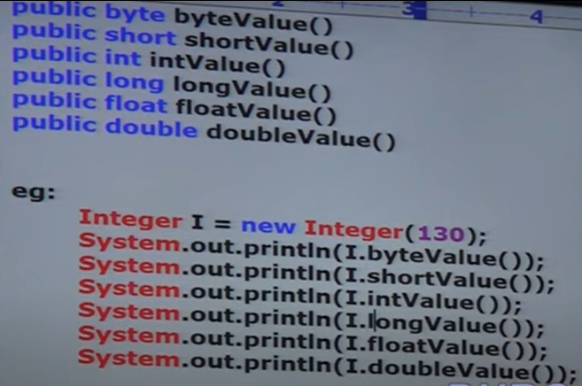

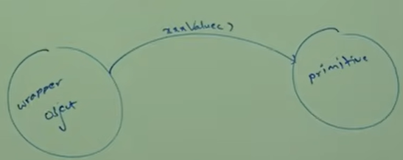

VIDEO 113:

parseXxx():  
we can use parseXxx() methods to convert String to primitive.

Form1:  
Every wrapper class except character class contains the following parsexxx() method to find primitive for the given object:  
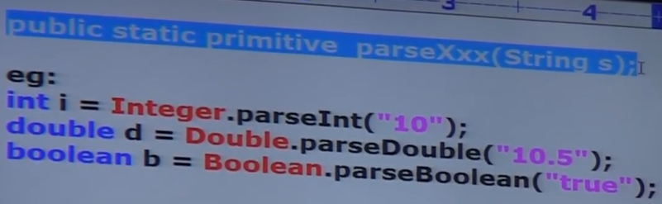

Form2:  
Every integral type wrapper class (Byte, Short, Integer, Long) contains the following parsexxx() method to convert specified radix string to primitive.

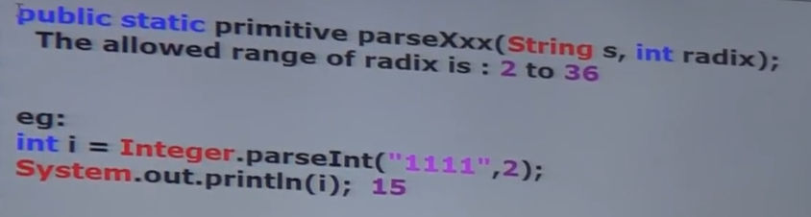

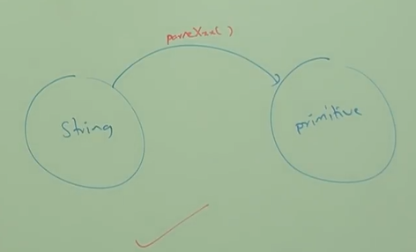

toString():  
we can use toString() method to convert wrapper object or primitive to String.

Form1:  
Every wrapper class contains the following toString() method to convert wrapper object to String type.  
public String toString();

It is the overriding version of object class toString() method.

Whenever we are trying to print wrapper object reference internally this toString() method will be called.  
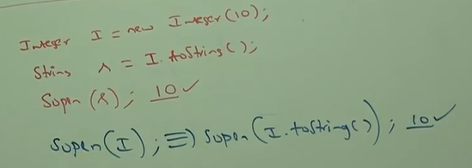

Form2:  
Every wrapper class including character class contains the following static toString() method to convert primitive to String.

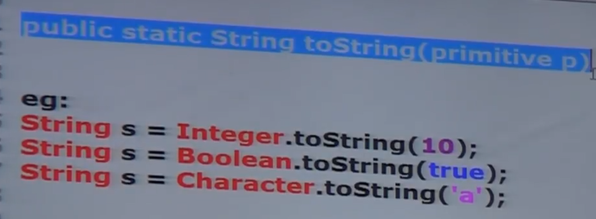

Form3:  
integer and Long class contains the following toString() method to convert primitive specified radix String.

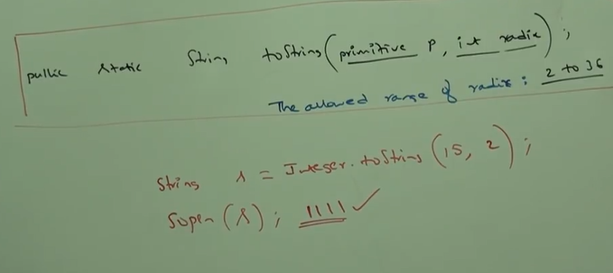

Form4:  
toXXXString() methods:  
Integer and Long classes contains the following toXXXString() method:

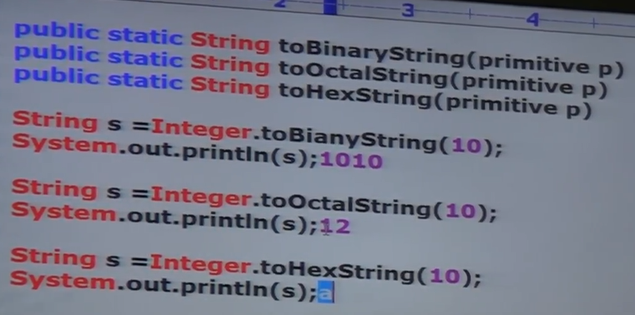

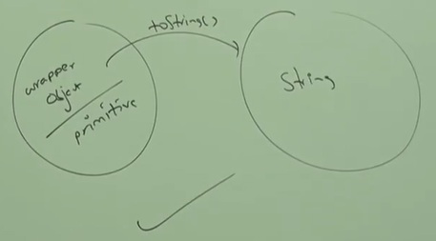

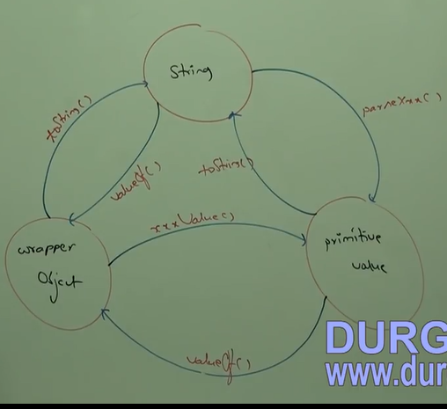

Partial Hierarchy of java.lang.package

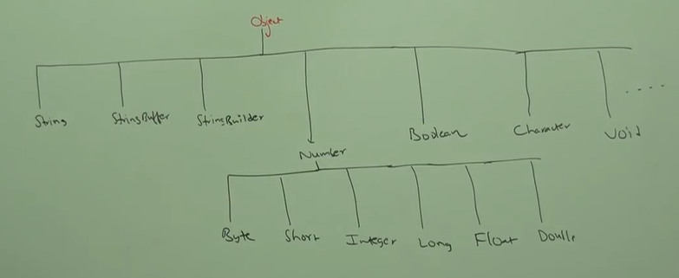

Conclusions:  
1. The wrapper classes which are not child class of Number are Boolean, Character.

2. The wrapper classes which are not direct child class of Object are Byte, Short, Integer, Long, Float, Double.

3. String, StringBuffer, StringBuilder and all wrapper classes are final classes.

4. In addition to String Objects all wrapper class object also immutable.

5. Sometimes void class is also considered as wrapper class.

Void class:  
It is a final class and direct child class of object. It doesn’t contain any methods and it contains only one variable Void.TYPE

In general, we can use Void class in reflections to check whether the method return type is void or not. Void is the class representation of void keyword in java.  
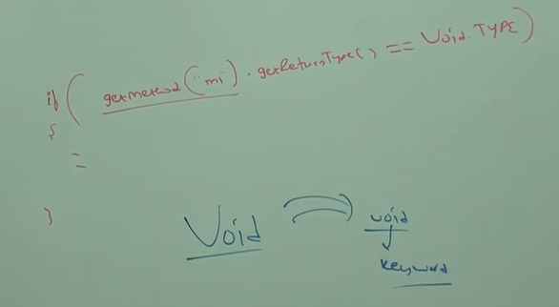

VIDEO 114:

Autoboxing:  
Automatic conversion of primitive to wrapper object by compiler is called autoboxing.  
ex: Integer I = 10; [ compiler converts int to Integer automatically by autoboxing ]

After compilation the above line will become:  
Integer I – Integer.valueOf(10); i.e. internally autoboxing concept is implemented by using valueOf method.

AutoUnboxing:  
Automatic conversion of wrapper object to primitive by compiler is called autounboxing.  
ex: Integer I = new Integer(10);

int I = I; [ compilre converts Integer to int automatically by autoboxing ]

After compilation the above line will become:  
int I = I.intValue() i.e. internally autounboxing concept is implemented by using xxxValue() methods.

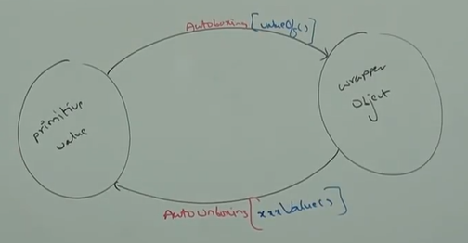

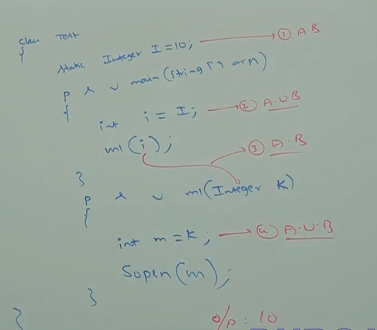

It is valid in 1.5 version but invalid in 1.4 version.

Note: Just because of autoboxing and autounboxing we can use primitives and wrapper objects interchangeable from 1.5 version onwards.

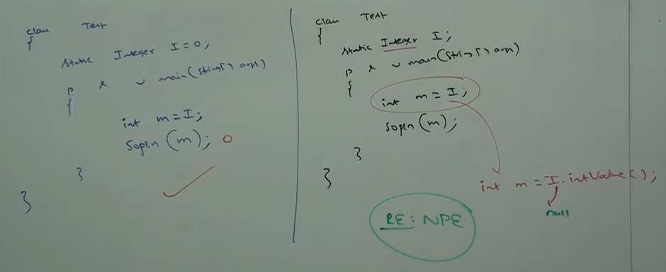

Note: on null reference, if we are trying to perform autounboxing then we will get RE saying NullPointerException.

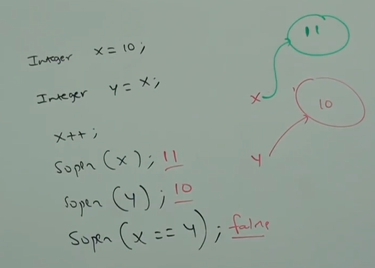

Note: All wrapper class objects are immutable i.e., once we create wrapper class object we can’t perform any changes in that object. If we are trying to perform any changes with those changes a new object will be created.

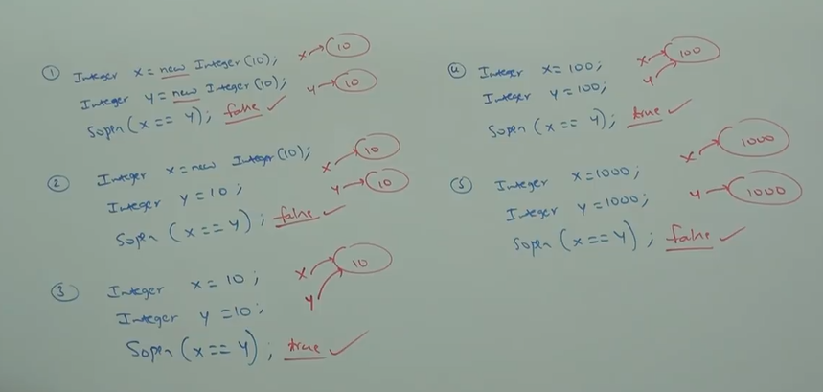

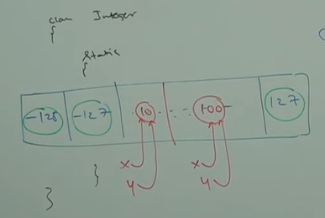

Conclusion:  
Internally to provide support for autoboxing, a buffer of wrapper object will be created at the time of wrapper class loading. While autoboxing if an object is required to create, first JVM will check whether this object is already present in the buffer or not, if this is already present in the buffer then existing buffer object will be used. If this is already not available in buffer, then JVM will create a new object.

Buffer concept is available in the following ranges:  
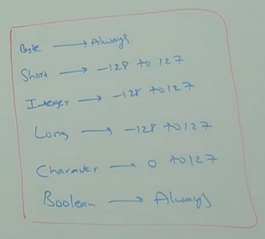

Except this range, in all remaining cases a new object will be created.

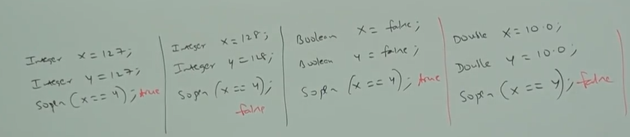

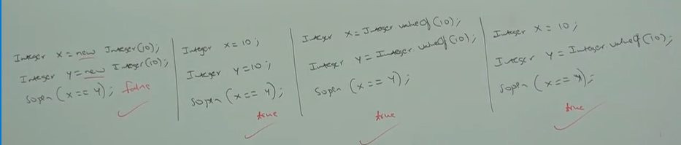

VIDEO 115:

Overloading w.r.t autoboxing, widening and var-arg methods:

Case1:

autoboxing vs widening:  
Widening dominates autoboxing  
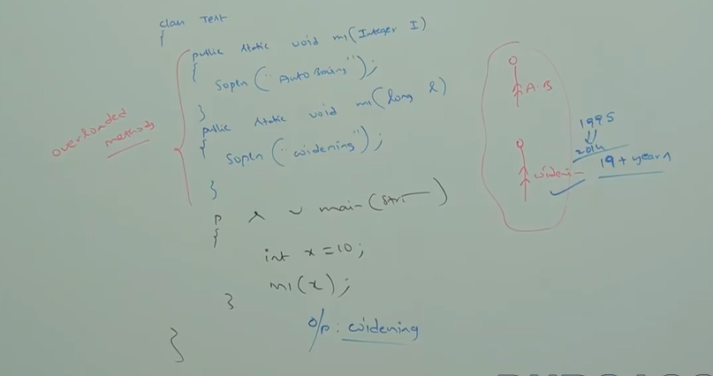

Case2:

Var-args vs widening:  
widening dominates var-args method

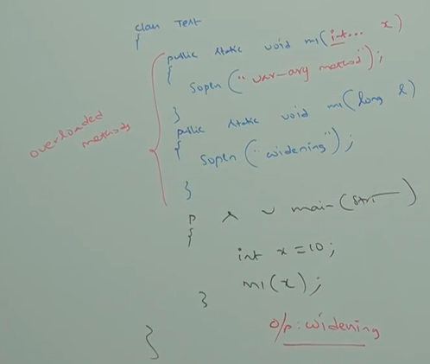

Case3:

Autoboxing vs var-args method:  
autoboxing dominates var-args method.

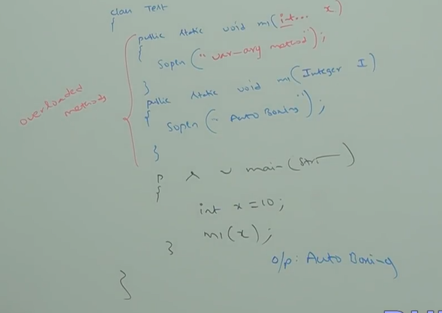

In general, var-args method will get least priority i.e. if no other method matched then only var-args will get the chance. It is exactly same as default case inside switch.

Note: while resolving overloaded methods compiler will always give the precedence in the following order:  
widening > Autoboxing > var-args method

Case4:

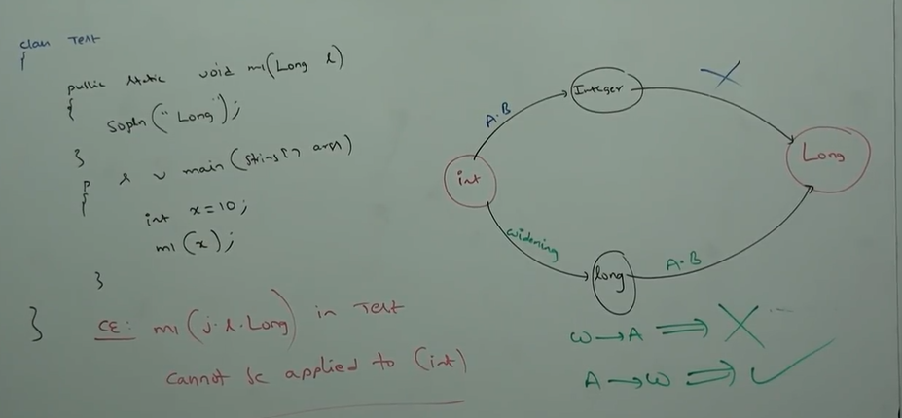

widening followed by autoboxing is not allowed in JAVA whereas autoboxing followed by widening is allowed.

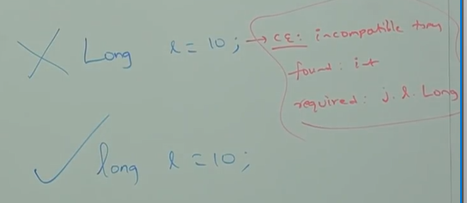

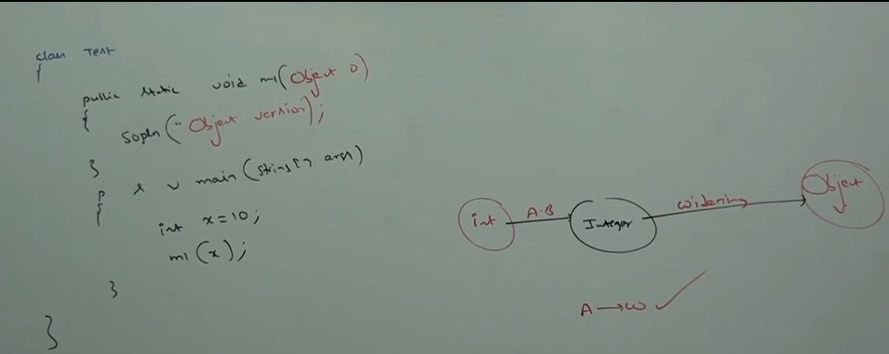

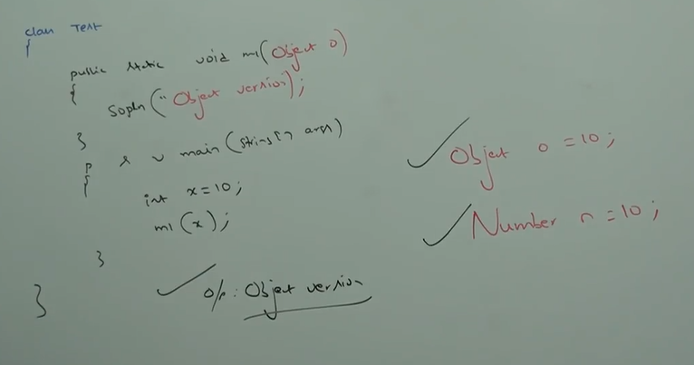

VIDEO 189:

Development:

Javac:  
We can use Javac command to compile single or group of java source files.

Javac [optional] Test.java

Javac [optional] A.java B.java C.java

Javac [optional] *.java

Optional = -version, -d, -source, -verbose, -cp/-classpath

Java :  
we can use java command to run a single class file.

Java [optional] Test A B C

Optional = -version, -D, -cp/classpath, -ea/-esa/-dsa/-da

Note: We can compile any number of source file at a time, but we can run only one dot class file at a time.

Classpath:  
classpath describe the location where required dot class files are available. Java compiler and JVM will use class path to locate required dot class file.

By default jvm will always searches in current working directory for the required dot class file. If we set classpath explicitly then jvm will search in our specified classpath location and jvm won’t search in current working directory.

We can set the classpath in the following three ways:

1. By using environment variable classpath 🡪 this way of setting the classpath is permanent and will be preserved across system restart.

2. At command prompt level by using set command:

set classpath = c:\durga_classes

This way of setting classpath will be preserved only for particular command prompt, once command prompt closes automatically classpath will be lost.

3. At command level by using -cp option:

Java -cp c:\durga_classes Test

This way of setting classpath will be preserved only for particular command, once command execution completes automatically classpath will be lost.

Note: among three ways of setting classpath, setting classpath at command level is recommended because dependent classes are varied from command to command.

Once we set the classpath we can run our program from any location.

Once we set the classpath, JVM won’t search in current working directory and it will always search in the specified classpath location only.

